**Basic data Structure**

**Module – 1:**



**Module 2:**



**Vector Built-in Functions:**

1. **Constructor**

|  |  |  |
| --- | --- | --- |
| **Name** | **Details** | **Time Complexity** |
| **vector<type>v;** | Construct a vector with 0 elements. | O(1) |
| **vector<type>v(N);** | Construct a vector with N elements and the value will be garbage. | O(N) |
| **vector<type>v(N,V);** | Construct a vector with N elements and the value will be V. | O(N) |
| **vector<type>v(v2);** | Construct a vector by copying another vector v2. | O(N) |
| **vector<type>v(A,A+N);** | Construct a vector by copying all elements from an array A of size N. | O(N) |

1. **Capacity**

|  |  |  |
| --- | --- | --- |
| **Name** | **Details** | **Time Complexity** |
| **v.size()** | Returns the size of the vector. | O(1) |
| **v.max_size()** | Returns the maximum size that the vector can hold. | O(1) |
| **v.capacity()** | Returns the current available capacity of the vector. | O(1) |
| **v.clear()** | Clears the vector elements. Do not delete the memory, only clear the value. | O(N) |
| **v.empty()** | Return true/false if the vector is empty or not. | O(1) |
| **v.resize()** | Change the size of the vector. | O(K); where K is the difference between new size and current size. |

1. **Modifiers**

|  |  |  |  |
| --- | --- | --- | --- |
| **Name** | **Details** | | **Time Complexity** |
| **v= or v.assign()** | | Assign another vector. | O(N) if sizes are different, O(1) otherwise. |
| **v.push_back()** | | Add an element to the end. | O(1) |
| **v.pop_back()** | | Remove the last element. | O(1) |
| **v.insert()** | | Insert elements at a specific position. | O(N+K); where K is the number of elements to be inserted. |
| **v.erase()** | | Delete elements from a specific position. | O(N+K); where K is the number of elements to be deleted. |
| **replace(v.begin(),v.end(),value,replace_value)** | | Replace all the value with replace value. Not under a vector. | O(N) |
| **find(v.begin(),v.end(),V)** | | Find the value V. Not under a vector. | O(N) |

1. **Element access**

|  |  |  |
| --- | --- | --- |
| **Name** | **Details** | **Time Complexity** |
| **v[i]** | Access the ith element. | O(1) |
| **v.at(i)** | Access the ith element. | O(1) |
| **v.back()** | Access the last element. | O(1) |
| **v.front()** | Access the first element. | O(1) |

1. **Iterators**

|  |  |  |
| --- | --- | --- |
| **Name** | **Details** | **Time Complexity** |
| **v.begin()** | Pointer to the first element. | O(1) |
| **v.end()** | Pointer to the last element. | O(1) |

**Vector initialization:**



**Vector Capacity:**



**Vector Resize:**



**Vector Modifiers -> Vector re-assign:**



**Vector Insert:**



**Vector Erase:**



**Vector replace:**



**Vector find:**



**Vector Input:**





**Vector of String:**



**Vector of String with Space:**



**Module 2.5:**



**Problem 2:**



**Problem 3:**



**Problem 4:**



**Problem 5:**



**Module 3:**

**Problem 1: (Prefix Sum Array)**



**Time limit exceeded in bruteforce**



**Here, it’s time complexity is O(Nq).**

* **N = 10^5 and q = 10^5**
* **Nq = 10^10 (It’s time complexity is more than 1.5 second)**

**That’s why it got a time limit exceeded error.**

Now using **Prefix sum Array** we will solve this problem.

**Prefix sum:** A prefix sum array, also known as a cumulative sum array, is an array that stores the cumulative sum of elements up to a certain index. This can be useful in various algorithms and problems where you need to efficiently compute the sum of a range of elements in an array.

Let's illustrate the process of creating a prefix sum array with a table using the example array [1, 2, 3, 4, 5].

| **Index** | **Original Array** | **Prefix Sum Array** |
| --- | --- | --- |
| 0 | 1 | 1 |
| 1 | 2 | 1 + 2 = 3 |
| 2 | 3 | 1 + 2 + 3 = 6 |
| 3 | 4 | 1 + 2 + 3 + 4 = 10 |
| 4 | 5 | 1 + 2 + 3 + 4 + 5 = 15 |

Here,

|  |  |  |  |  |  |
| --- | --- | --- | --- | --- | --- |
| Original Array = | 1 | 2 | 3 | 4 | 5 |

|  |  |  |  |  |  |
| --- | --- | --- | --- | --- | --- |
| Prefix Sum Array = | 1 | 3 | 6 | 10 | 15 |



**Algorithm Of this code is below:**

1. Input:

* Read integers n and q from the input, representing the size of the array and the number of queries, respectively.
* Read array elements a[i] for each i from 0 to n-1.

2. Prefix Sum Computation:

* Initialize an array **prefix_sum** of type **long long int** to store the prefix sum.
* Calculate the prefix sum array **prefix_sum** for the given array **a** using a loop.

3. Query Processing:

* For each query (**q** times):
  + Read integers **l** and **r** from the input, representing the range of indices in the array.
  + Calculate the sum of elements in the range **[l, r]** using the prefix sum array:
    - If l is 1, set sum to prefix_sum[r - 1].
    - If l is not 1, set sum to prefix_sum[r - 1] - prefix_sum[l - 2]. This handles the case where l is not at the beginning of the array.
  + Print the calculated sum.

4. Output:

* Print the sum for each query on a new line.

**Same approach just a little bit different style in code.**



**Module 3.5: Binary Search**

Let's use an example with the array **[2, 4, 6, 8, 10, 12, 14, 16, 18, 20]** and the target value **12** for binary search.

|  |  |  |  |  |  |  |
| --- | --- | --- | --- | --- | --- | --- |
| **Iteration** | **Low** | **High** | **Mid** | **Value at Mid** | **Comparison** | **New Range** |
| **1** | **0** | **9** | **4** | **10** | **< target** | **10-9** |
| **2** | **5** | **9** | **7** | **16** | **> target** | **5-6** |
| **3** | **5** | **6** | **5** | **12** | **= target** | **Found!** |

## Explanation:

1. **Iteration 1:**

* Initial range: [2, 4, 6, 8, 10, 12, 14, 16, 18, 20] (low = 0, high = 9).
* Midpoint: mid = (0 + 9) / 2 = 4.
* Value at midpoint: 10 (less than the target).
* Adjust the range to the right half: low = 5, high = 9.

1. **Iteration 2:**

* Updated range: **[12, 14, 16, 18, 20]** (low = 5, high = 9).
* Midpoint: **mid = (5 + 9) / 2 = 7**.
* Value at midpoint: **16** (greater than the target).
* Adjust the range to the left half: **low = 5, high = 6**.

1. **Iteration 3:**

* Updated range: **[12]** (low = 5, high = 6).
* Midpoint: **mid = (5 + 6) / 2 = 5**.
* Value at midpoint: **12** (equal to the target).
* Target found!

This example demonstrates how binary search efficiently narrows down the search range and finds the target value in just a few iterations.

Top of Form

Let’s see another example with animated way.

















Another example where searching value is **not found.**













Binary Search Code in C++:



Problem:



Solution:



Here this problem is solved using **Brute Force Approach.** In this way it has been solved but the time limit exceeded. Because of its time complexity is O(N*q). This is impossible to complete run in 1 second.

**Here, it’s time complexity is O(Nq).**

* **N = 10^5 and q = 10^5**
* **Nq = 10^10 (It’s time complexity is more than 1 second)**

**That’s why it got a time limit exceeded error.**

It’s Time Complexity is:



So, let’s try to solve it with Apply **Binary Search** for efficient time complexity.



**Time Complexity Analysis of above code:**

1. Array Sorting:

* Sorting the array using **sort(a, a + n)** takes O(n log n) time.

2. Binary Search:

* For each query (loop executed 'q' times), binary search is performed.
* Binary search has a time complexity of O(log n).
* Therefore, the overall time complexity for 'q' queries is O(q * log n).

3. Overall Time Complexity:

* The dominant factor is the binary search within the loop.
* The overall time complexity is O(n log n) (for sorting) + O(q log n) (for binary search within the loop).

In summary, the overall time complexity of the code is O(n log n + q log n). If 'q' is significantly smaller than 'n', this approach can be more efficient compared to the linear search in the previous example.

**Module 3.5**

**Problem 1:**





**Problem 2: Prefix Sum Array**





**Problem 3 :**





**Problem 4:**





**Problem 5:**





**WEEK 2**

**Module 5: Singly Linked List**



**Create Node:**

** **



**Create node with constructor**



**Dynamic Node:**



**How Singly Linked List Works:**



head -> next

a -> next

**Print Linked List**







7

2

3

**NULL**

2CA

**1D**

**52C**

**Module 6:**



**Here,** ‘ptr’ is the address of ‘val’.



**Here,** ‘*ptr’ is the value of ‘val’.



**Here,** If we de-reference the p in fun function then keep NULL in it then it will change the value of val/*ptr to NULL.



**Here,** If we don’t de-reference the p in fun function and keep NULL in it then it will not change the value of val. It just changes the value of p.



**But Now I want to change the value of ptr as NULL by changing the value of p. Where, if I will keep NULL in p inside fun function then ptr also will be NULL. In this system called reference.**

**And here p and ptr are the same variable now. And there addresses are same.**



**Module 6.2:**

**Insert at Tail:**









**Insert Node at any position:**



Not Change X

Change √



**Insert node at any position.**





**Output of above code:**





**Insert at head:**



**Delete a node:**









**Delete Head:**











**Input Linked List :**





**Module 7:**



**Singly Linked List:**



**Insert Node:**

** **



****Insert at head:





**Insert at tail** with O(1) complexity:





**Delete Node:**





|  |  |  |
| --- | --- | --- |
|  | **Array** | **Linked List** |
| **Insert Tail** | **O(1)** | **O(1)** |
| **Insert Head** | **O(N)** | **O(1)** |
| **Insert Any Position** | **O(N)** | **O(N)** |

**Delete head in singly linked list:**





Input linked list at tail with complexity O(1):





Print Linked List & **Reverse** Print Linked List in **Recursively**.





Sort Linked List (Ascending Order):



**Module 9:**



**Doubly Linked List:**

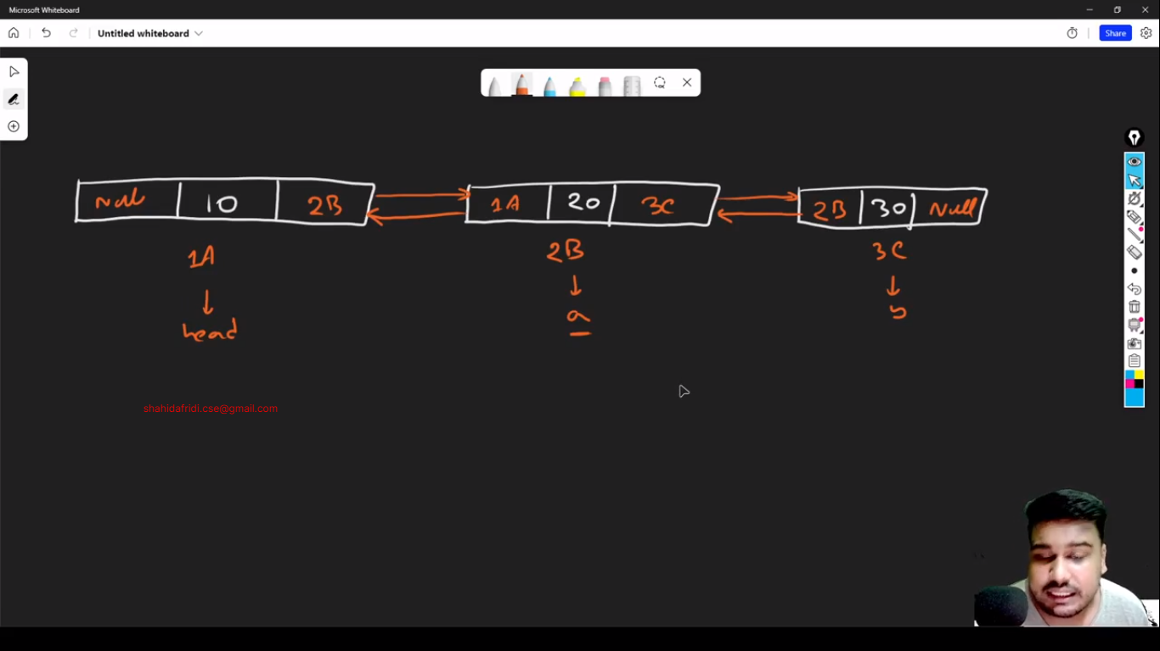

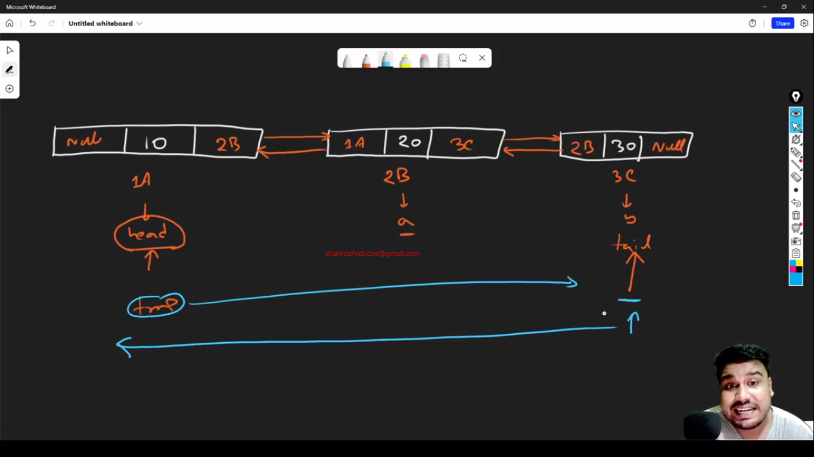

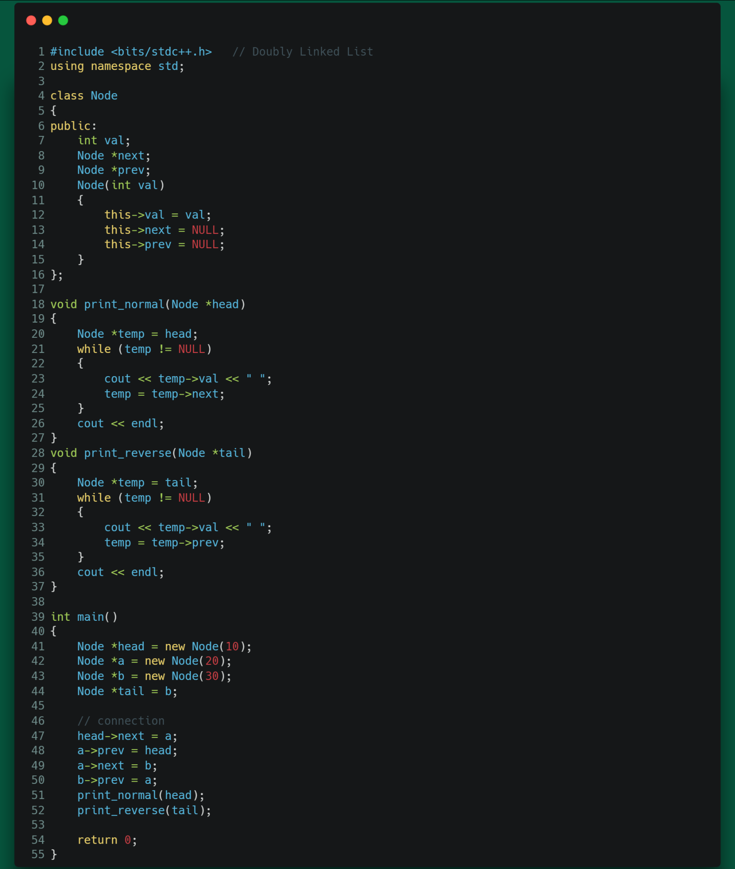

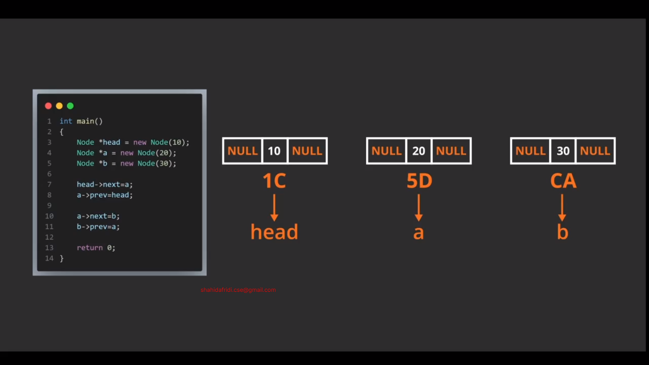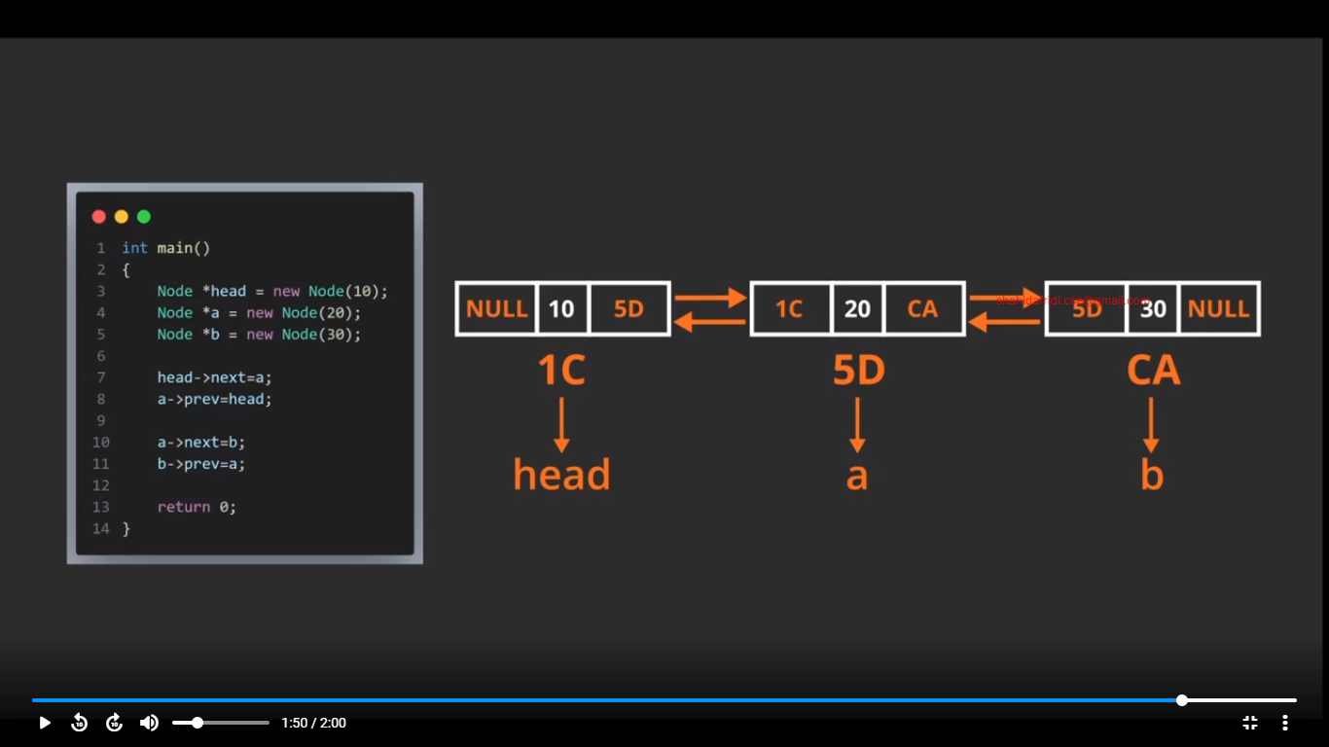

Insert at any position in doubly Linked List:

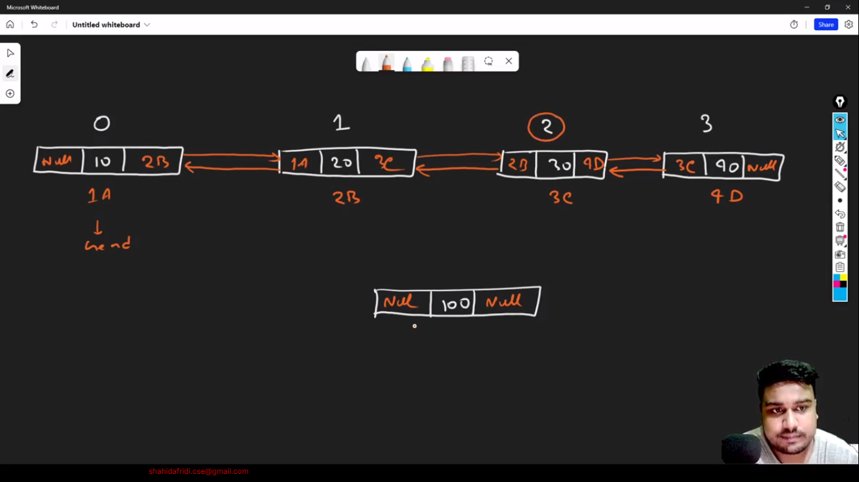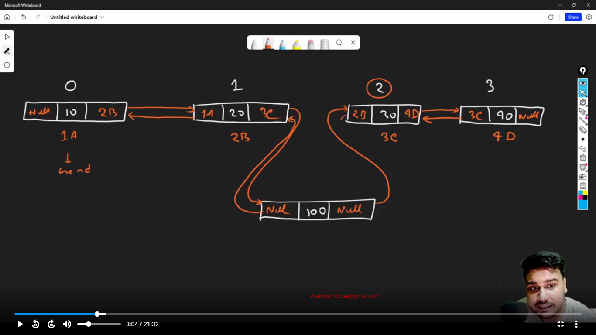

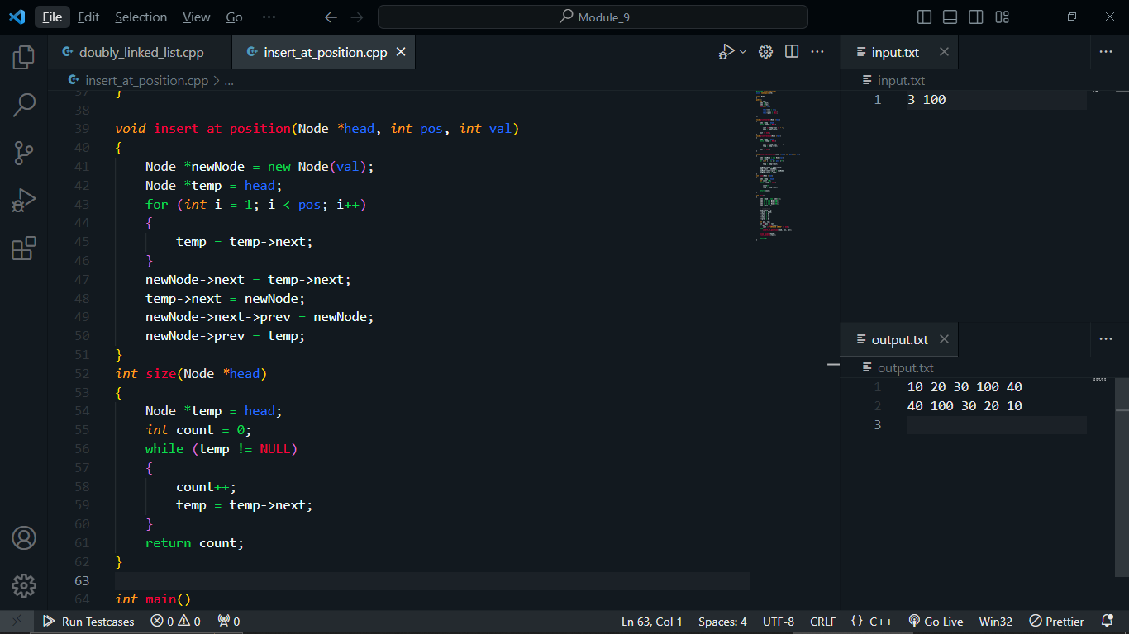

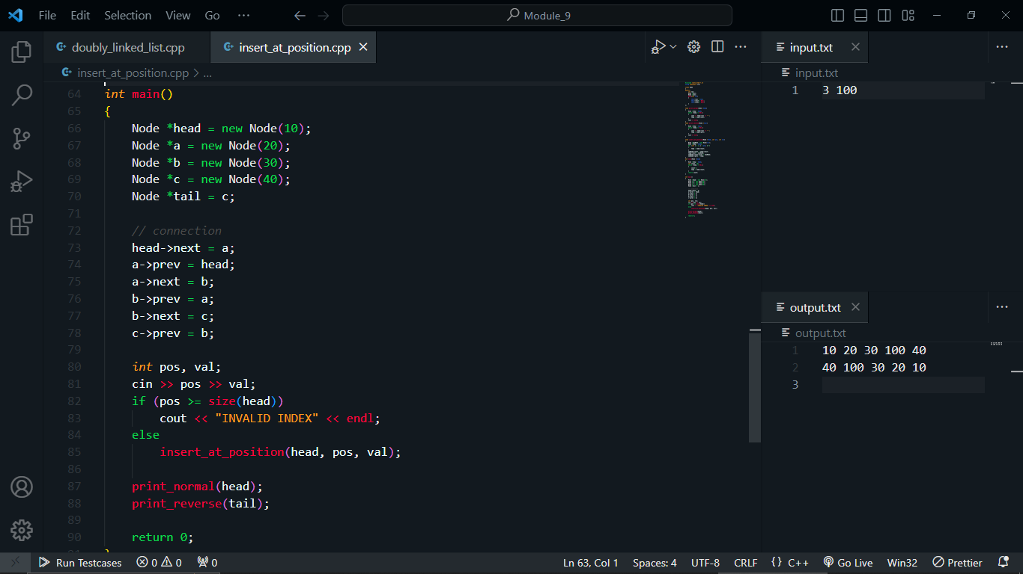

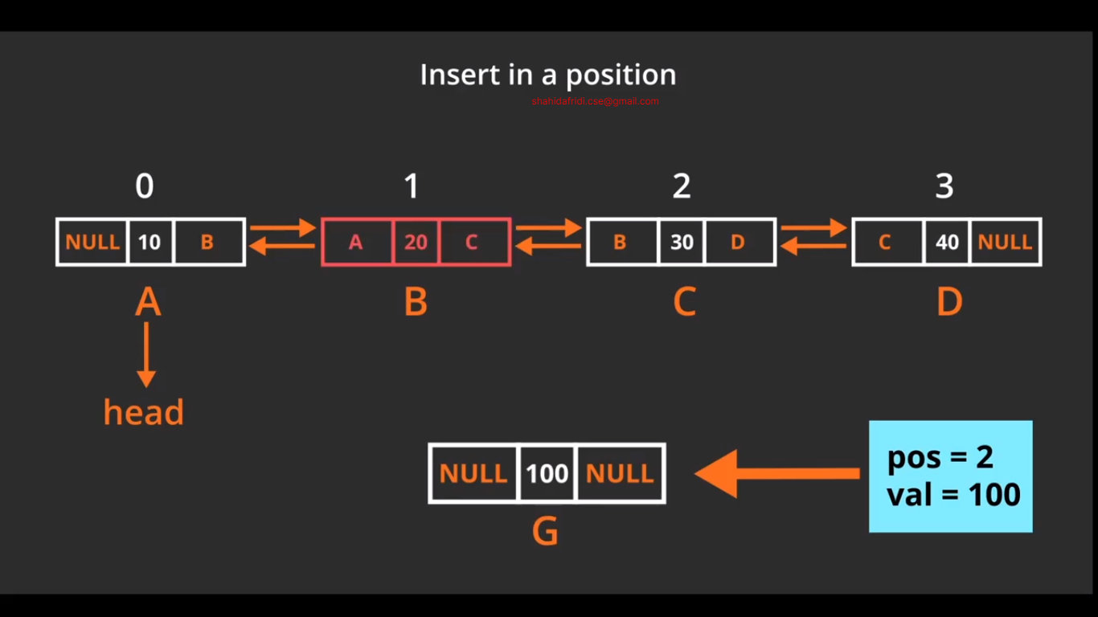

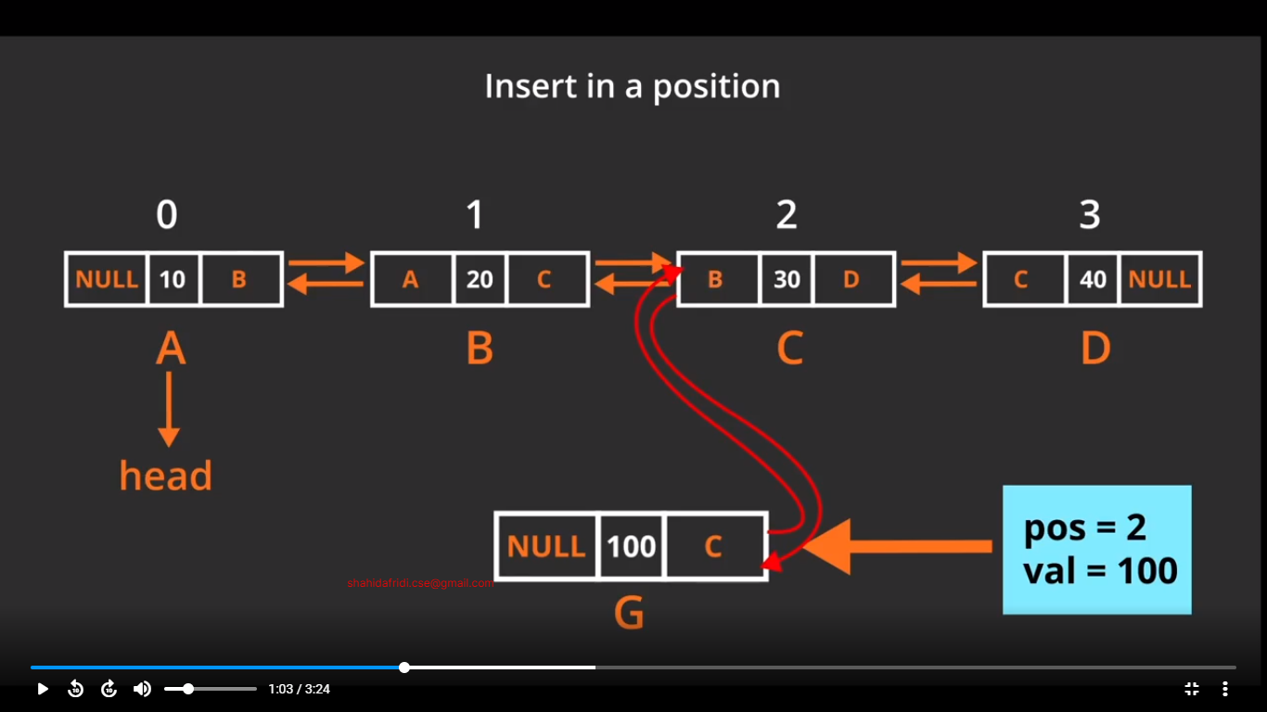

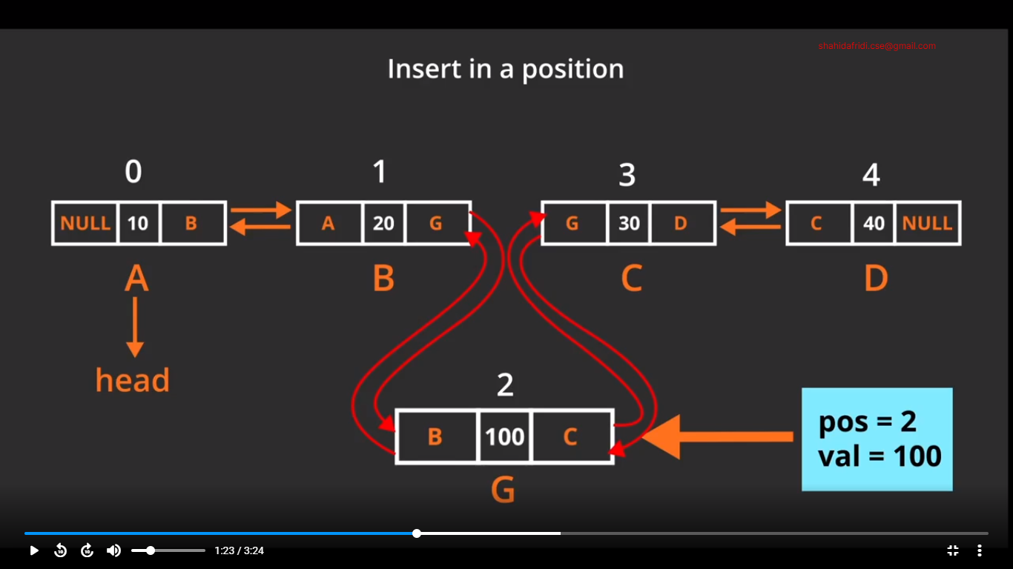

Insert Node at head:

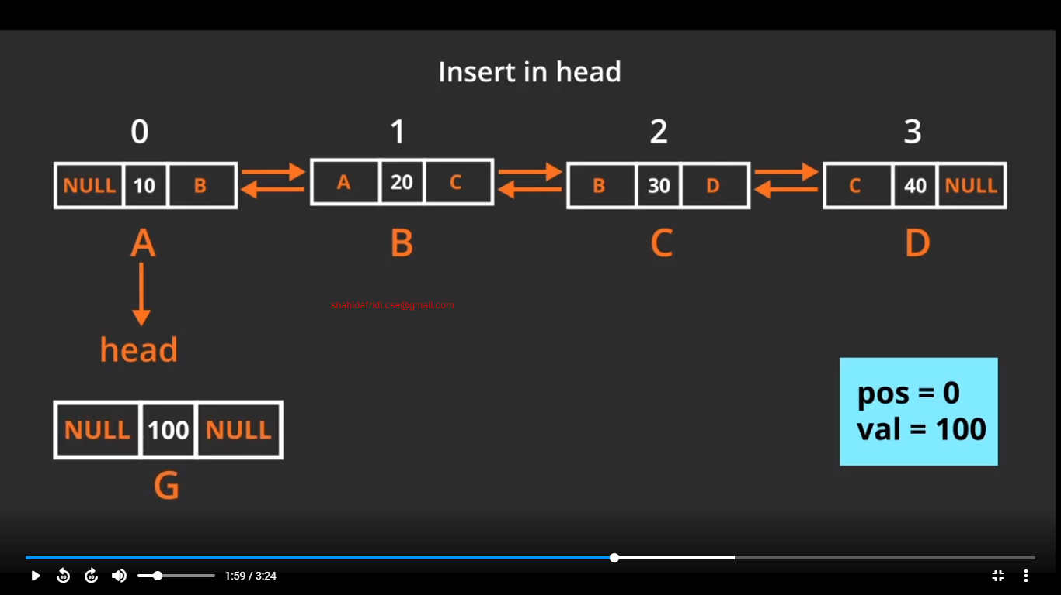

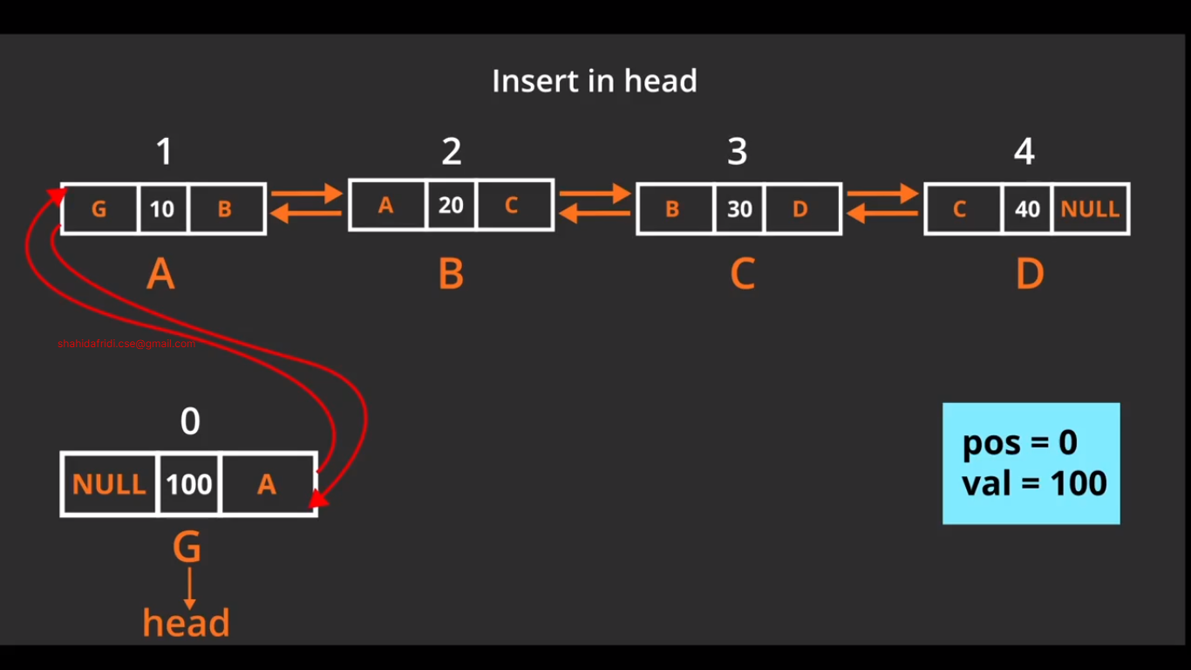

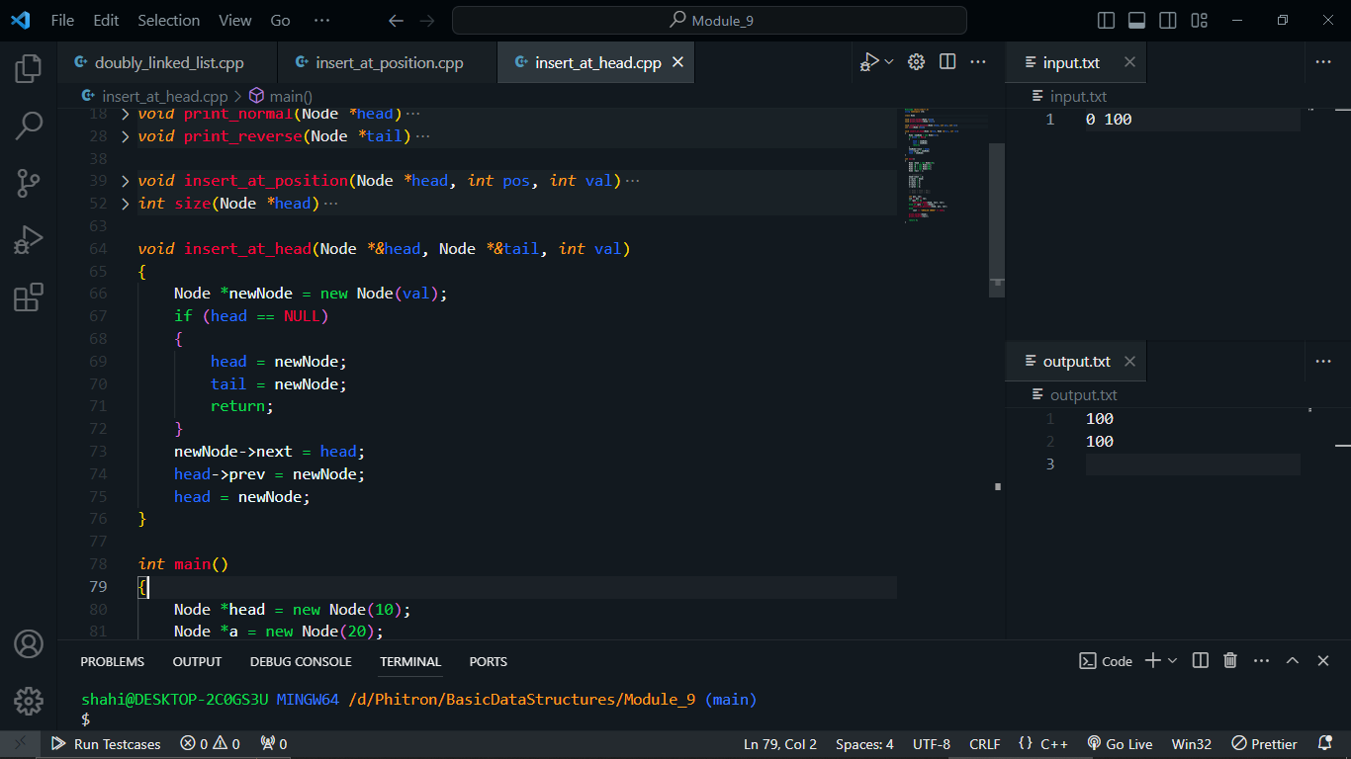

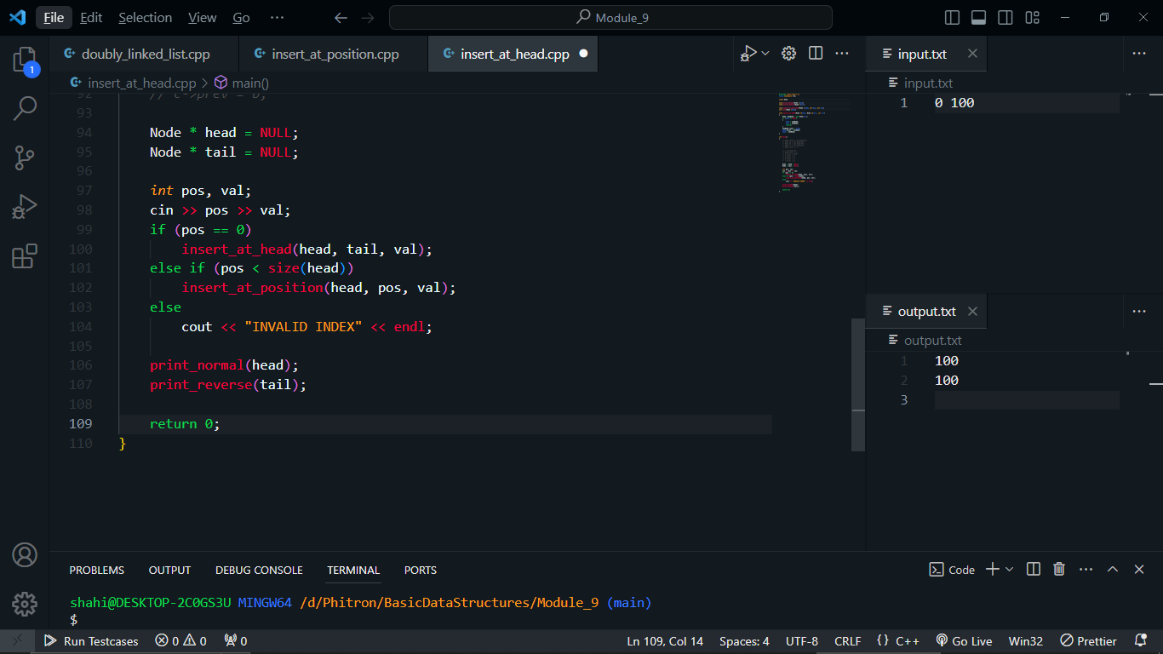

Insert Node at tail:

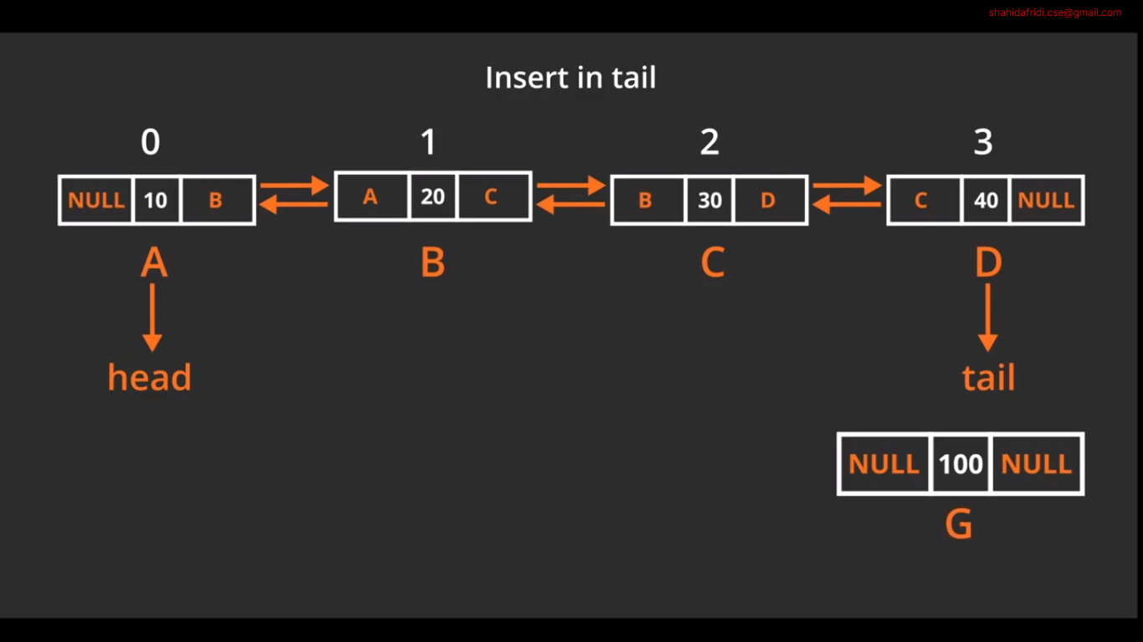

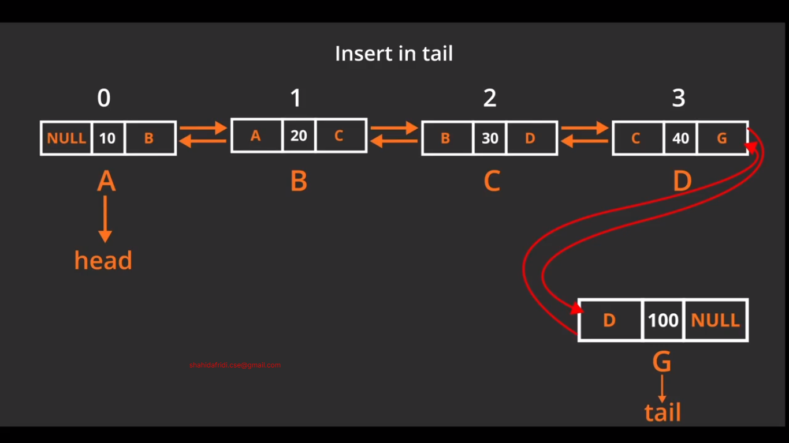

Code:

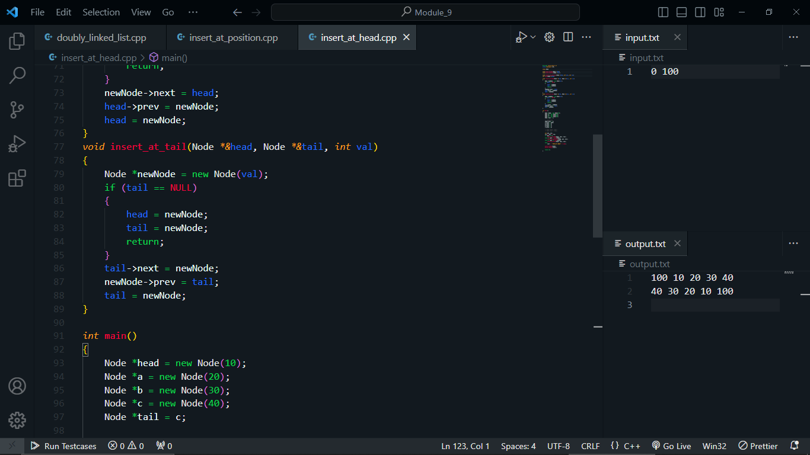

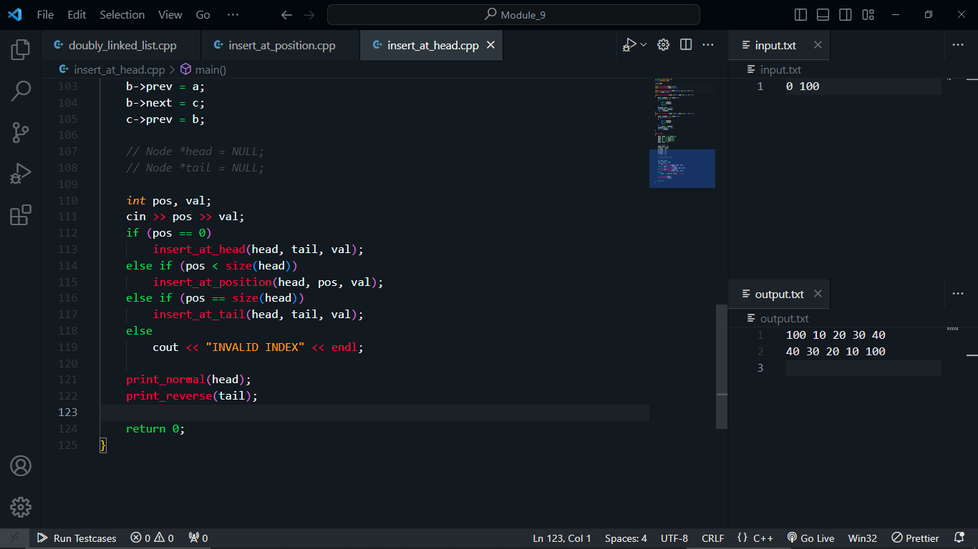

Delete Node from position:

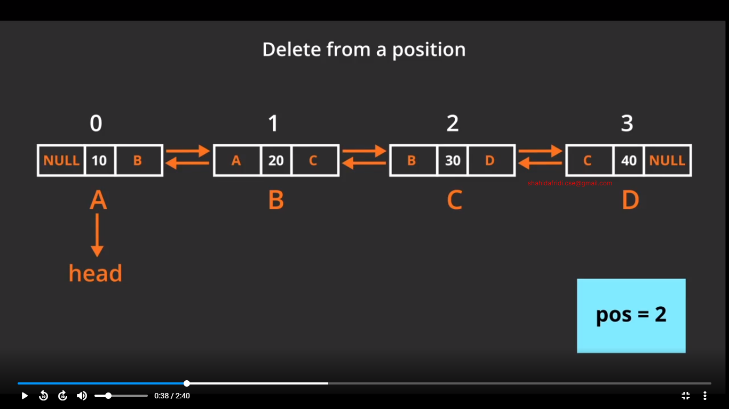

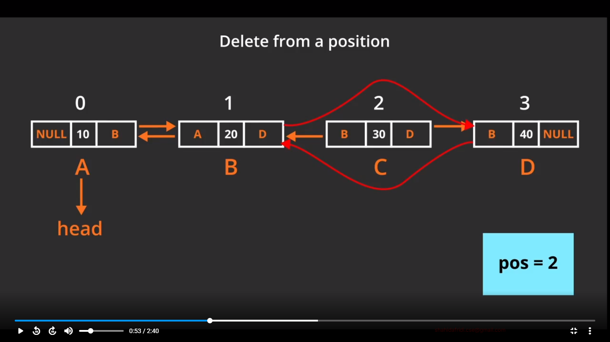

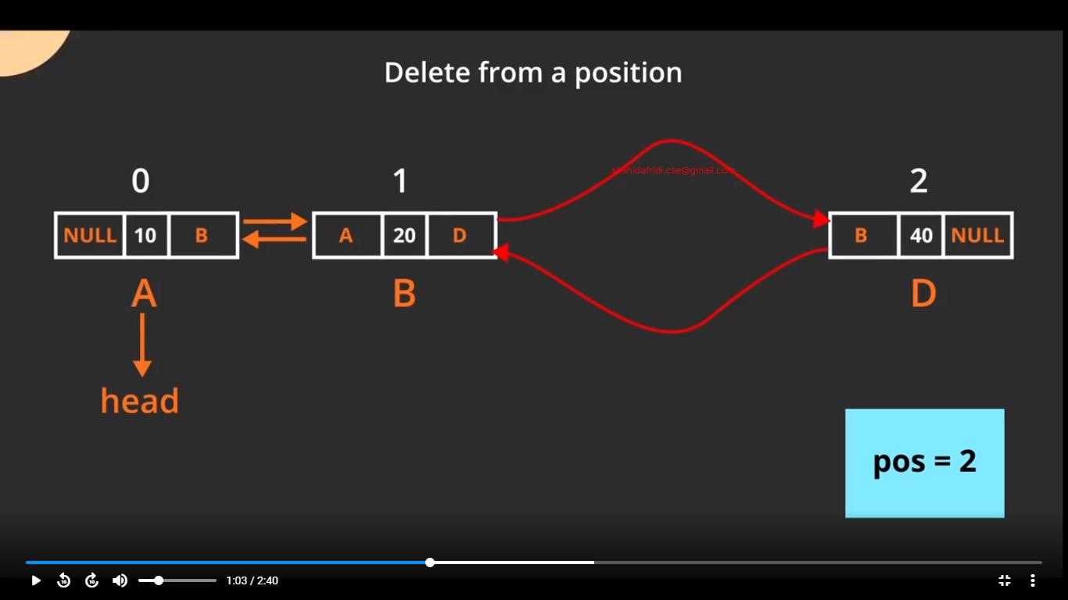

Code:

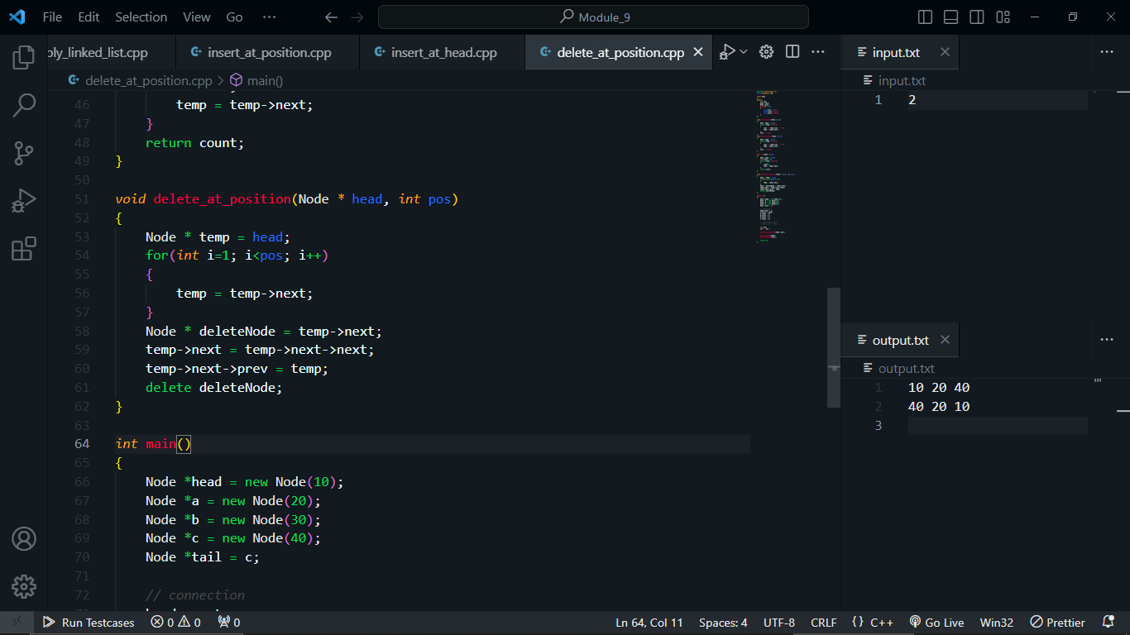

Delete Node from Head:

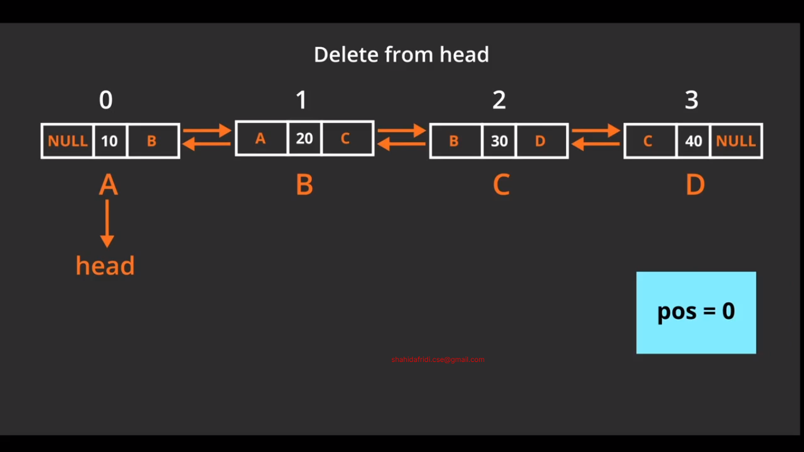

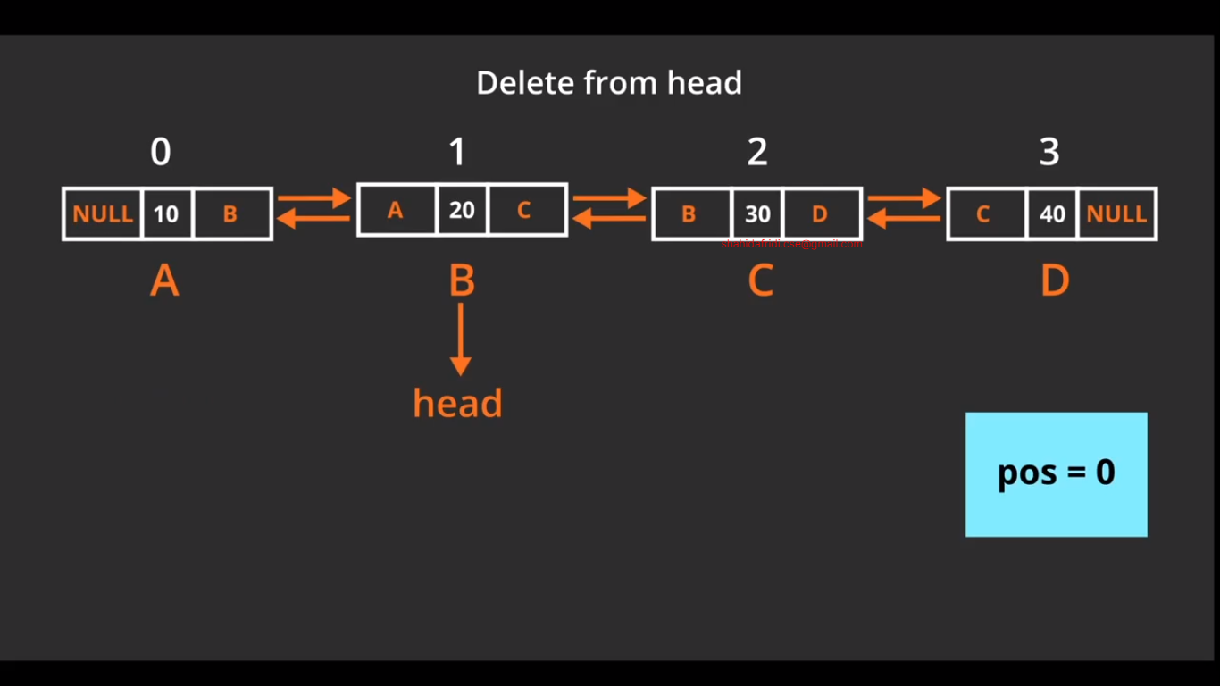

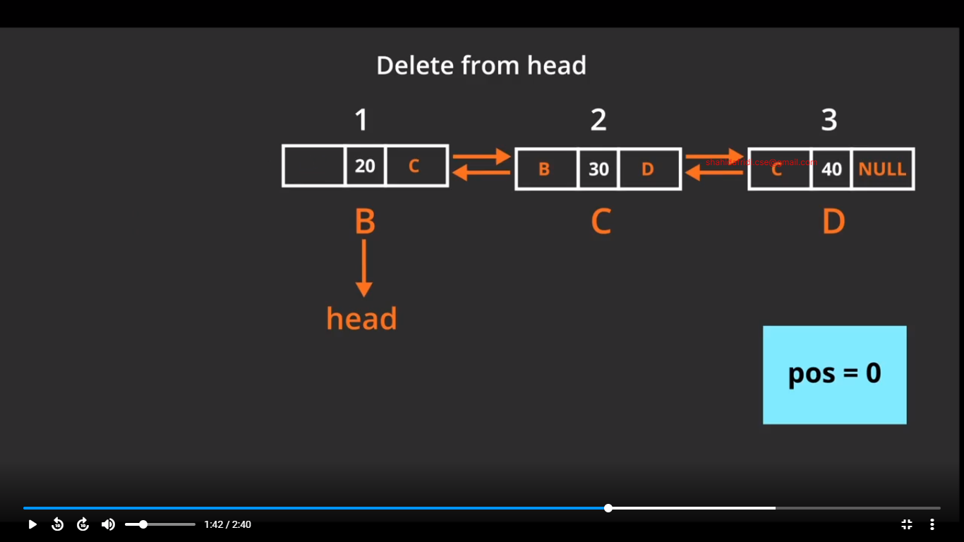

Code:

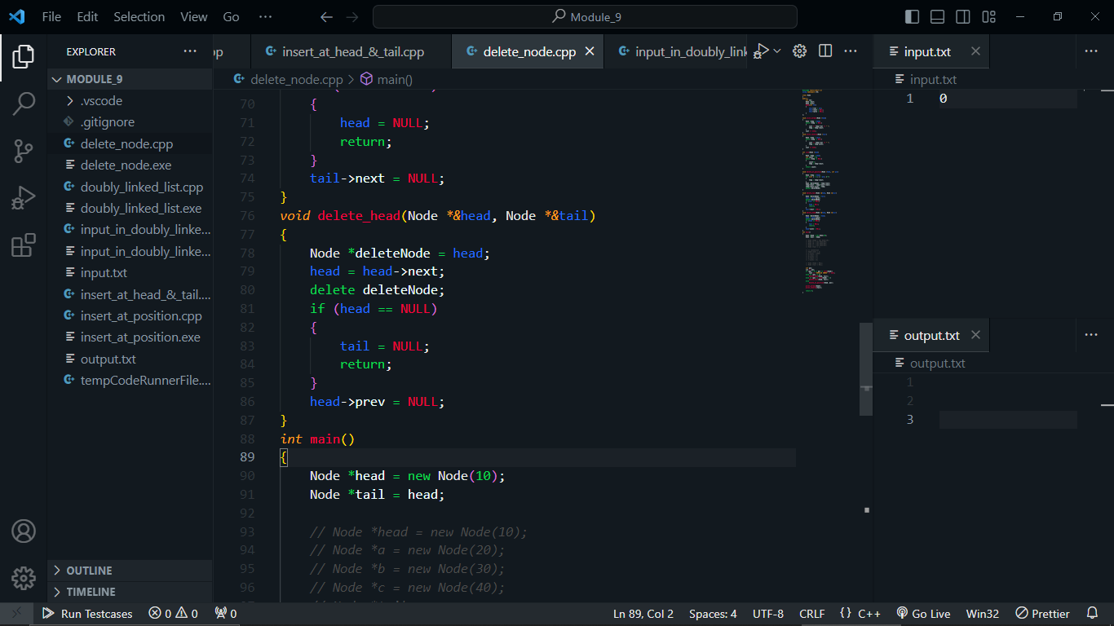

Delete Tail:

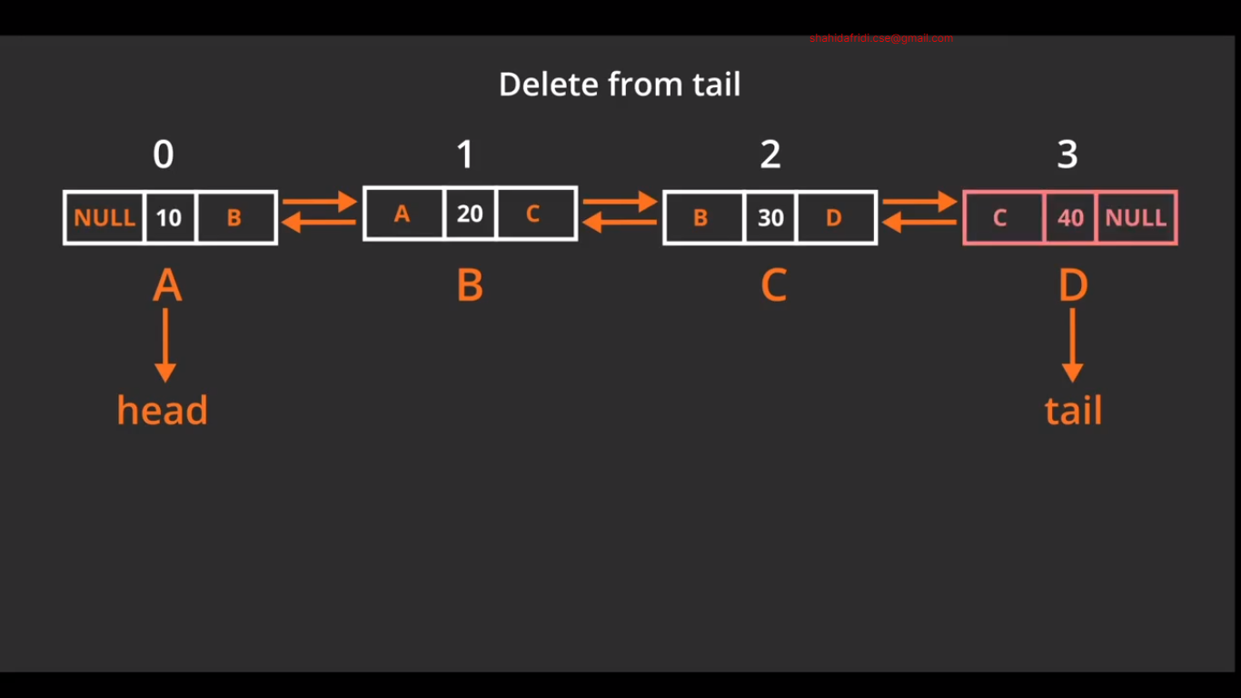

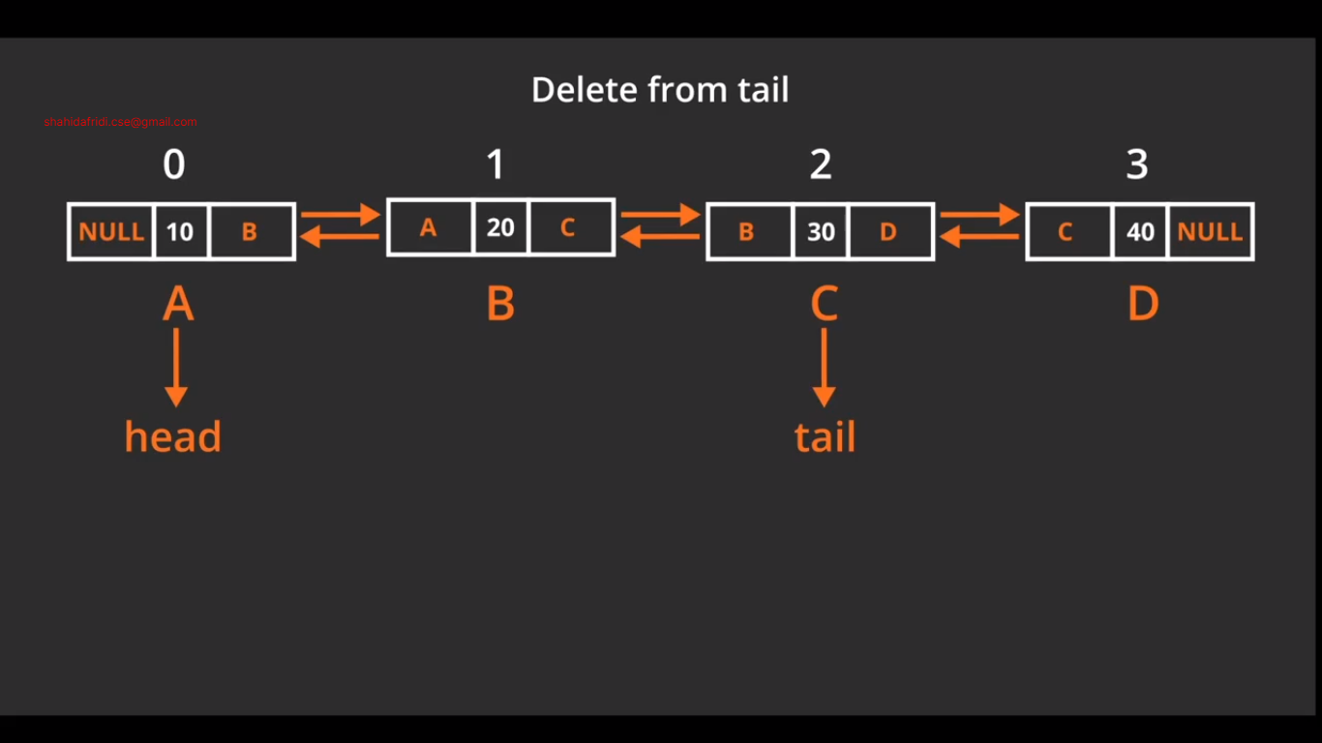

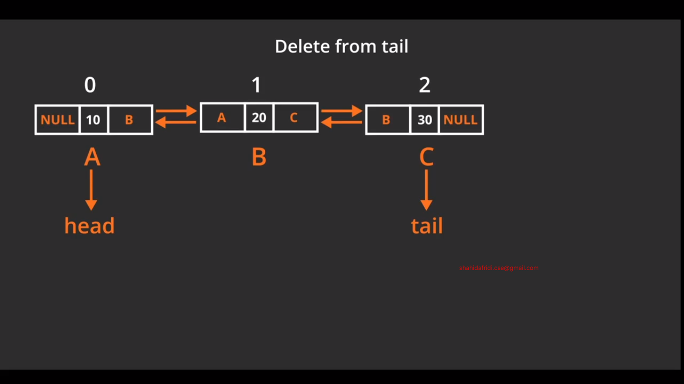

Code:

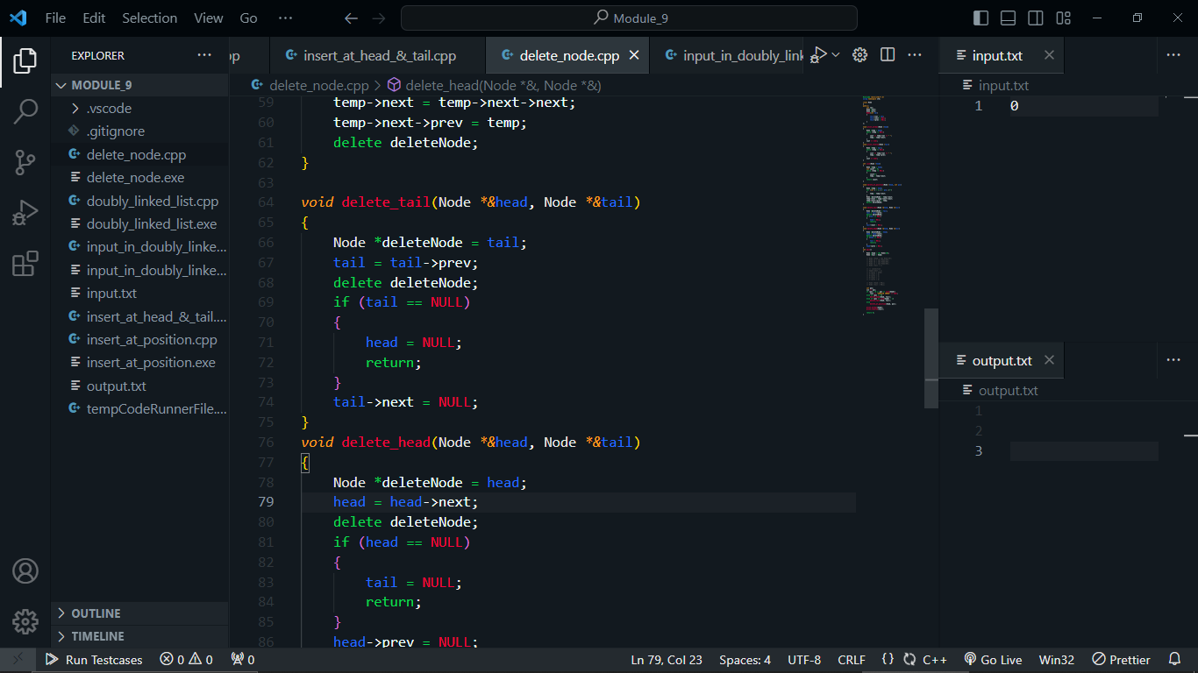

Time Complexity difference between Array, Singly Linked List & Doubly Linked List.

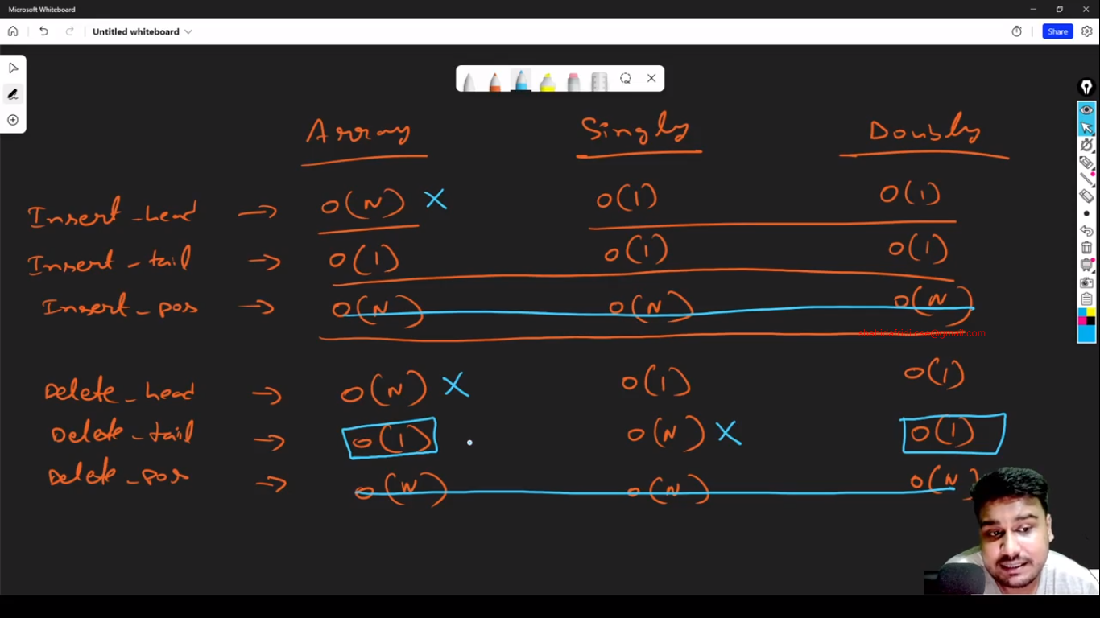

|  |  |  |  |
| --- | --- | --- | --- |
| **Time Complexity difference between Array, Singly Linked List & Doubly Linked List** | | | |
|  | Array | Singly Linked List | Doubly Linked List |
| **Insert Head** | **O(N)** | **O(1)** | **O(1)** |
| Insert Tail | **O(1)** | **O(1)** | **O(1)** |
| Insert Position | **O(N)** | **O(N)** | **O(N)** |
| **Delete Head** | **O(N)** | **O(1)** | **O(1)** |
| **Delete Tail** | **O(1)** | **O(N)** | **O(1)** |
| Delete Position | **O(N)** | **O(N)** | **O(N)** |

Input in doubly linked list:

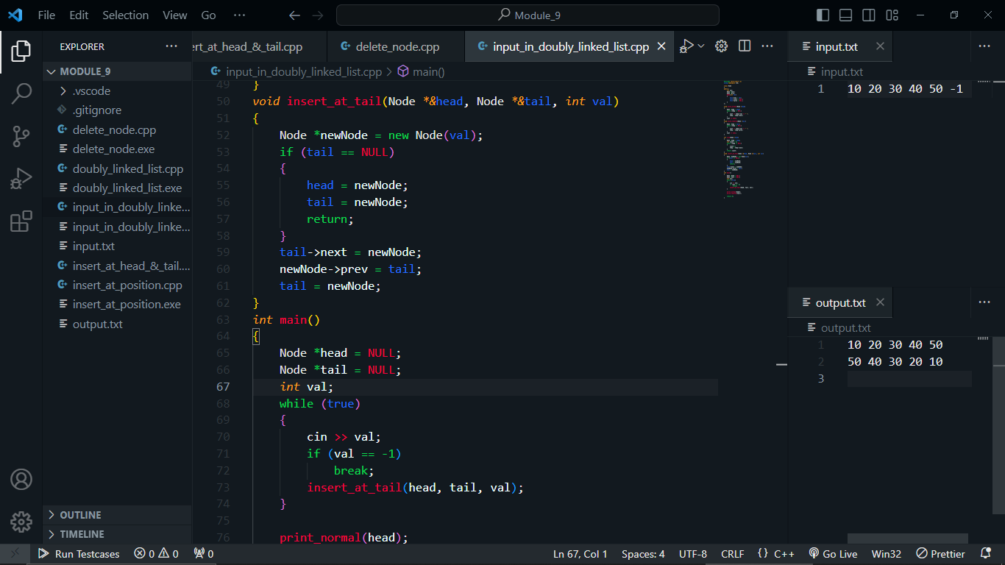

Module 10:

**List Built-in Functions:**

1. **Constructor**

|  |  |  |
| --- | --- | --- |
| **Name** | **Details** | **Time Complexity** |
| **list<type>myList;** | Construct a list with 0 elements. | **O(1)** |
| **list<type>myList(N);** | Construct a list with N elements and the value will be garbage. | **O(N)** |
| **list<type>myList(N,V);** | Construct a list with N elements and the value will be V. | **O(N)** |
| **list<type>myList(list2);** | Construct a list by copying another list list2. | **O(N)** |
| **list<type>myList(A,A+N);** | Construct a list by copying all elements from an array A of size N. | **O(N)** |

1. **Capacity**

|  |  |  |
| --- | --- | --- |
| **Name** | **Details** | **Time Complexity** |
| **myList.size()** | Returns the size of the list. | **O(1)** |
| **myList.max_size()** | Returns the maximum size that the vector can hold. | **O(1)** |
| **myList.clear()** | Clears the list elements. Do not delete the memory, only clear the list. | **O(N)** |
| **myList.empty()** | Return true/false if the list is empty or not. | **O(1)** |
| **myList.resize()** | Change the size of the list. | **O(K);**  Where K is the difference between new size and current size. |

1. **Modifiers**

|  |  |  |
| --- | --- | --- |
| **Name** | **Details** | **Time Complexity** |
| **myList= or myList.assign(list2.begin(),**  **list2.end())** | Assign another list. | **O(N)** |
| **myList.push_back()** | Add an element to the tail. | **O(1)** |
| **myList.push_front()** | Add an element to the head. | **O(1)** |
| **myList.pop_back()** | Delete the tail. | **O(1)** |
| **myList.pop_front()** | Delete the head. | **O(1)** |
| **myList.insert()** | Insert elements at a specific position. | **O(N+K)**  Where K is the number of elements to be inserted. |
| **myList.erase()** | Delete elements from a specific position. | **O(N+K)**  Where K is the number of elements to be deleted. |
| **replace(myList.begin(),**  **myList.end(),**  **value,**  **replace_value)** | Replace all the value with replace_value. Not under a list STL. | **O(N)** |
| **find(myList.begin(),**  **myList.end(),**  **V)** | Find the value V. Not under a list STL. | **O(N)** |

1. **Operations**

|  |  |  |
| --- | --- | --- |
| **Name** | **Details** | **Time Complexity** |
| **myList.remove(V)** | Remove the value V from the list. | **O(N)** |
| **myList.sort()** | Sort the list in ascending order. | **O(NlogN)** |
| **myList.sort(greater<type>())** | Sort the list in descending order | **O(NlogN)** |
| **myList.unique()** | Deletes the duplicate values from the list. You must sort the list first. | **O(N),**  **with sort (NlogN)** |
| **myList.reverse()** | Reverse the list. | **O(N)** |

1. **Element access**

|  |  |  |
| --- | --- | --- |
| **Name** | **Details** | **Time Complexity** |
| myList.back() | Access the tail element. | **O(1)** |
| myList.front() | Access the head element. | **O(1)** |
| next(myList.begin(),i) | Access the ith element | **O(N)** |

1. **Iterators**

|  |  |  |
| --- | --- | --- |
| **Name** | **Details** | **Time Complexity** |
| **myList.begin()** | Pointer to the first element. | O(1) |
| **myList.end()** | Pointer to the last element. | O(1) |

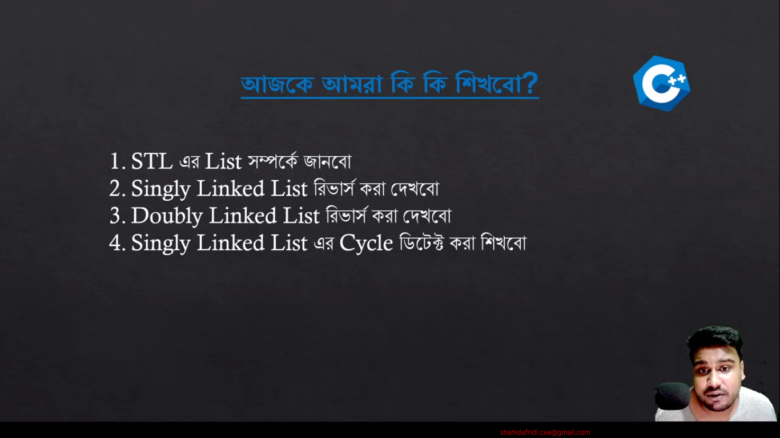

List Constructors:

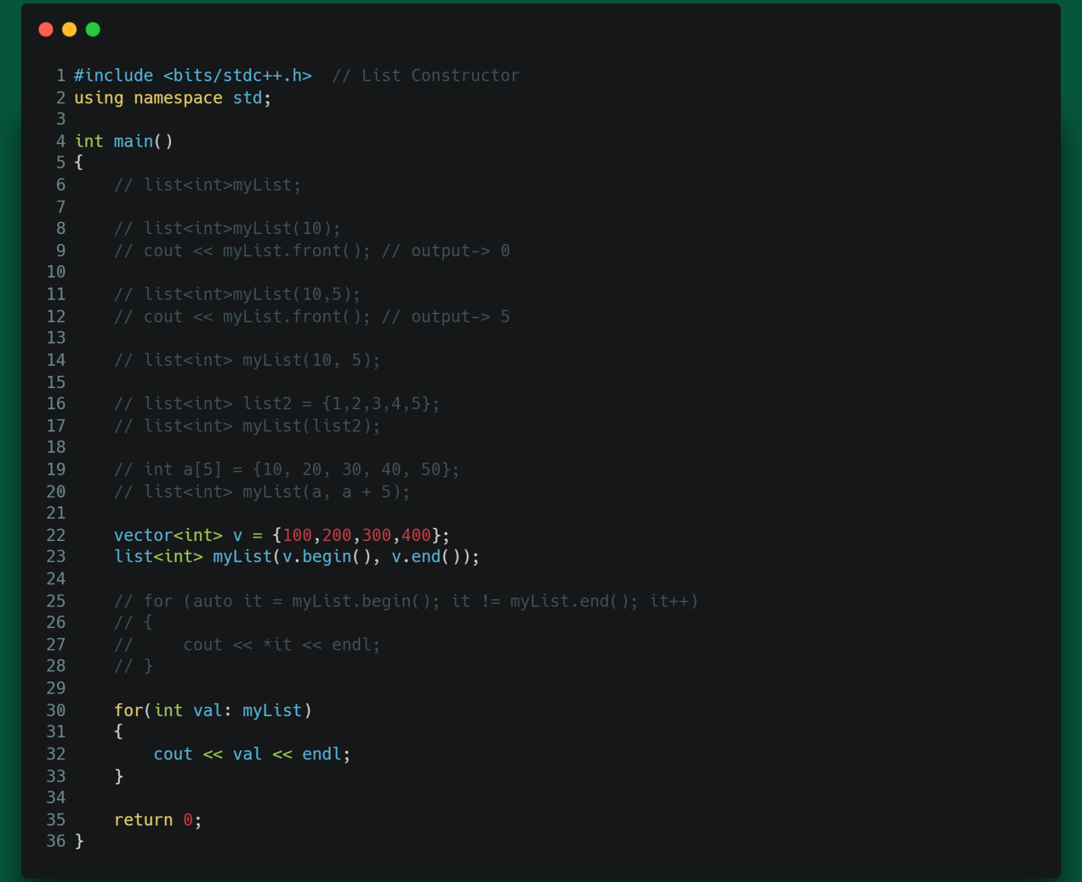

List Capacity Function:

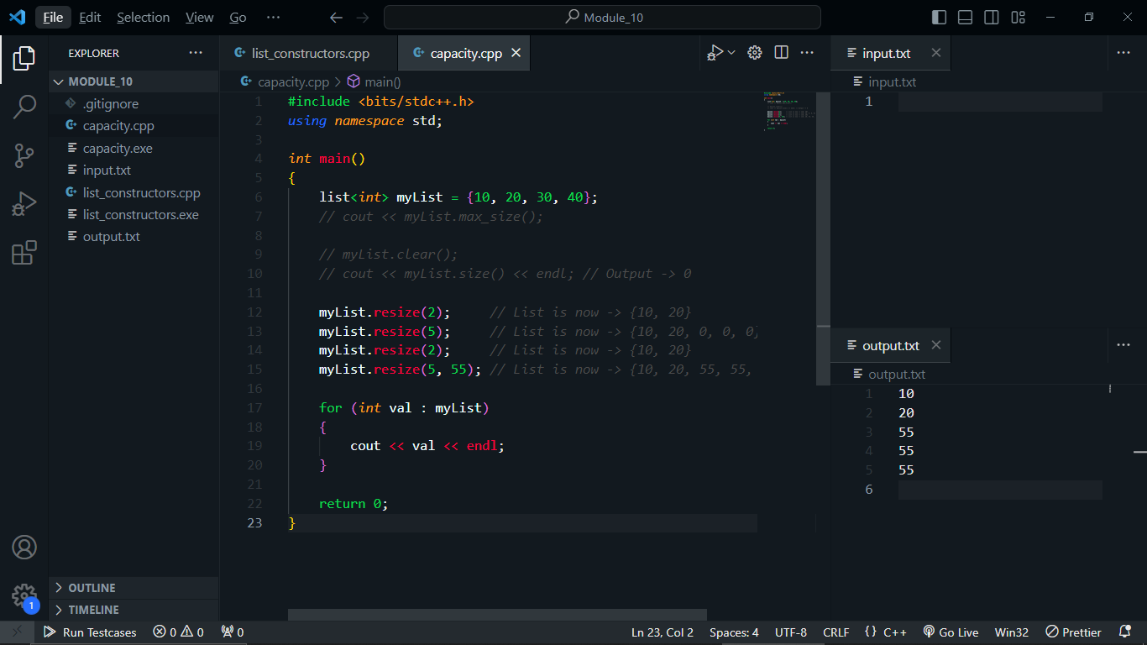

New list Assign:

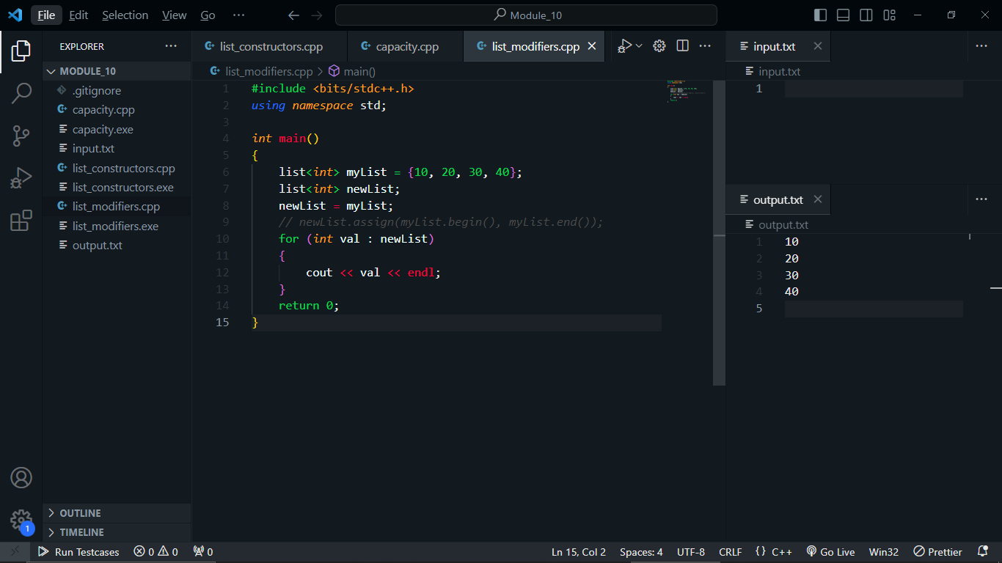

List Modifiers:

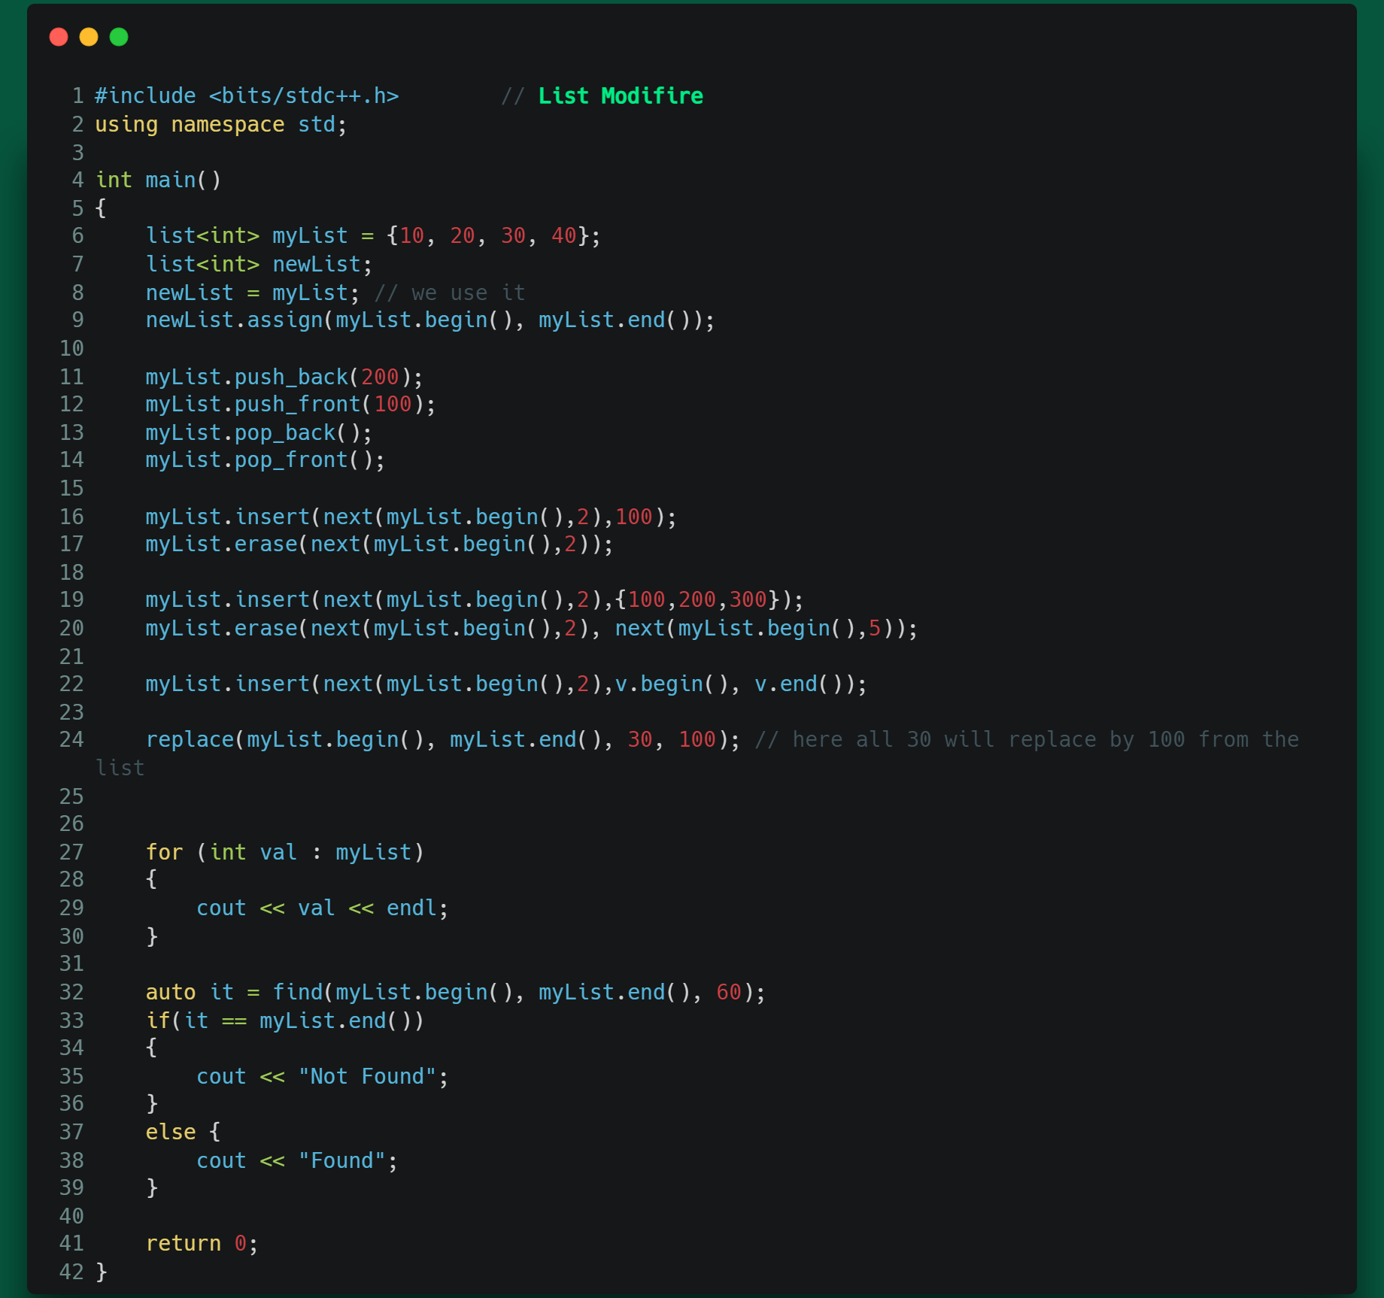

Operation Functions:

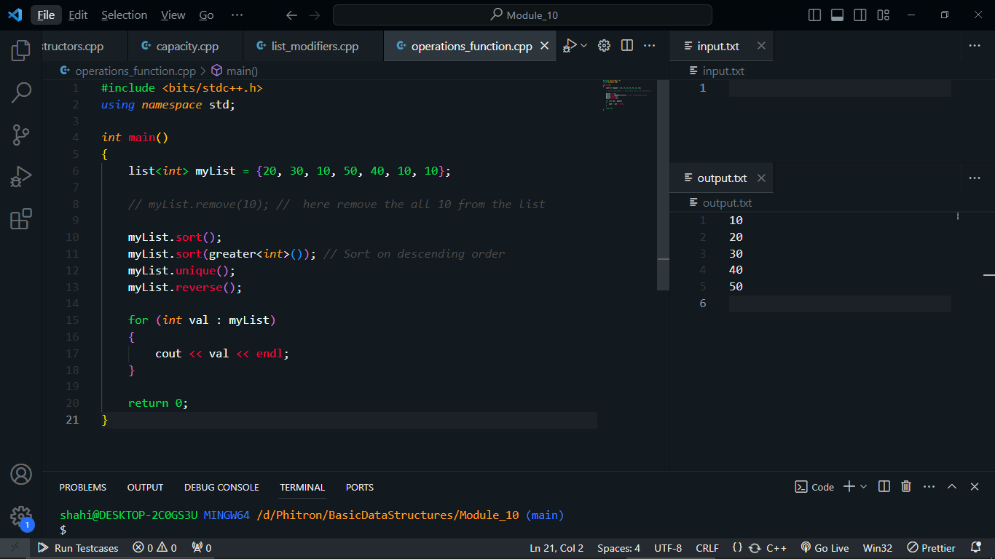

Reverse Singly Linked List:

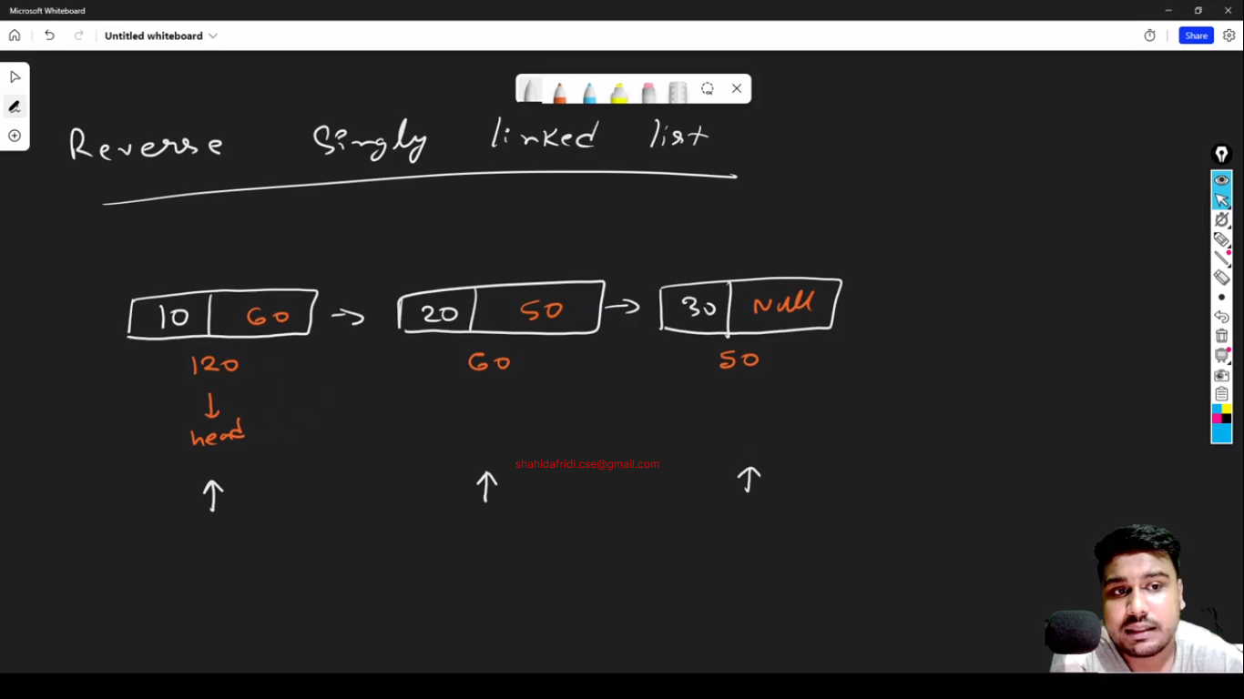

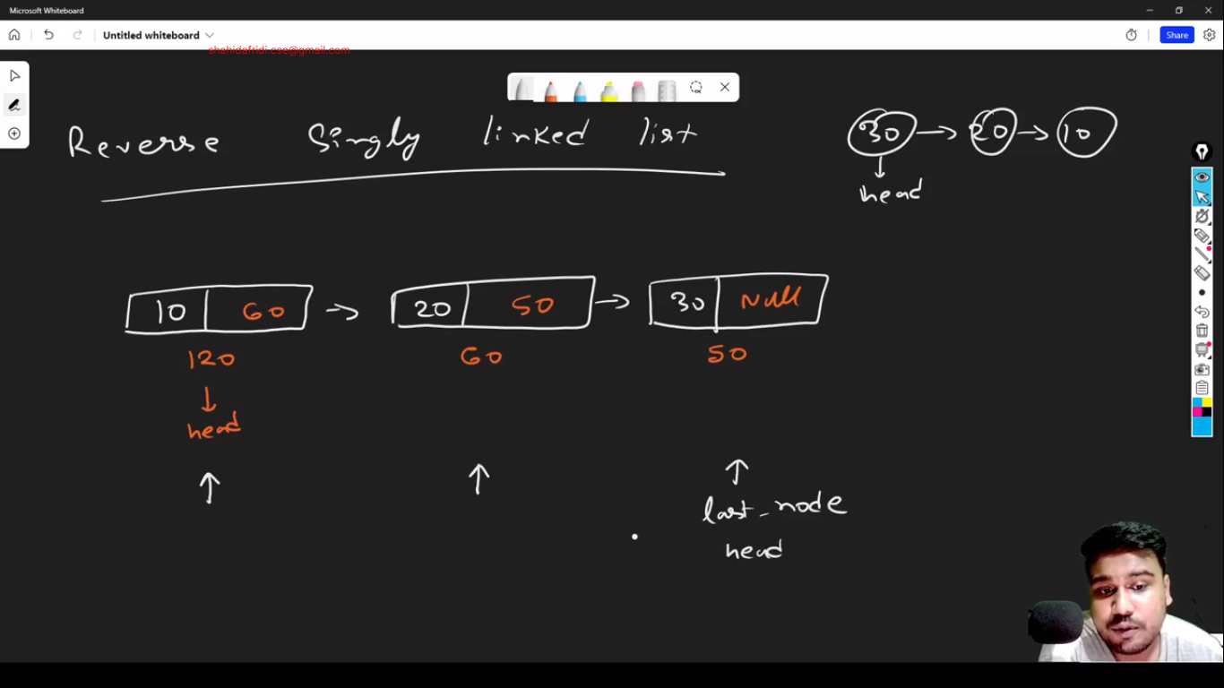

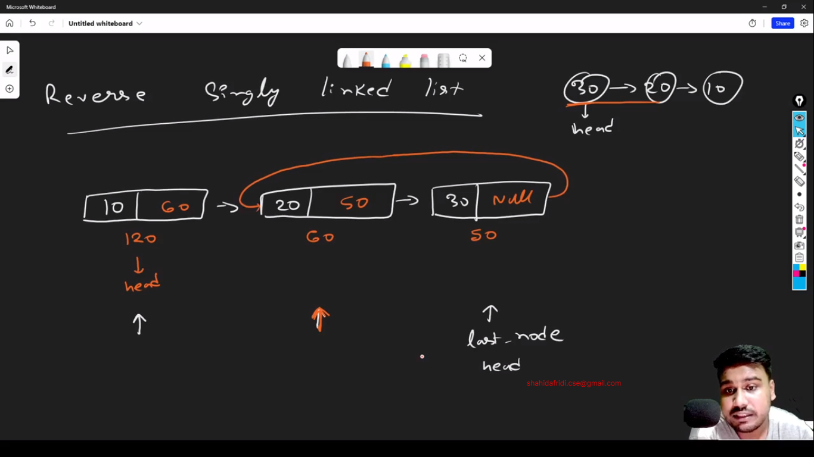

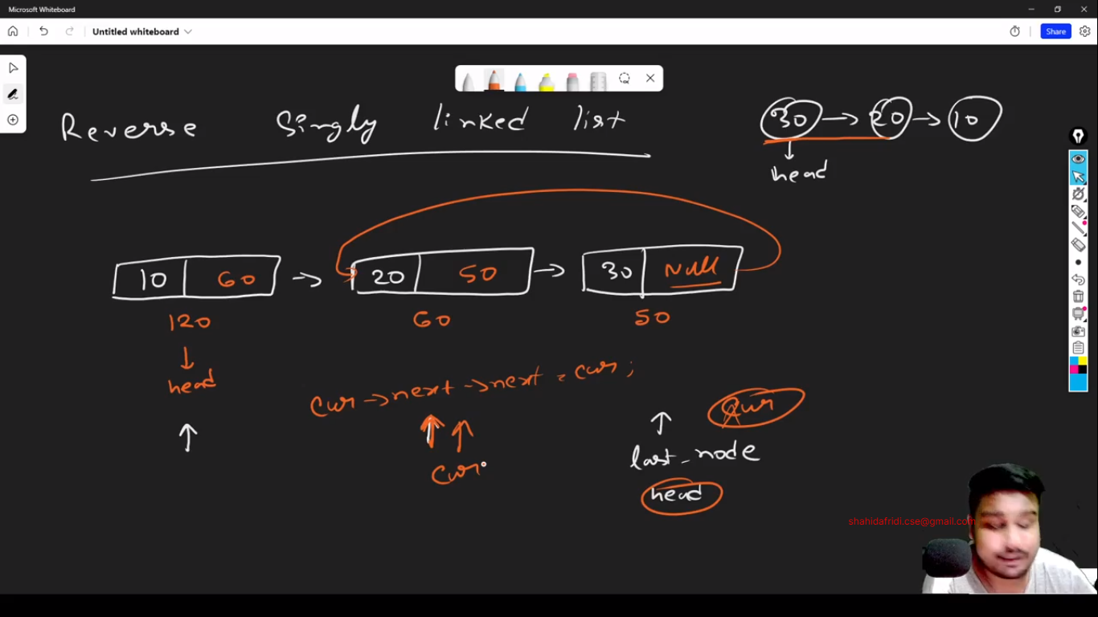

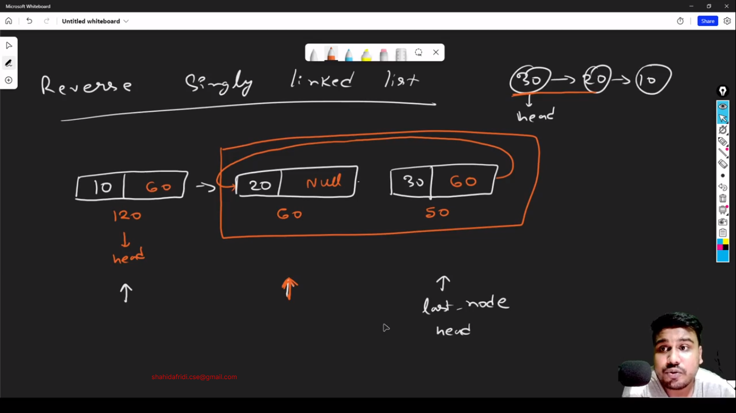

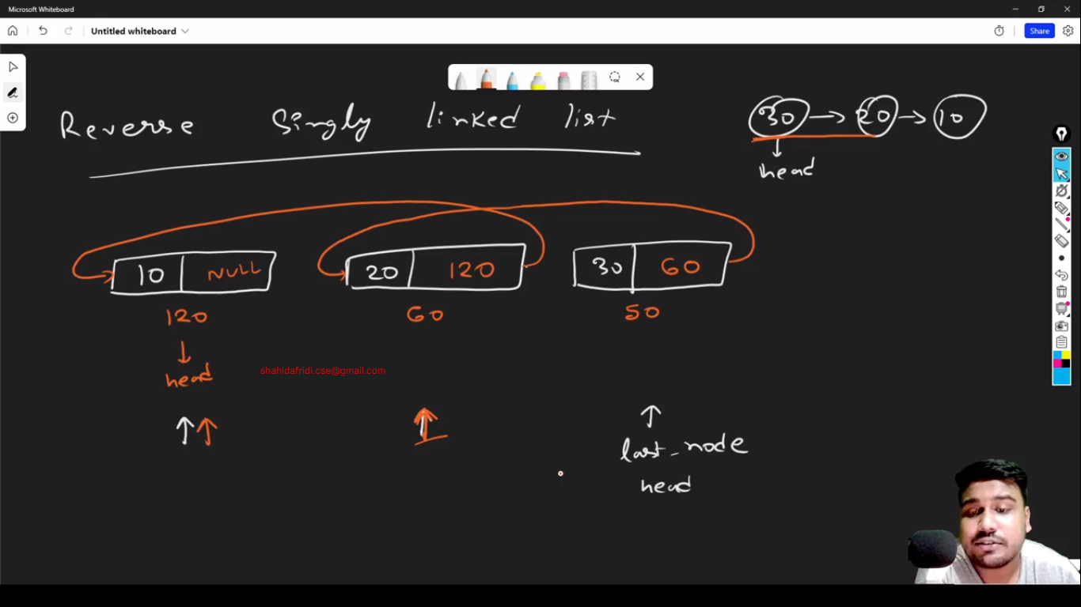

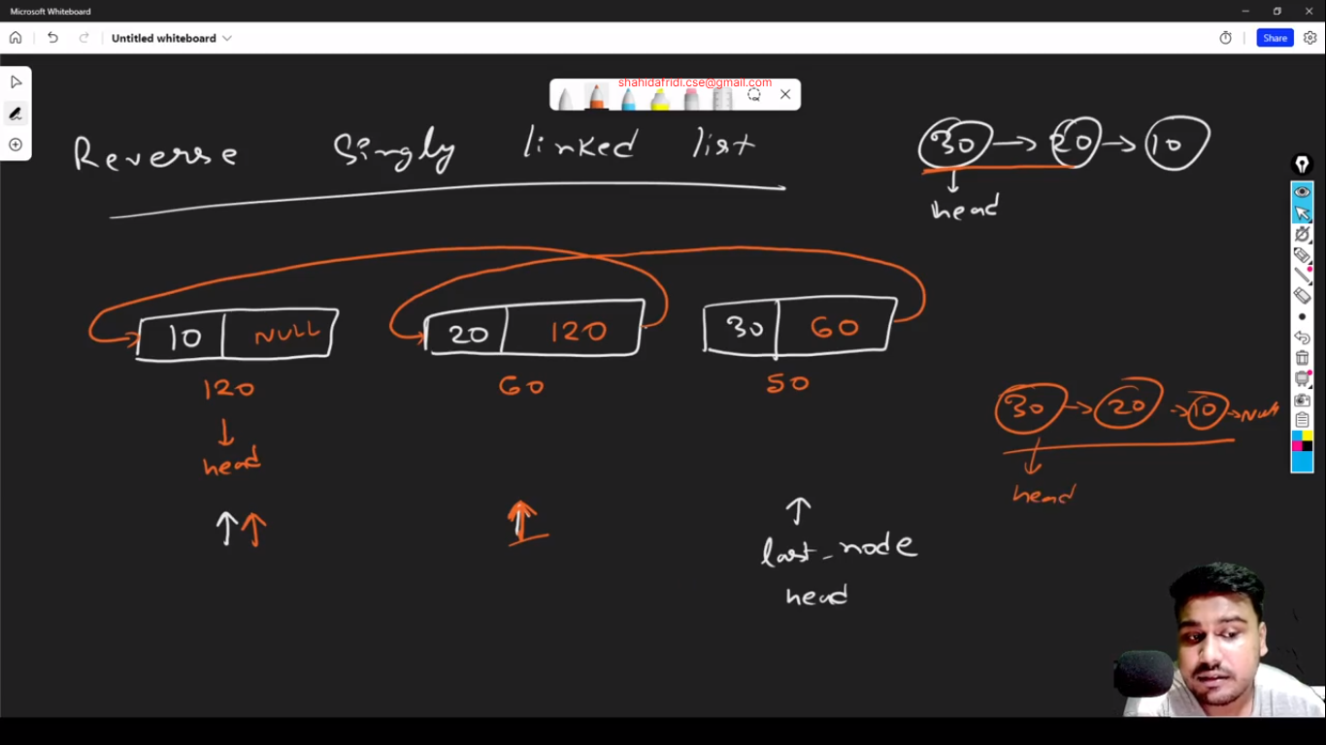

Code:

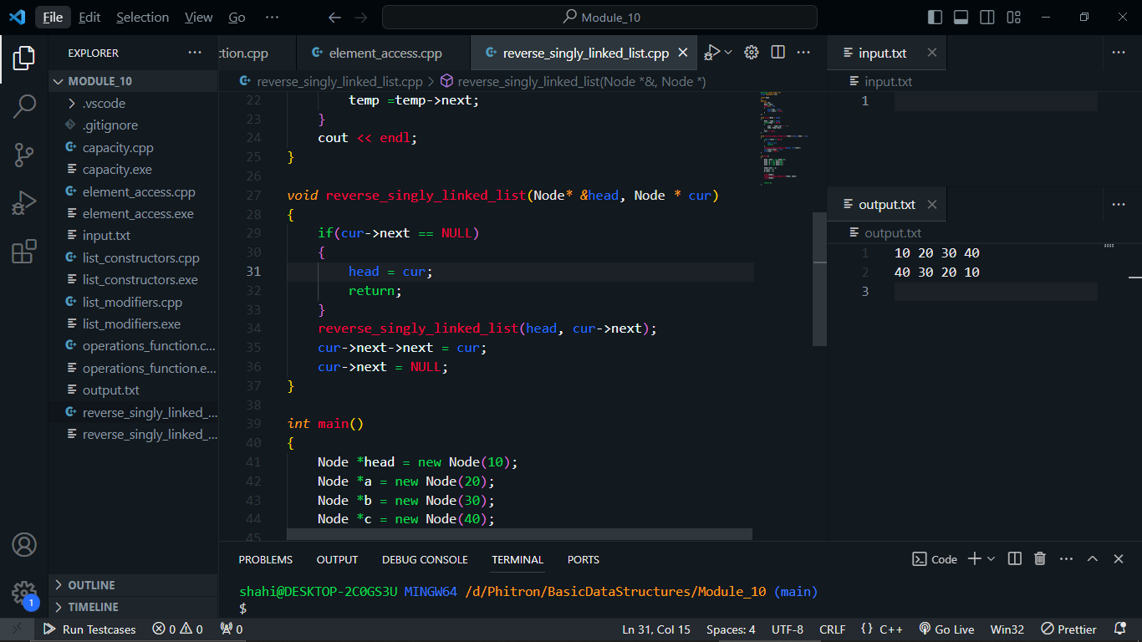

Reverse Doubly Linked List:

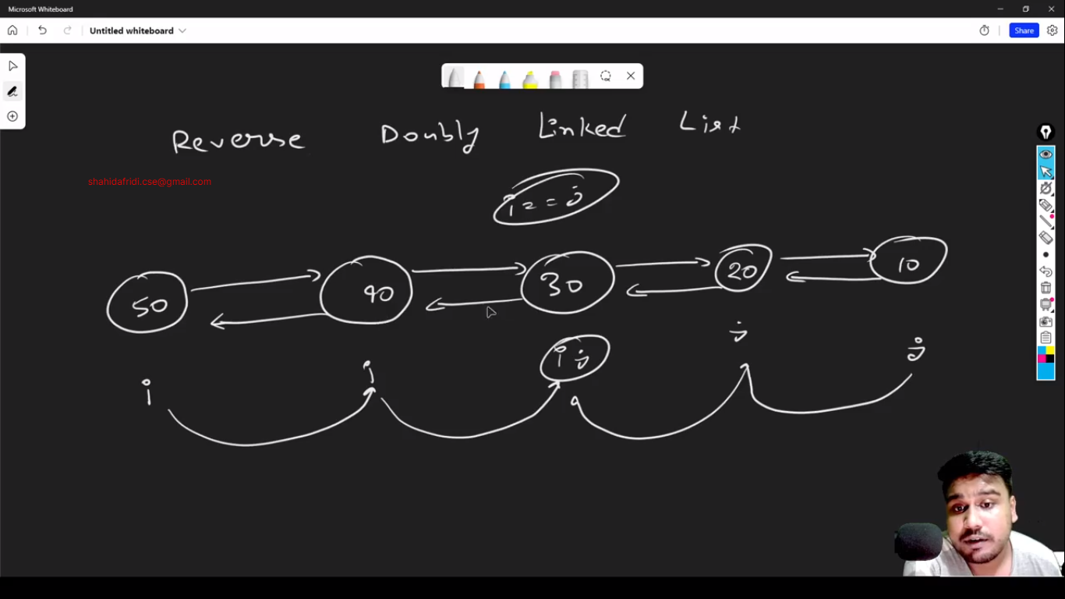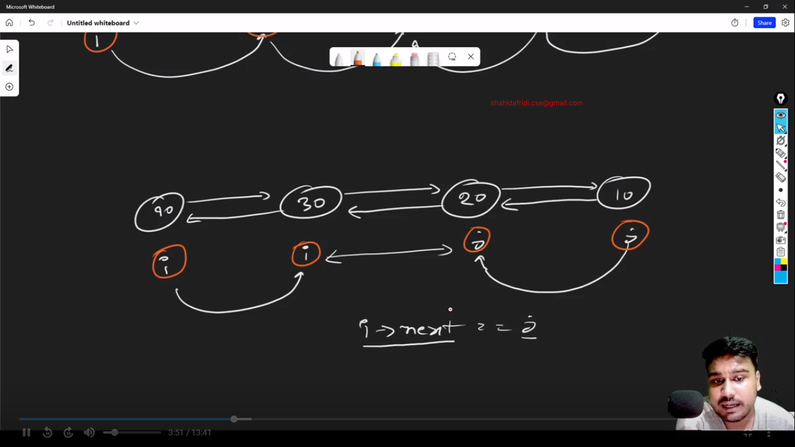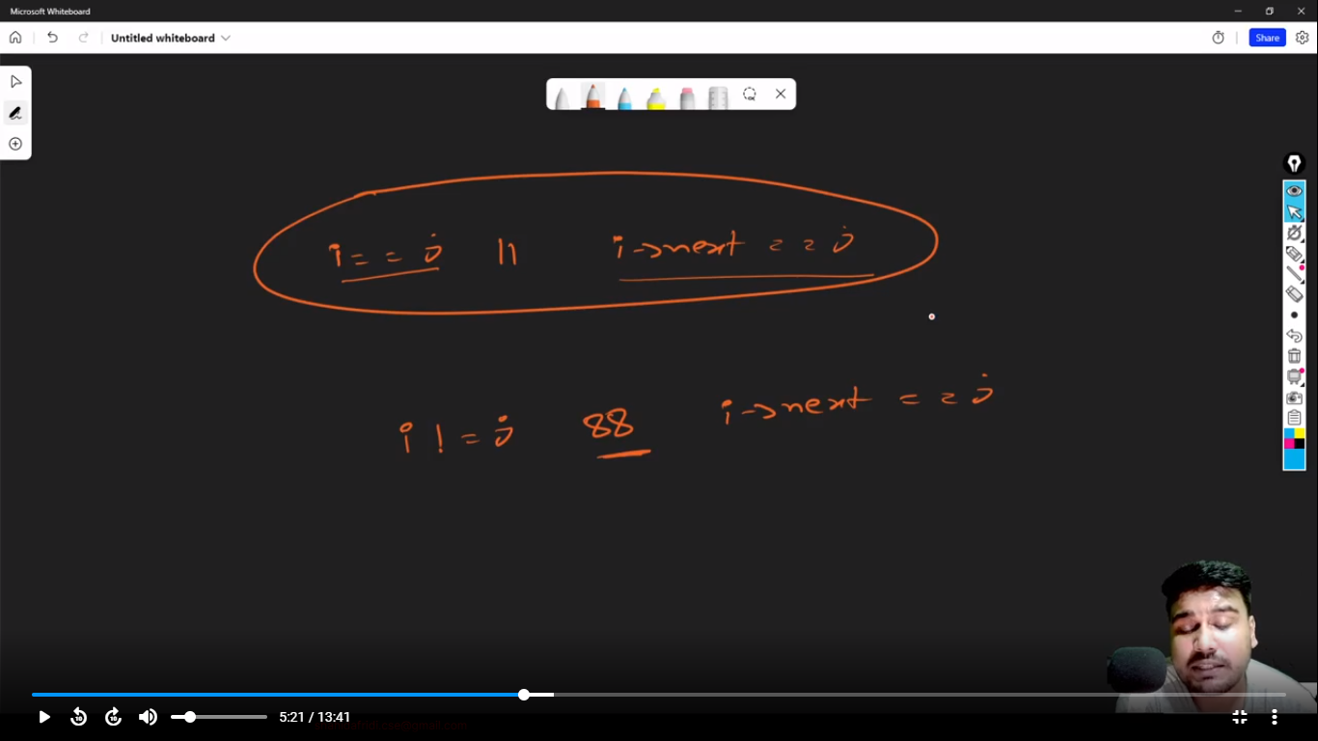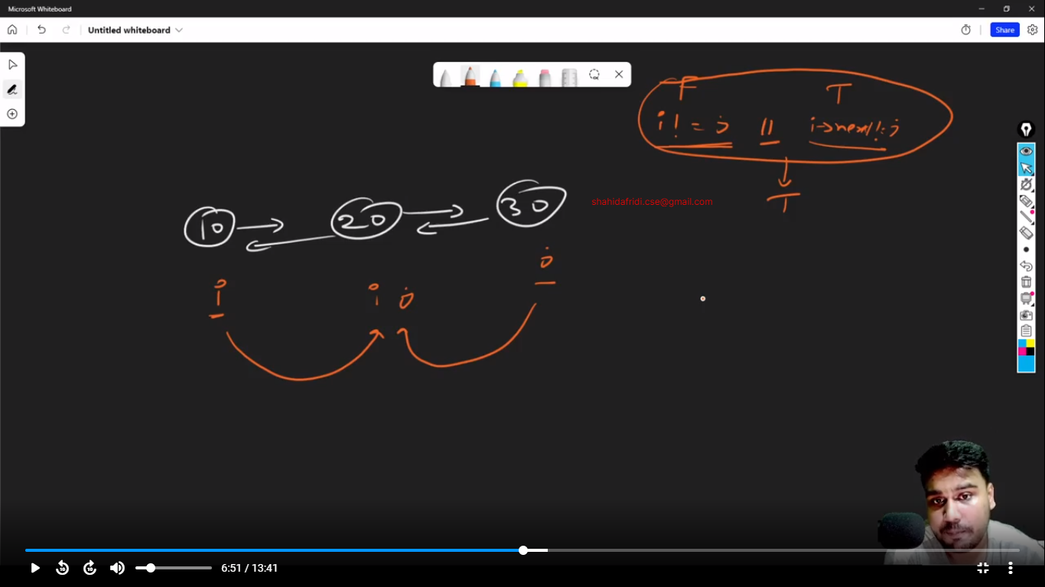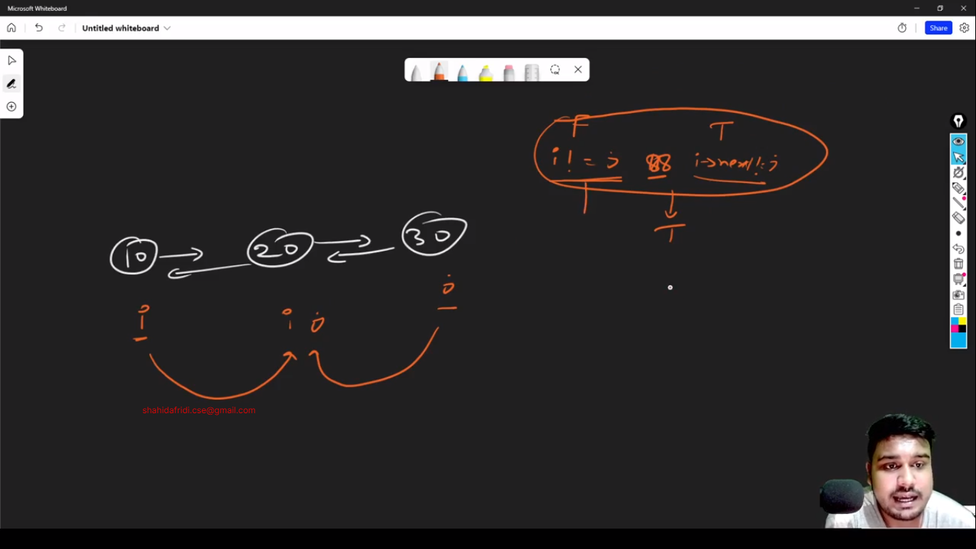

Code:

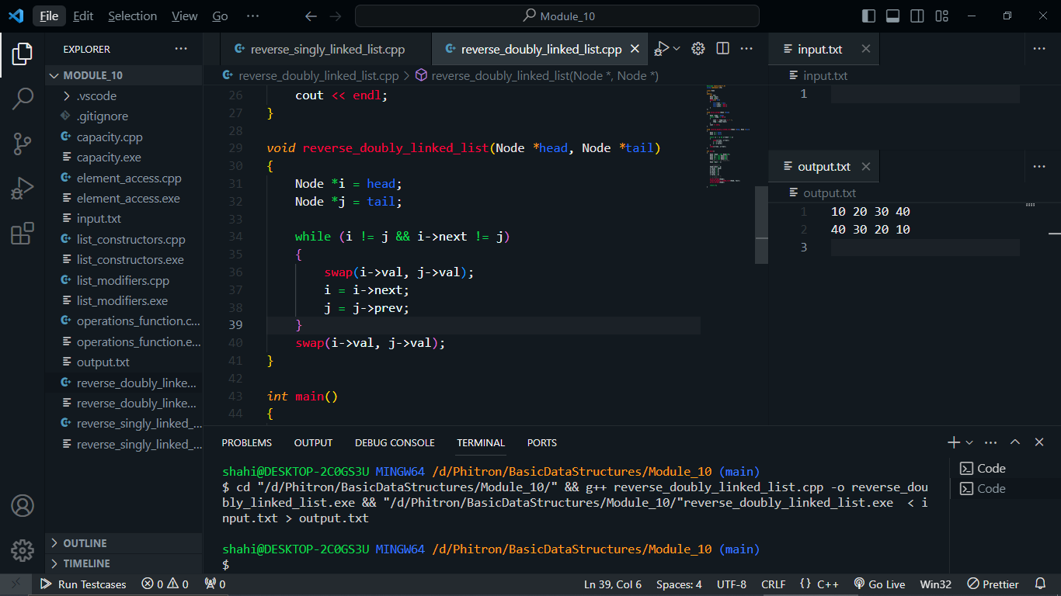

Detect Cycle in Singly Linked List:

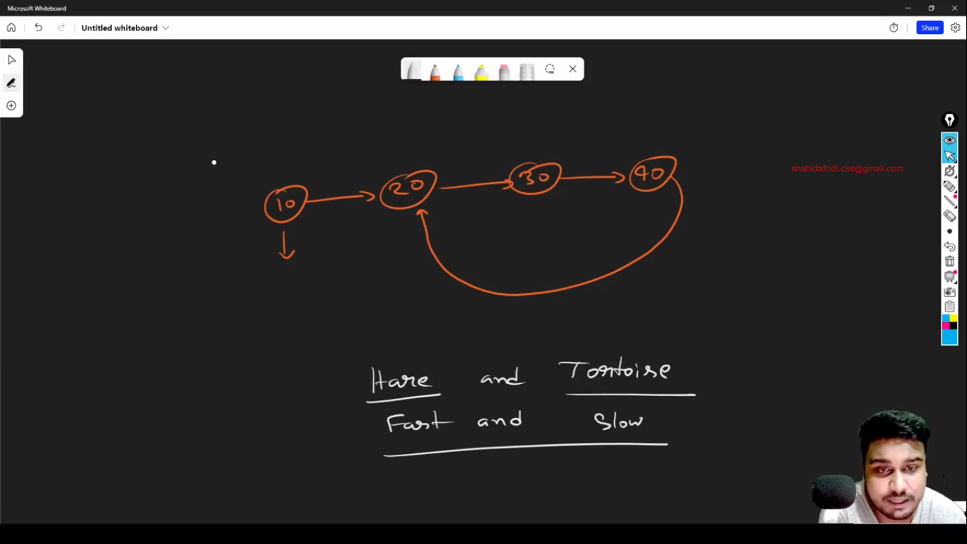

Module 10.5:

**PRACTICE PROBLEM 1:**

Question: Take two doubly linked lists as input and check if they are the same or not.

|  |  |
| --- | --- |
| **Sample Input** | **Sample Output** |
| 10 20 30 40 50 -1  10 20 30 40 50 -1 | YES |
| 10 20 30 40 50 -1  10 20 30 40 -1 | NO |
| 10 20 30 40 -1  10 20 30 40 50 -1 | NO |
| 10 20 30 40 -1  40 30 20 10 -1 | NO |
| 1 2 3 4 5 -1  5 4 1 2 6 -1 | NO |

Code: https://github.com/shahidafridi-swe/BasicDataStructures/blob/main/Module_10.5/problem_1.cpp

**PRACTICE PROBLEM 2:**

Question: Take a doubly linked list as input and reverse it. After that print the linked list.

|  |  |
| --- | --- |
| **Sample Input** | **Sample Output** |
| 10 20 30 -1 | 30 20 10 |
| 10 20 30 40 -1 | 40 30 20 10 |

Code: https://github.com/shahidafridi-swe/BasicDataStructures/blob/main/Module_10.5/reverse_doubly_linked_list.cpp

**PRACTICE PROBLEM 3:**

Question: Take a doubly linked list as input and check if it forms any palindrome or not.

|  |  |
| --- | --- |
| **Sample Input** | **Sample Output** |
| 10 20 30 20 10 -1 | YES |
| 10 20 30 30 20 10 -1 | YES |
| 10 20 30 40 20 10 -1 | NO |
| 10 20 30 20 40 -1 | NO |
| 10 20 30 10 10 -1 | NO |
| 10 20 20 20 10 -1 | YES |

Code: https://github.com/shahidafridi-swe/BasicDataStructures/blob/main/Module_10.5/palindrome_doubly_linked_list.cpp

**PRACTICE PROBLEM 4:**

Question: You have a doubly linked list which is empty initially. You need to take a value Q which refers to queries. For each query you will be given X and V. You will insert the value V to the Xth index of the doubly linked list and print the list in both left to right and right to left. If the index is invalid then print “Invalid”.

|  |  |
| --- | --- |
| **Sample Input** | **Sample Output** |
| 6  0 10  1 20  4 30  0 30  1 40  5 50 | 10  10  10 20  20 10  Invalid  30 10 20  20 10 30  30 40 10 20  20 10 40 30  Invalid |

Code: https://github.com/shahidafridi-swe/BasicDataStructures/blob/main/Module_10.5/insert_in_doubly_linked_list.cpp

**PRACTICE PROBLEM 5:**

Question: Take a doubly linked list as input and sort it in ascending order. Then print the list.

|  |  |
| --- | --- |
| **Sample Input** | **Sample Output** |
| 1 4 5 2 7 -1 | 1 2 4 5 7 |
| 20 40 30 10 50 60 -1 | 10 20 30 40 50 60 |

Code : <https://github.com/shahidafridi-swe/BasicDataStructures/blob/main/Module_10.5/sort_doubly_linked_list.cpp>

Module 11:

Module 13:



Stack: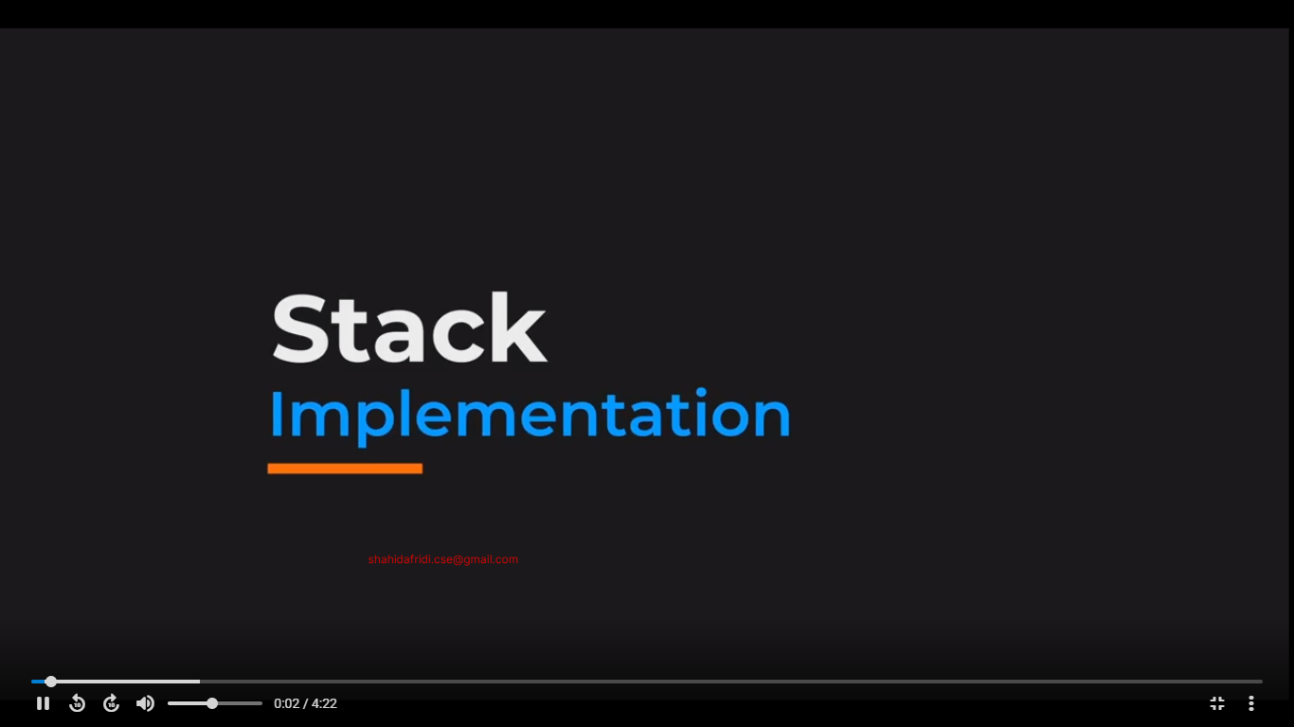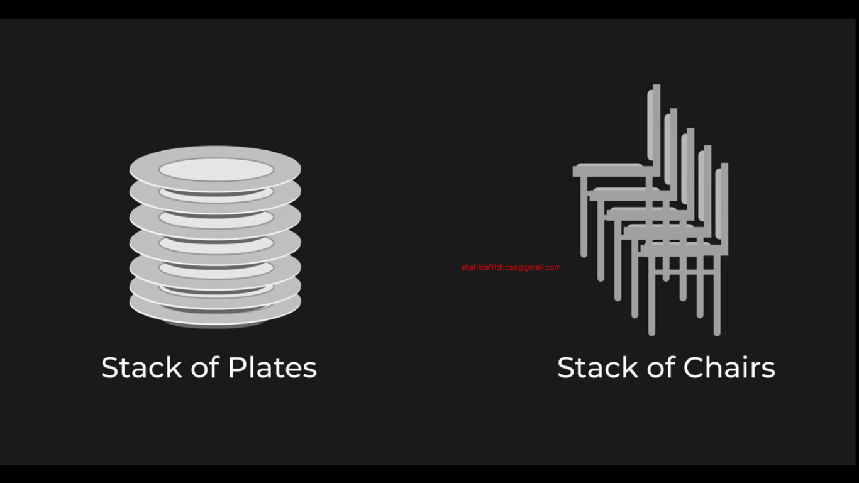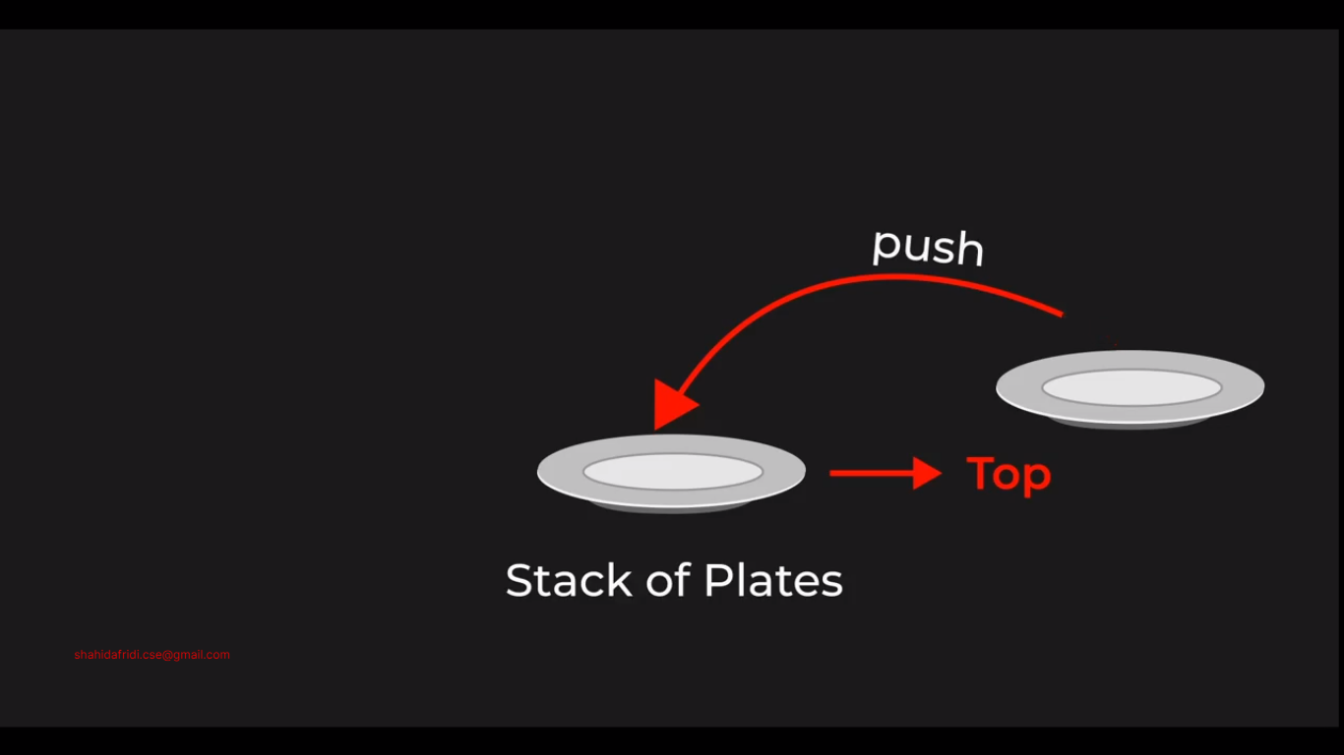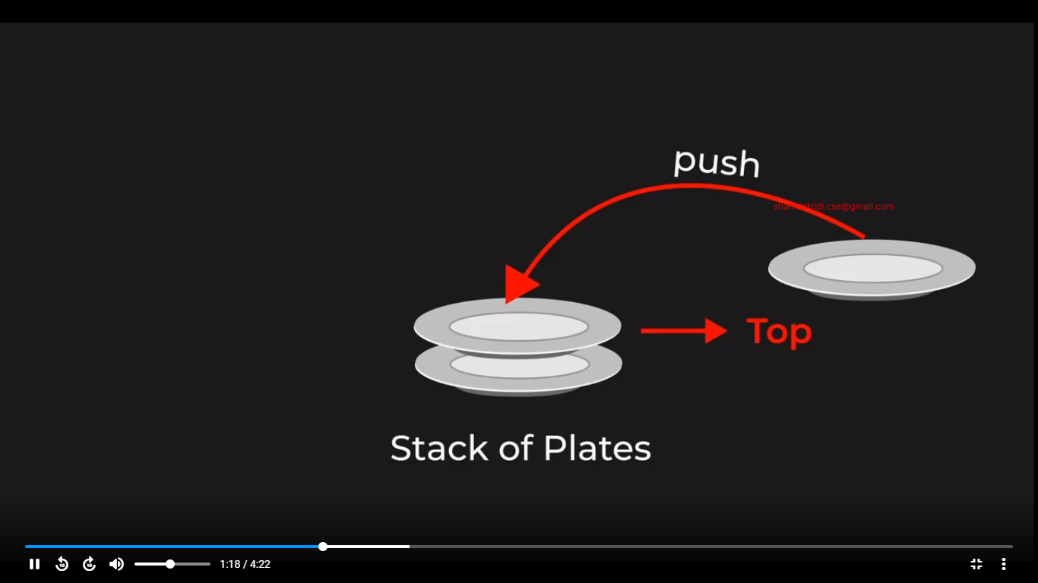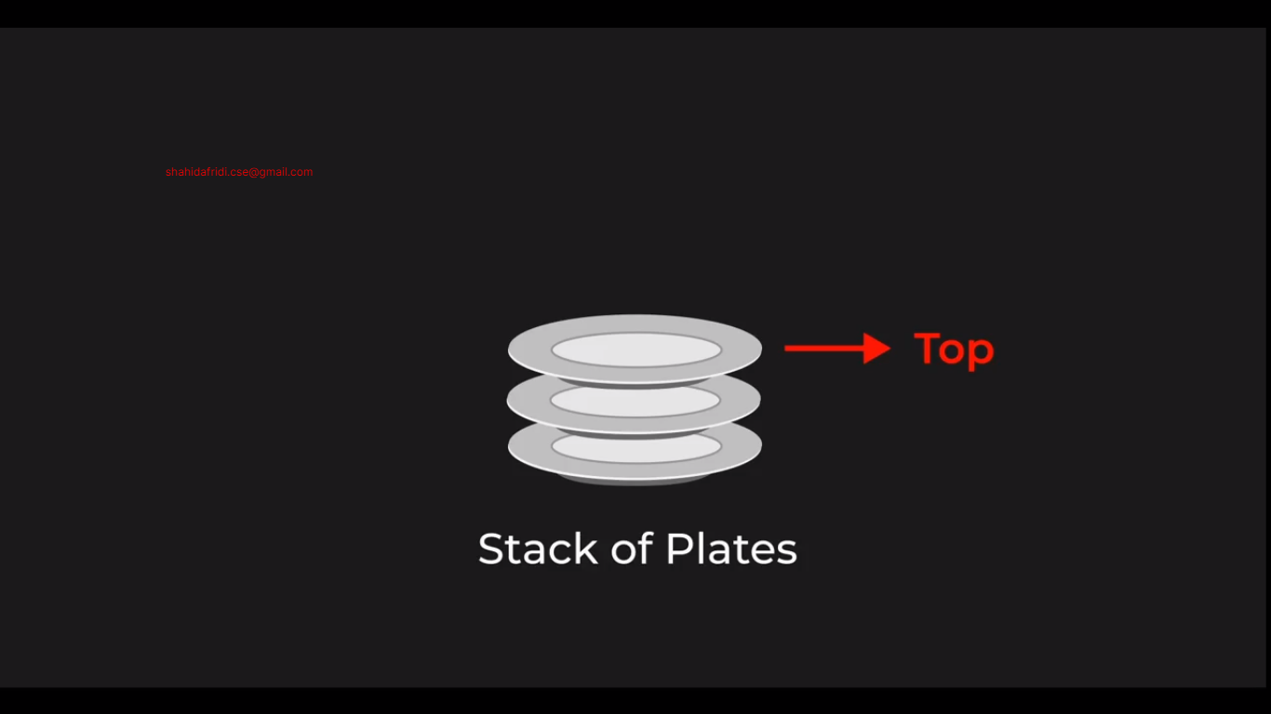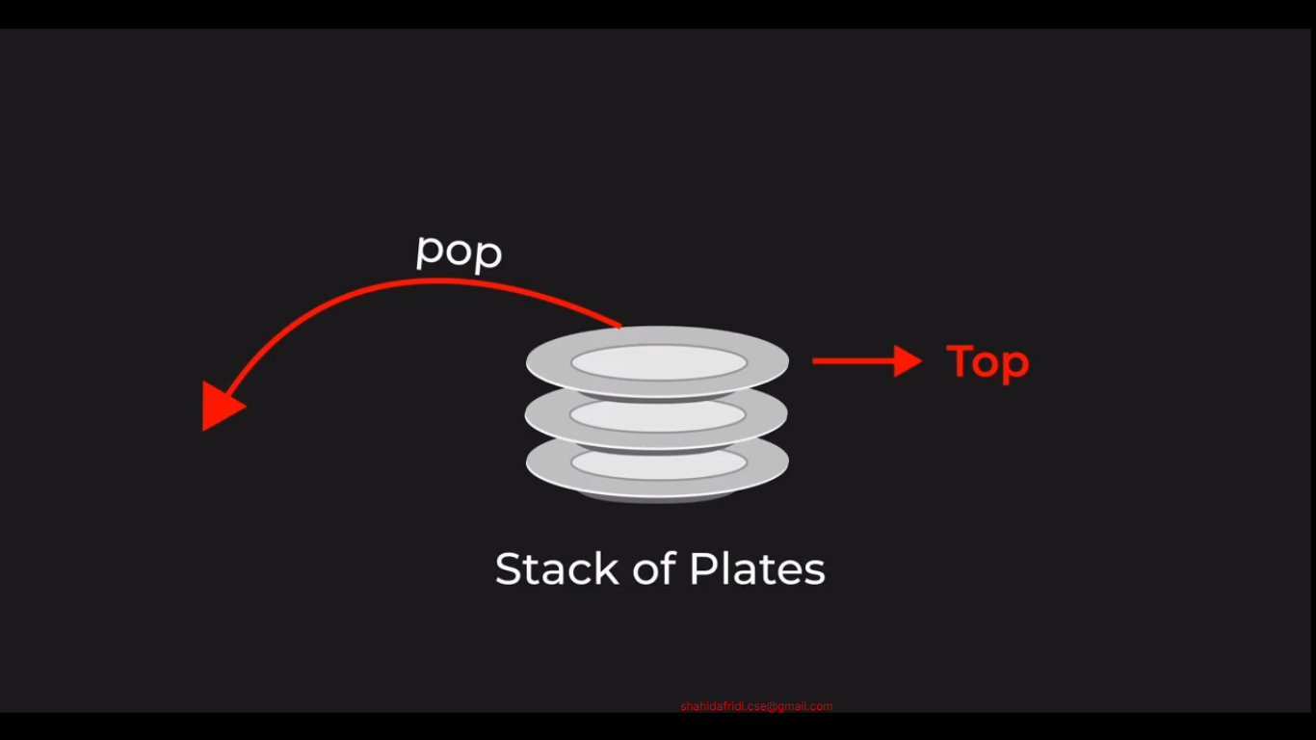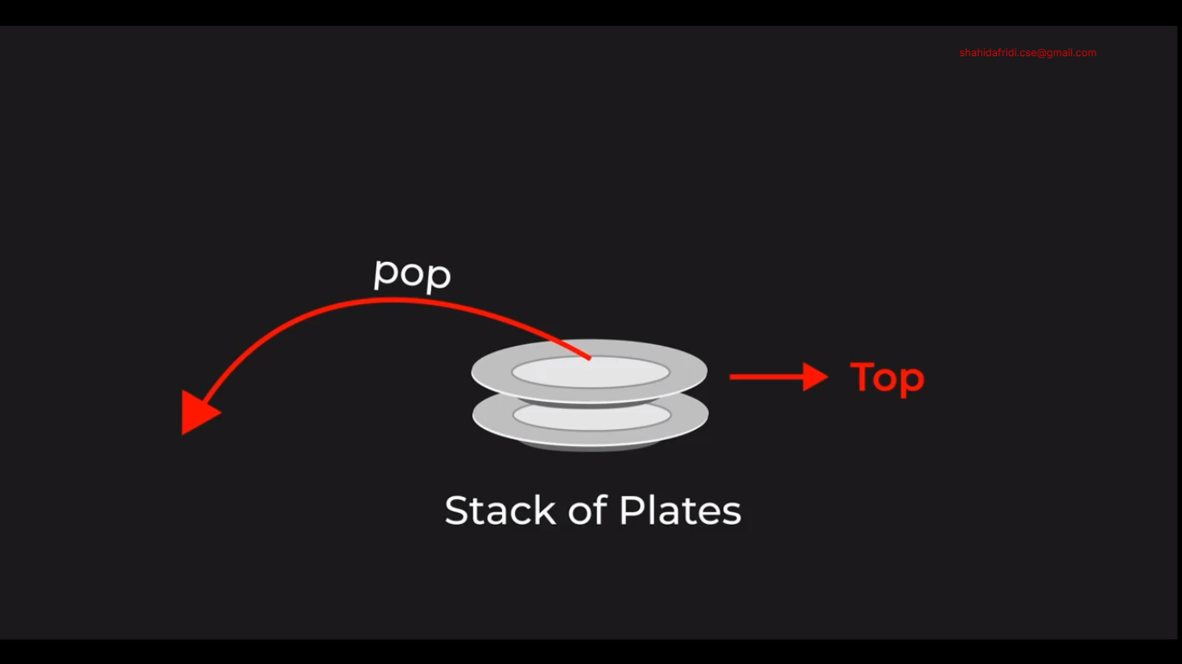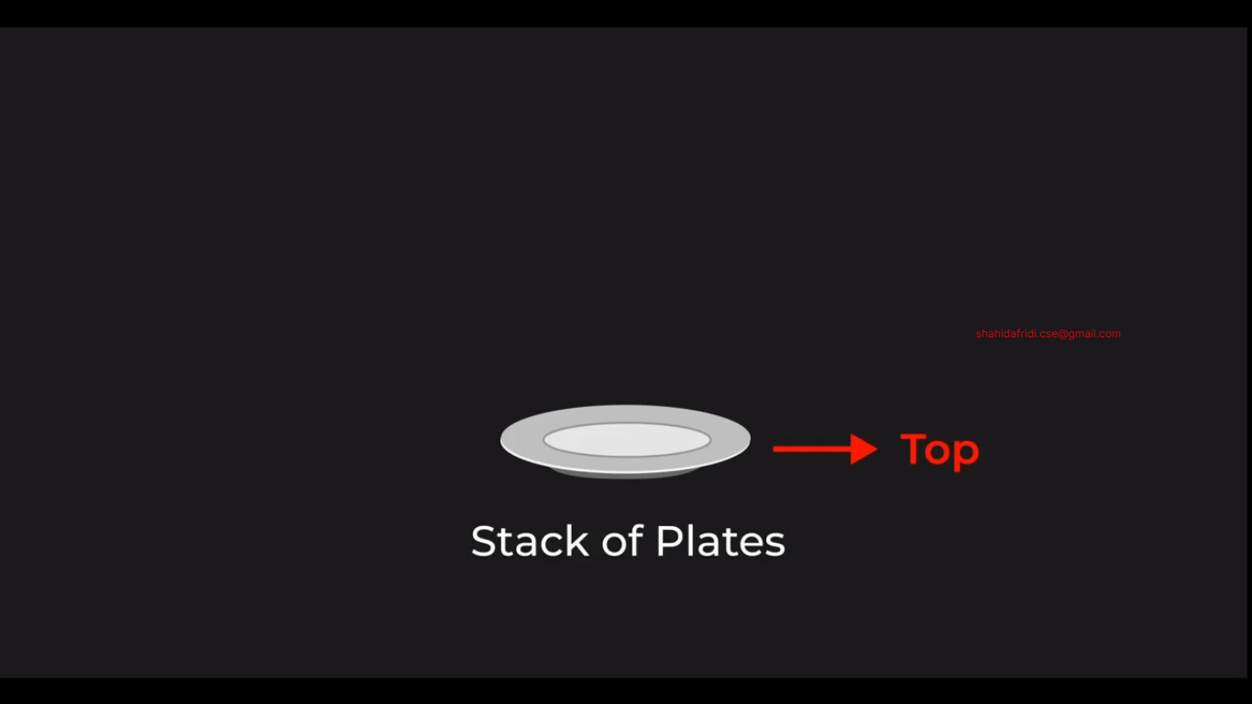

Another example of stack:

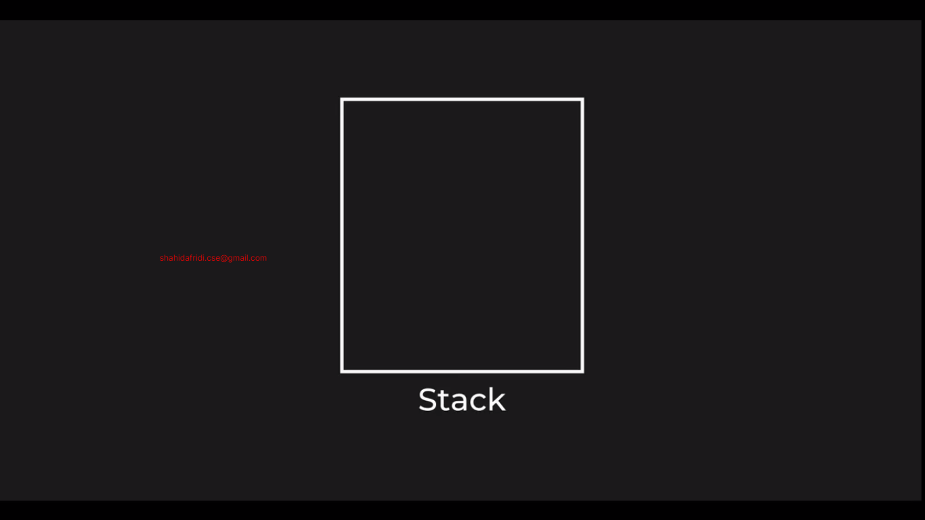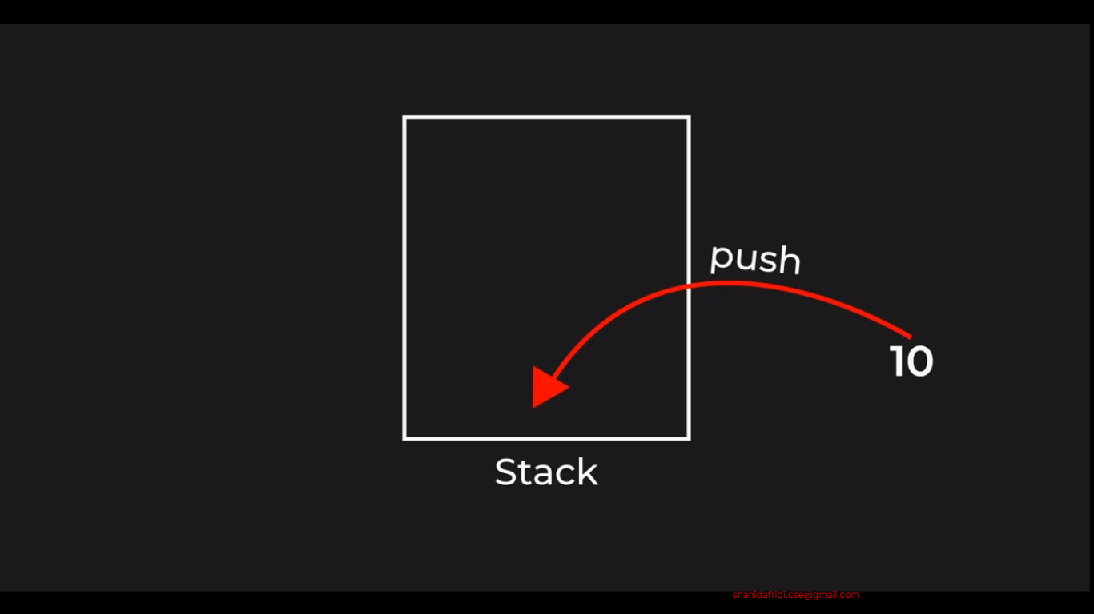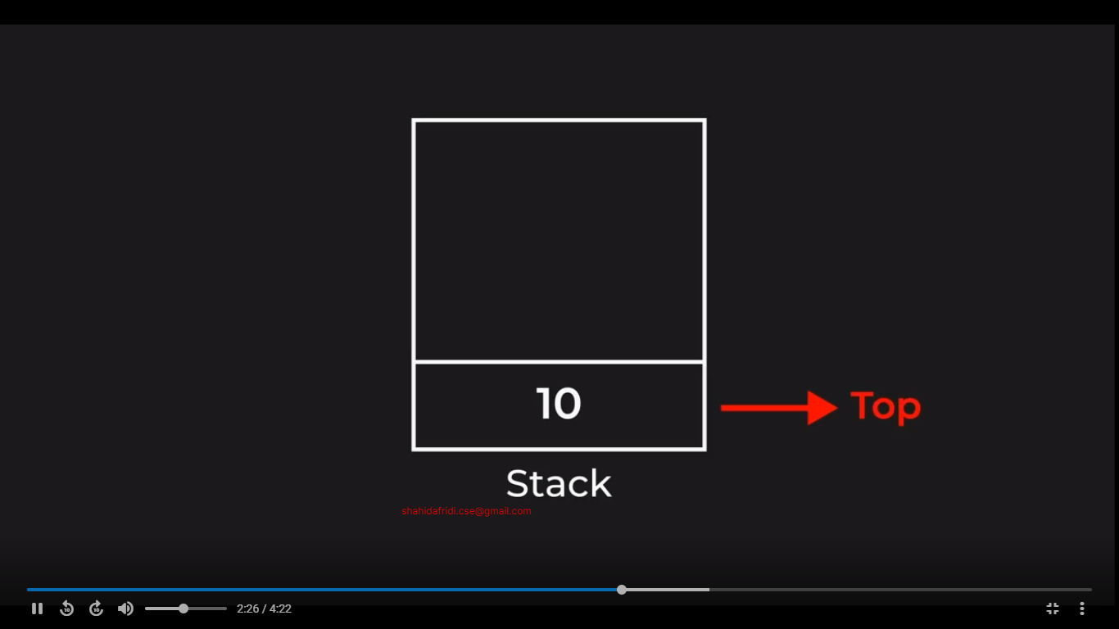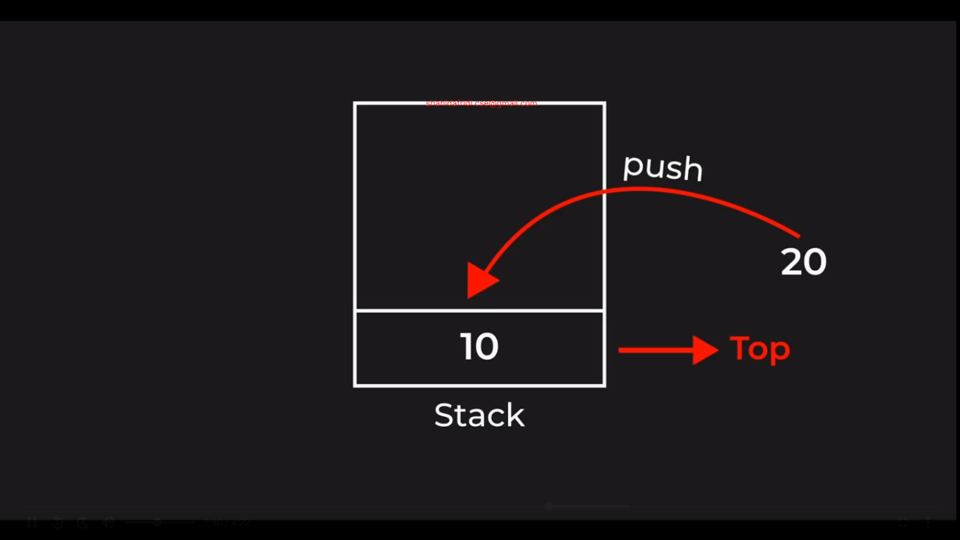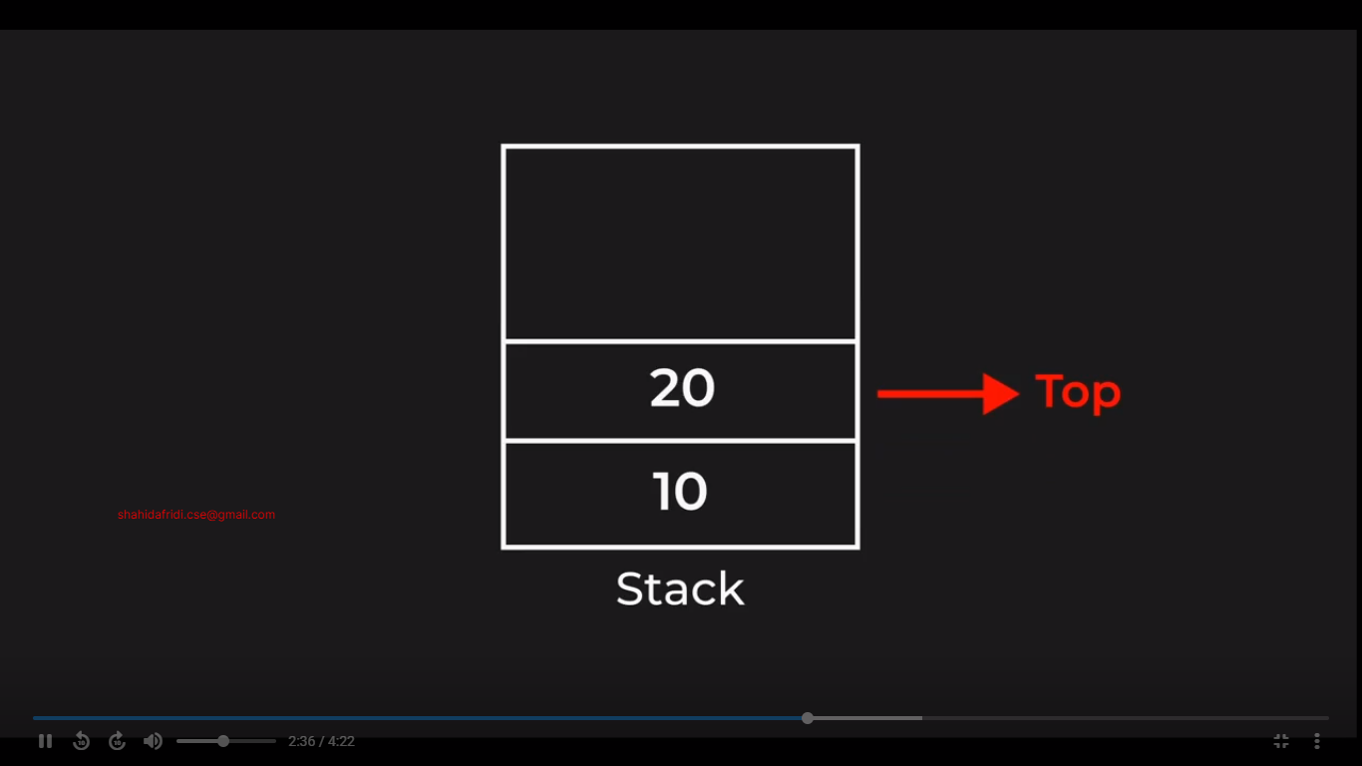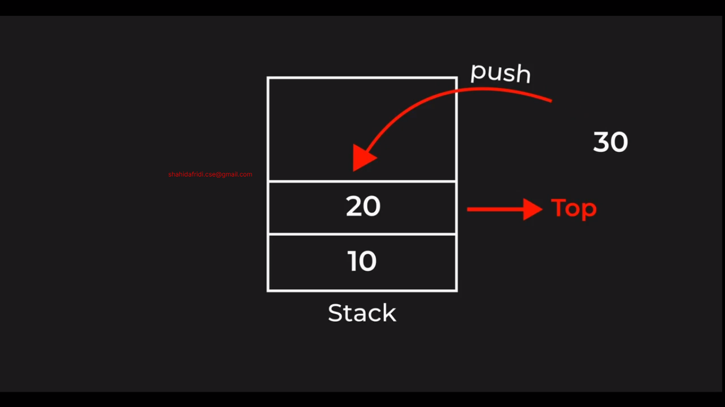

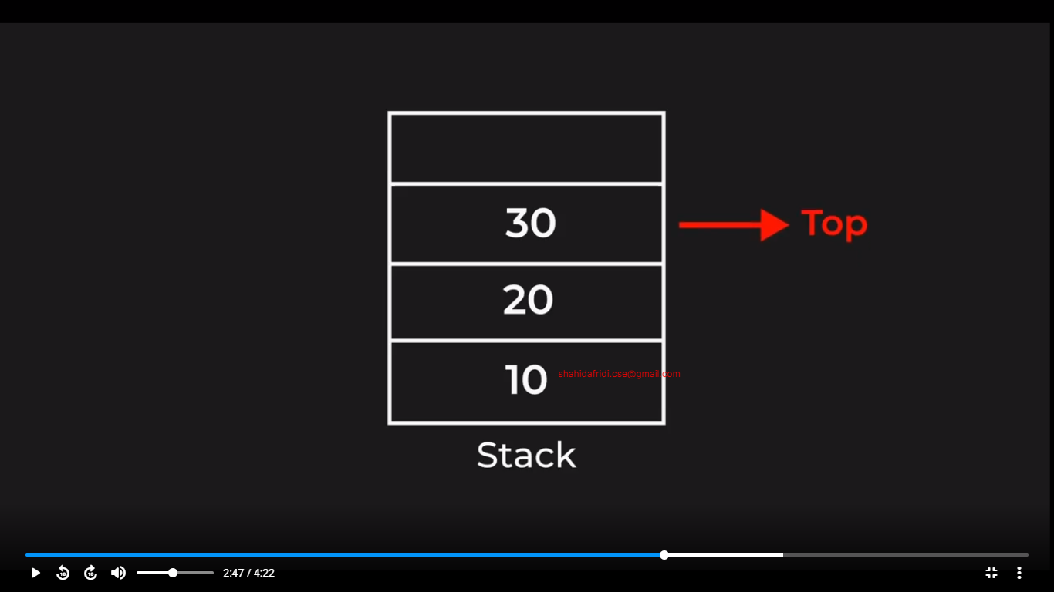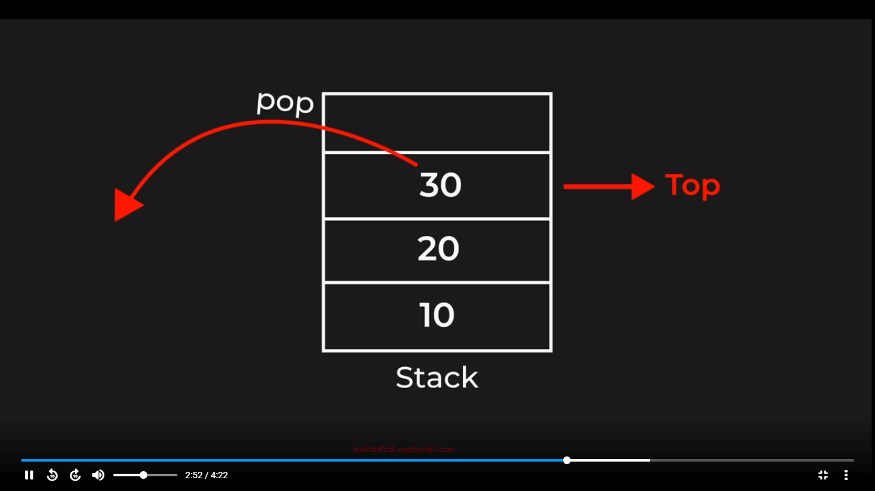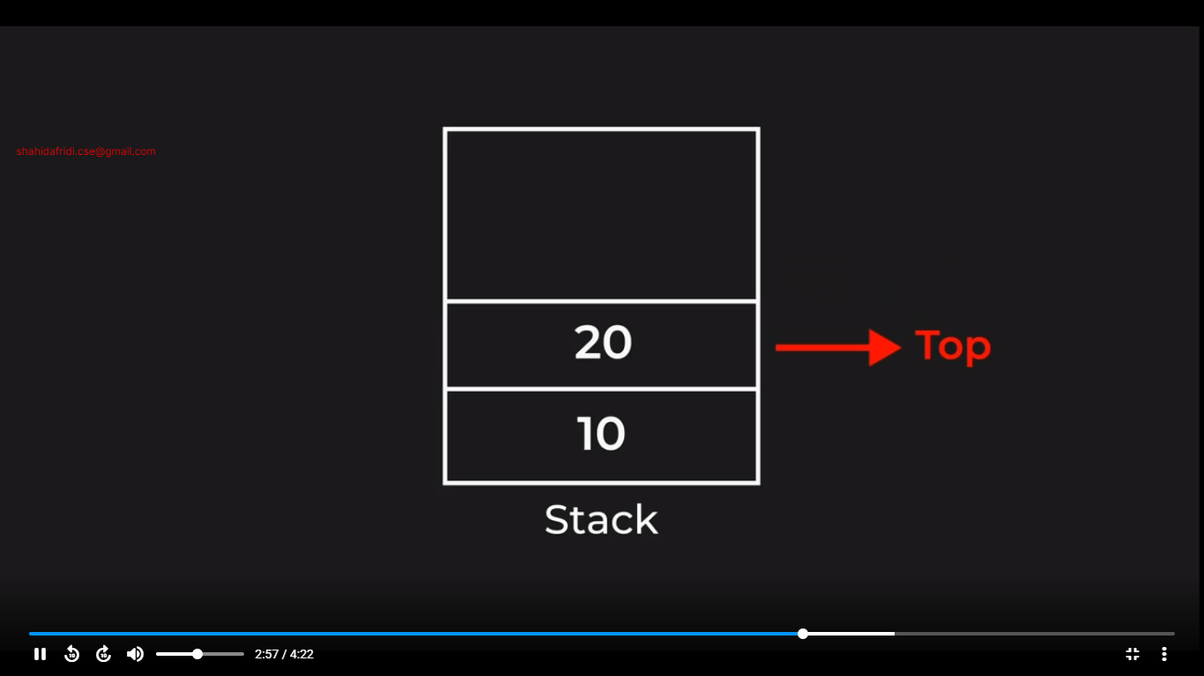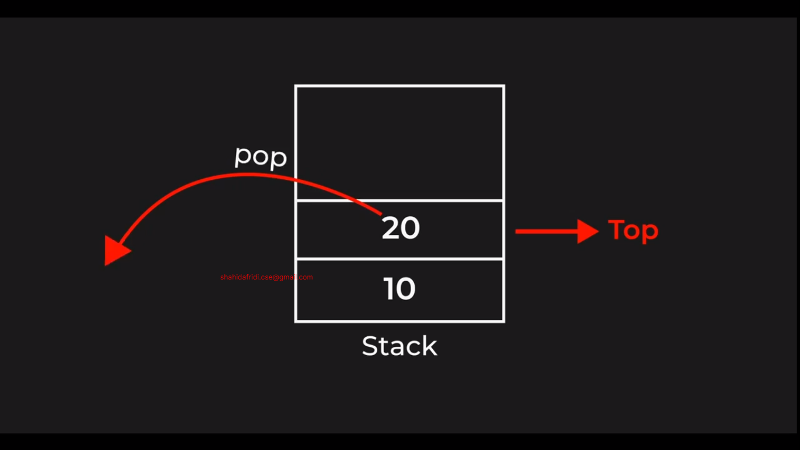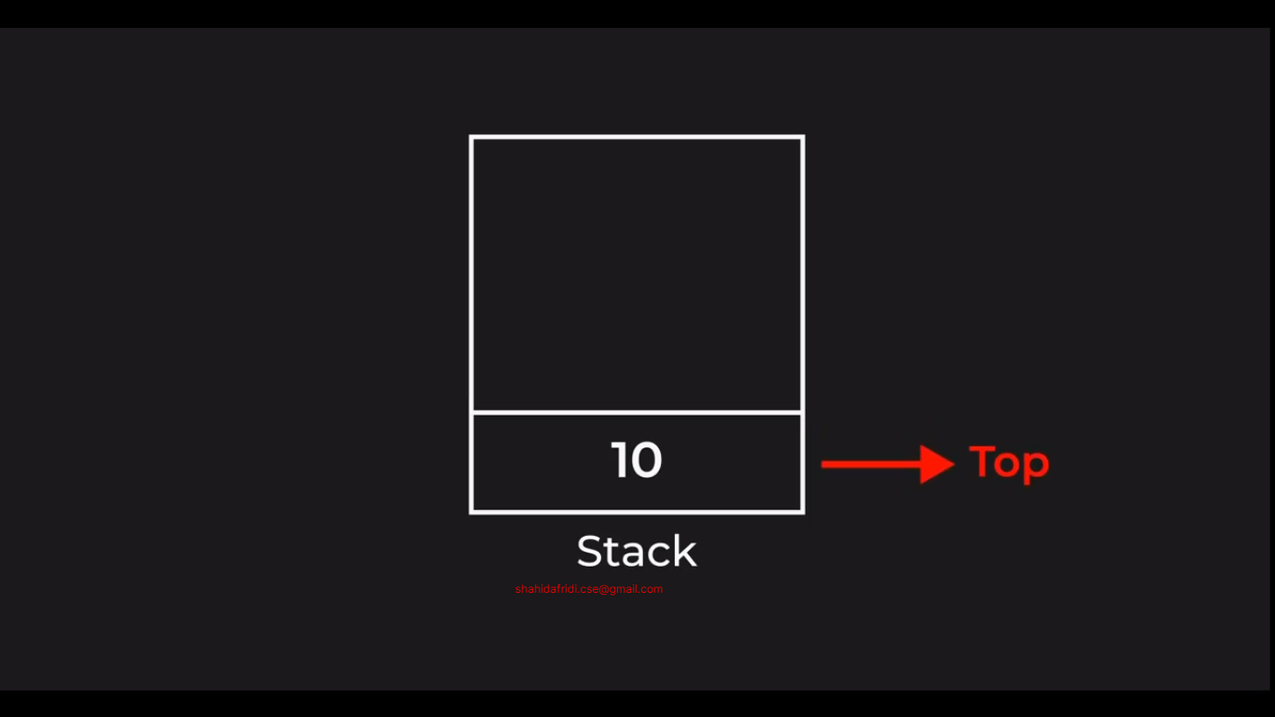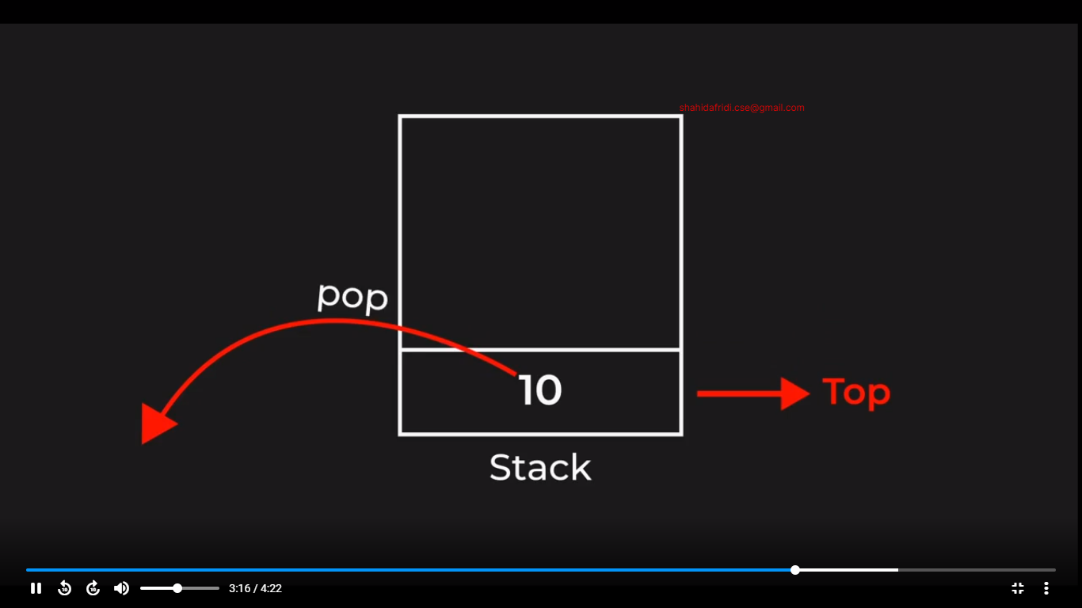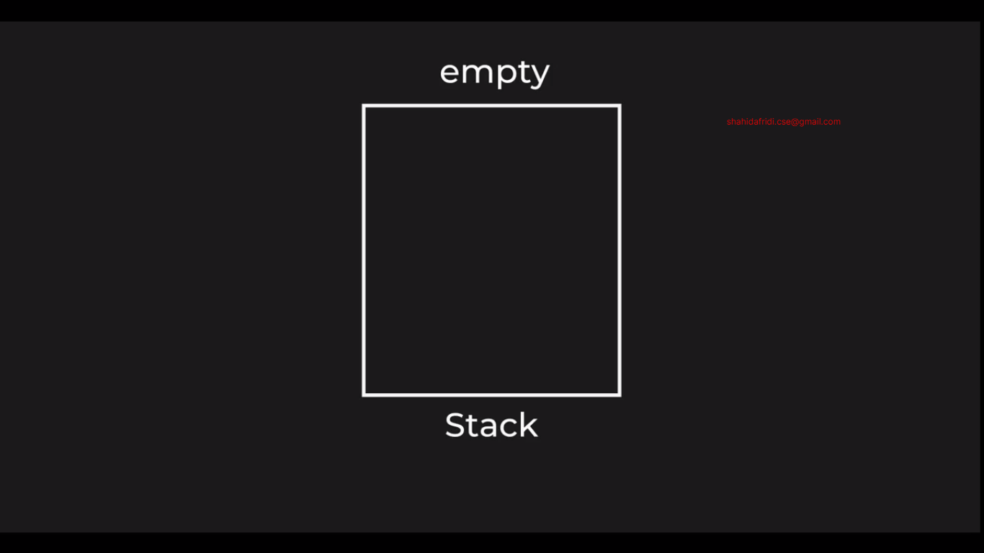

ADT => Abstract Data Structure / Higher Level Data Structure

Lower Level Data Structure / Container (Array, Linked List)

Stack is not a data structure. It’s a concept/theory. And it use internally Array or Linked List.

Where Stack is a Abstract data structure/ Higher level data structure. And the array and linked list are container.

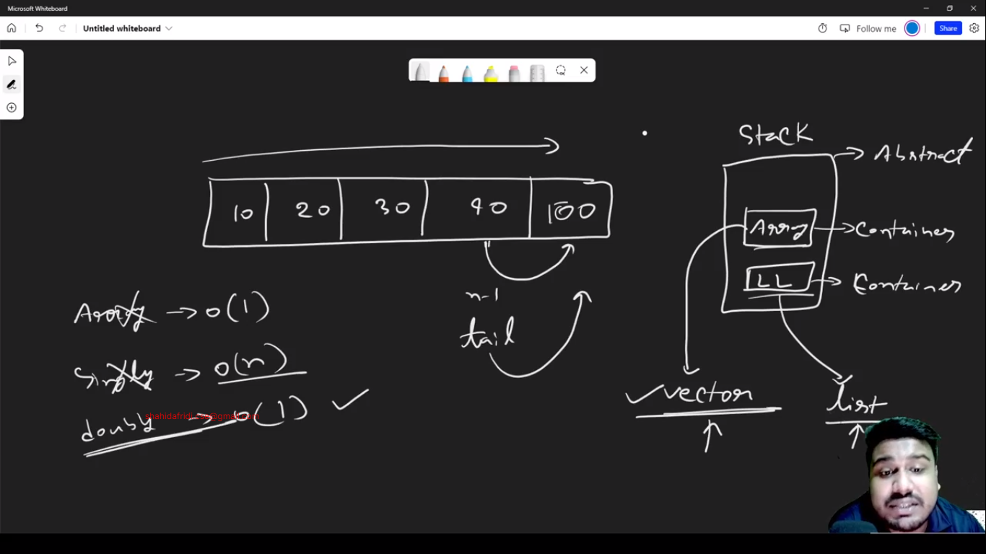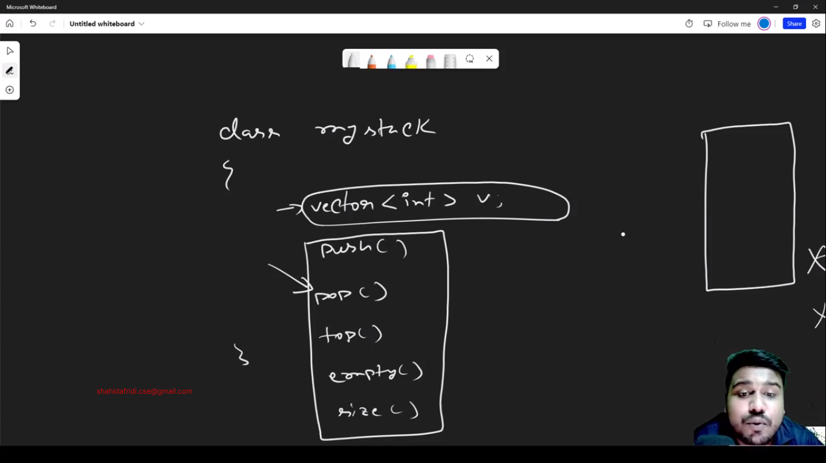

Stack Using Vector: 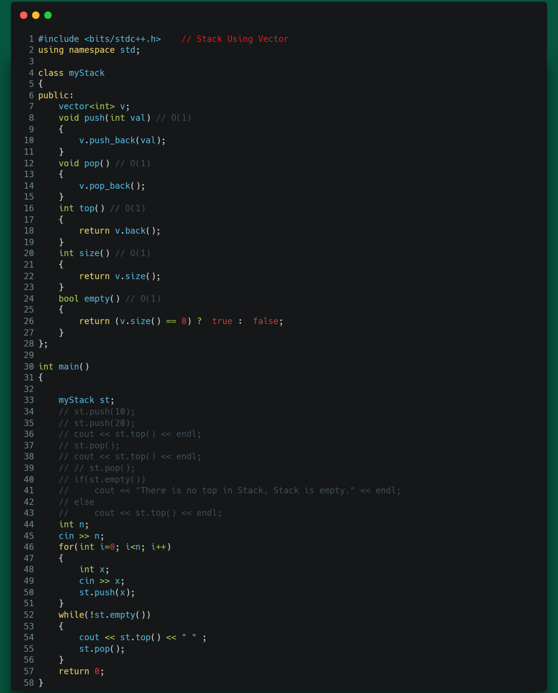

Stack using List: 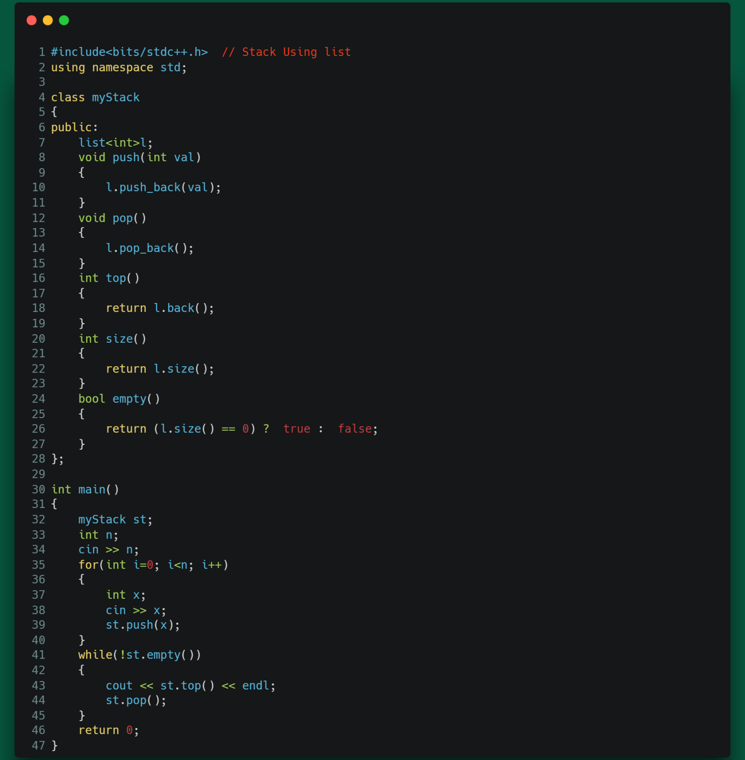

Stack Using Doubly Linked List: 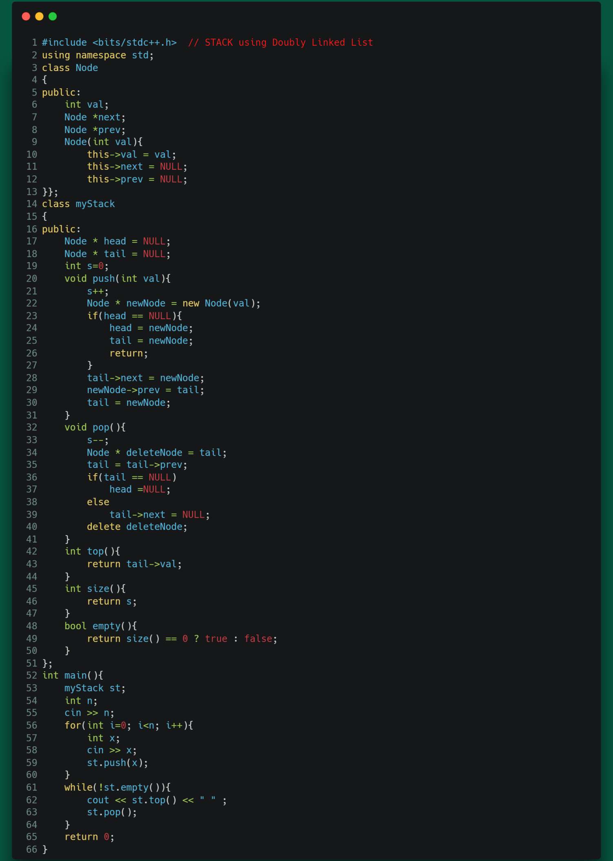

STL STACK:

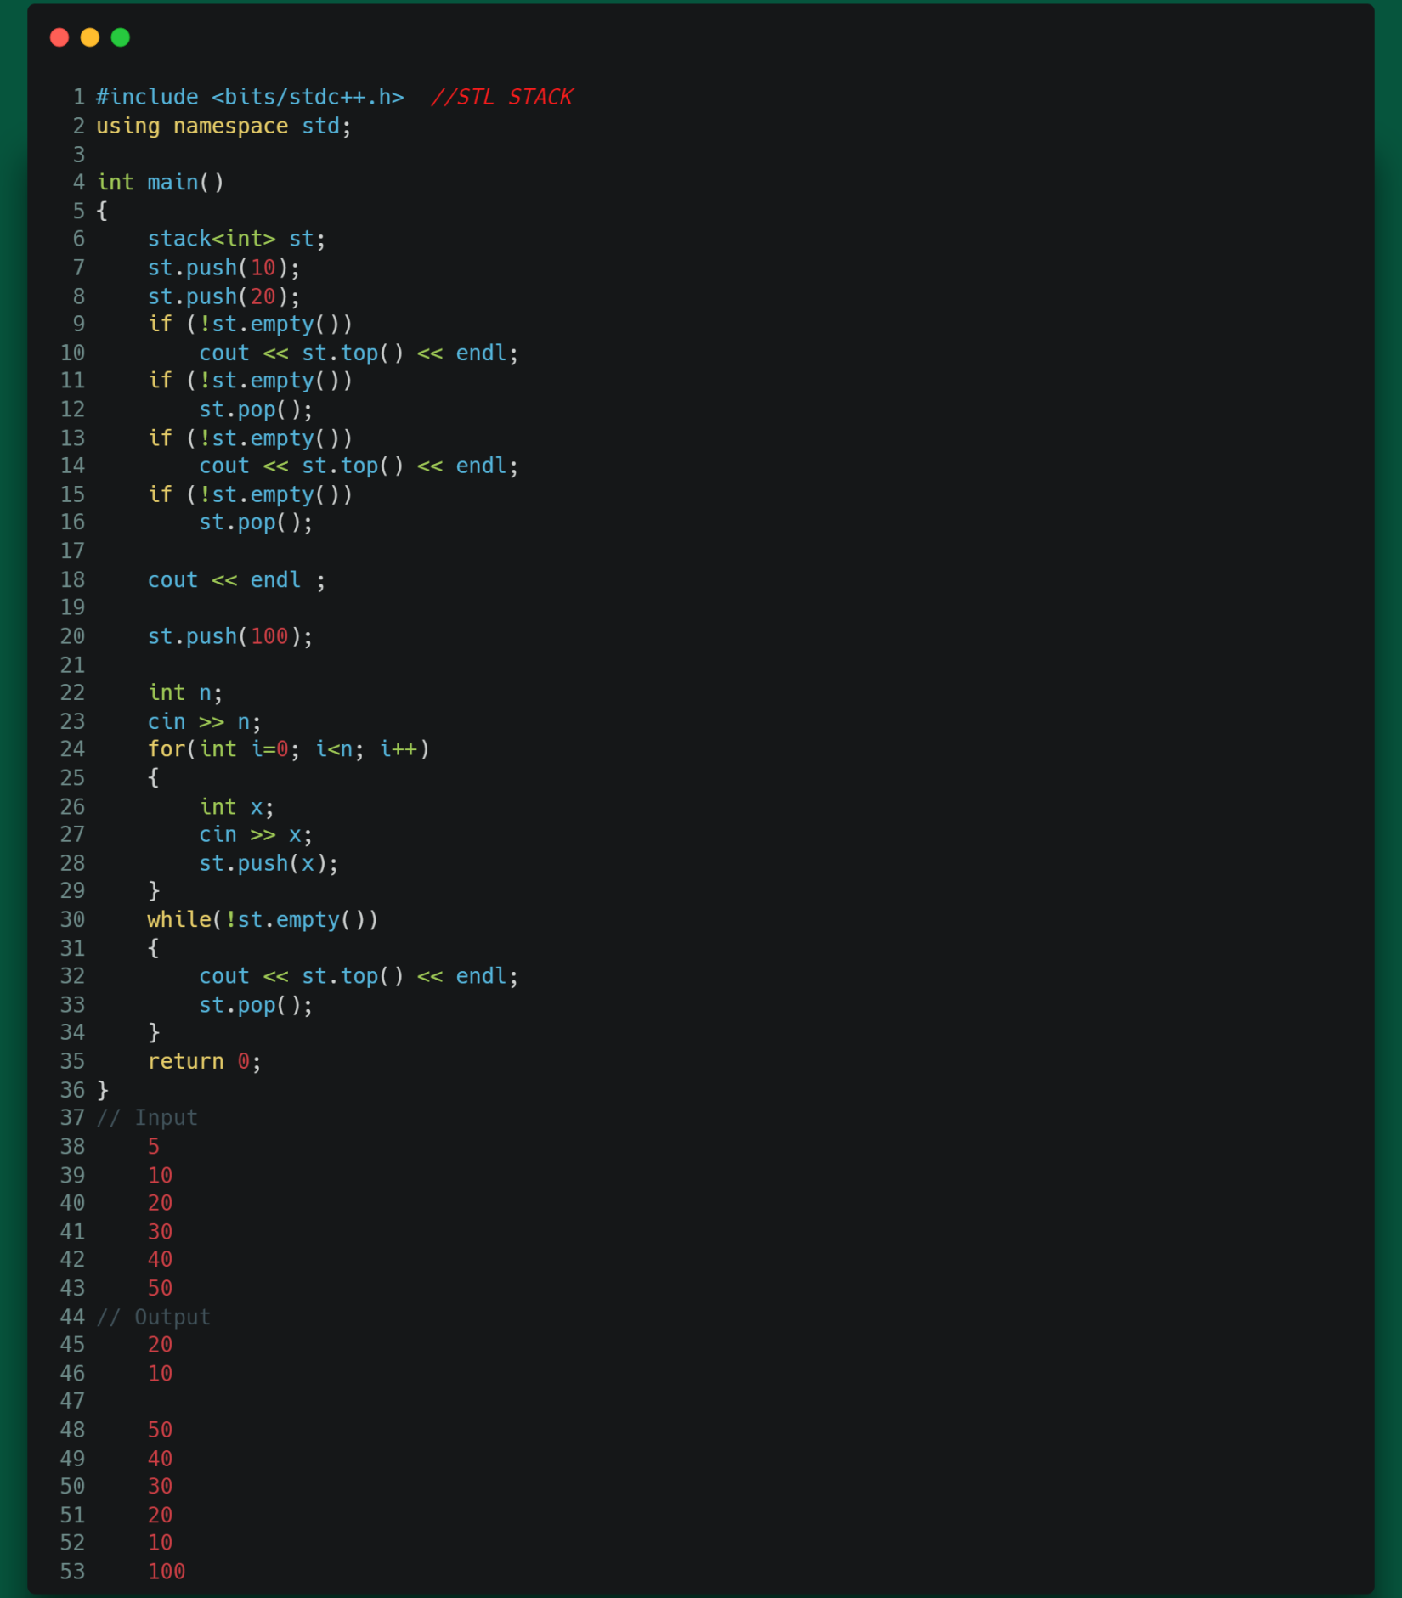

Module 14:



QUEUE:

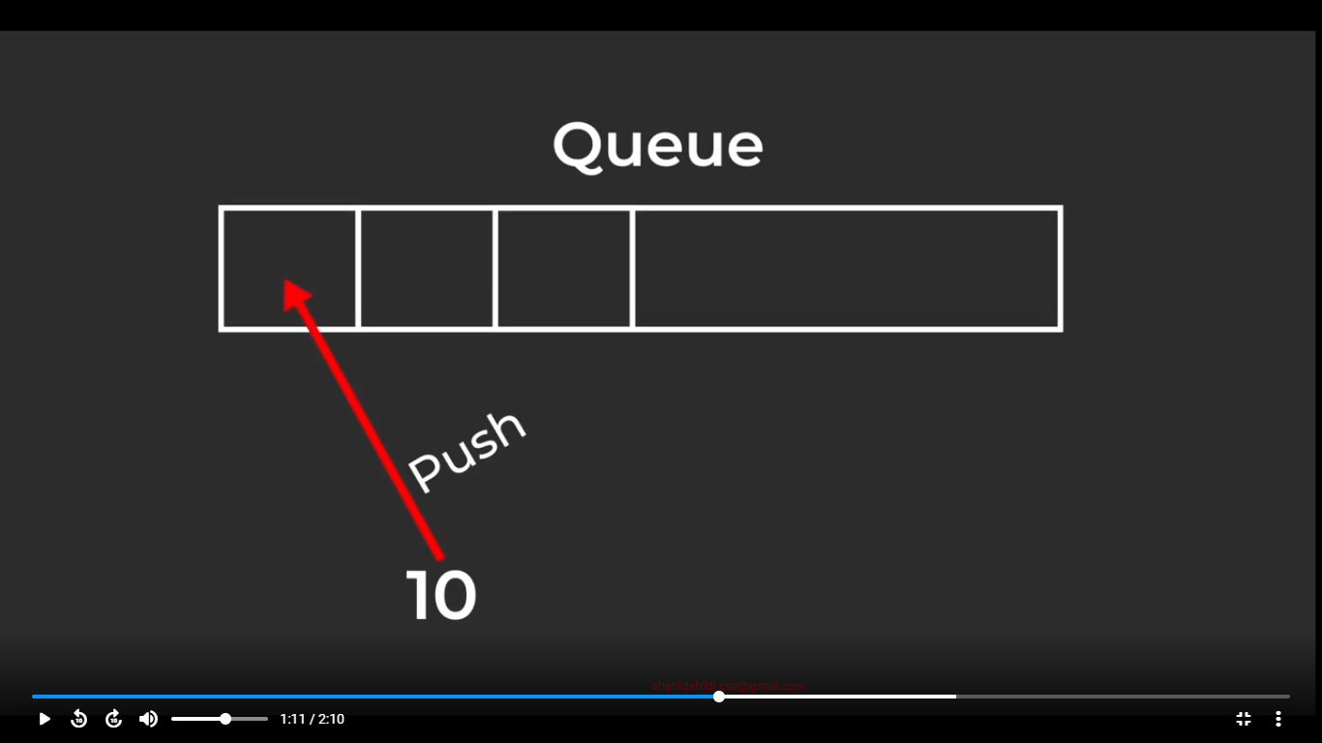

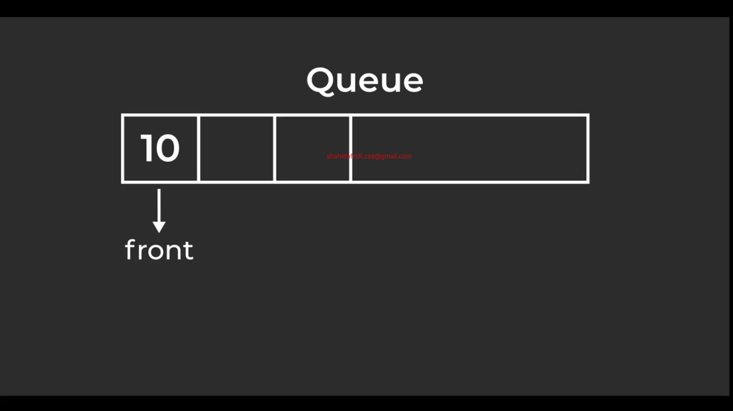

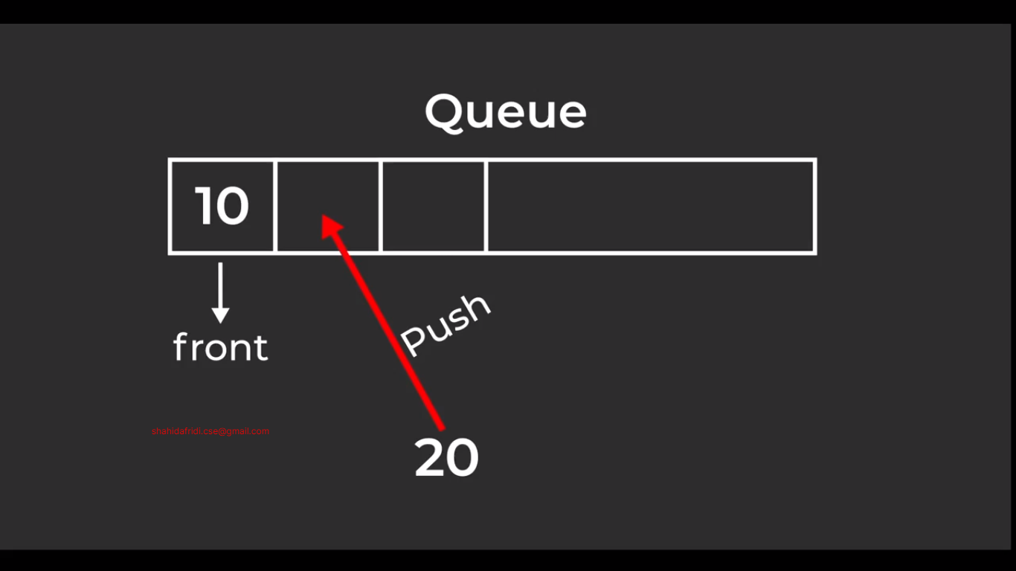

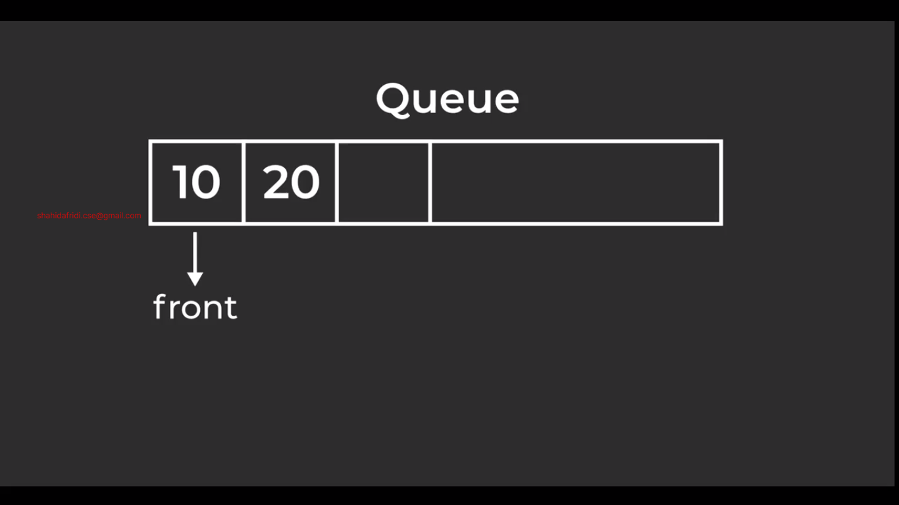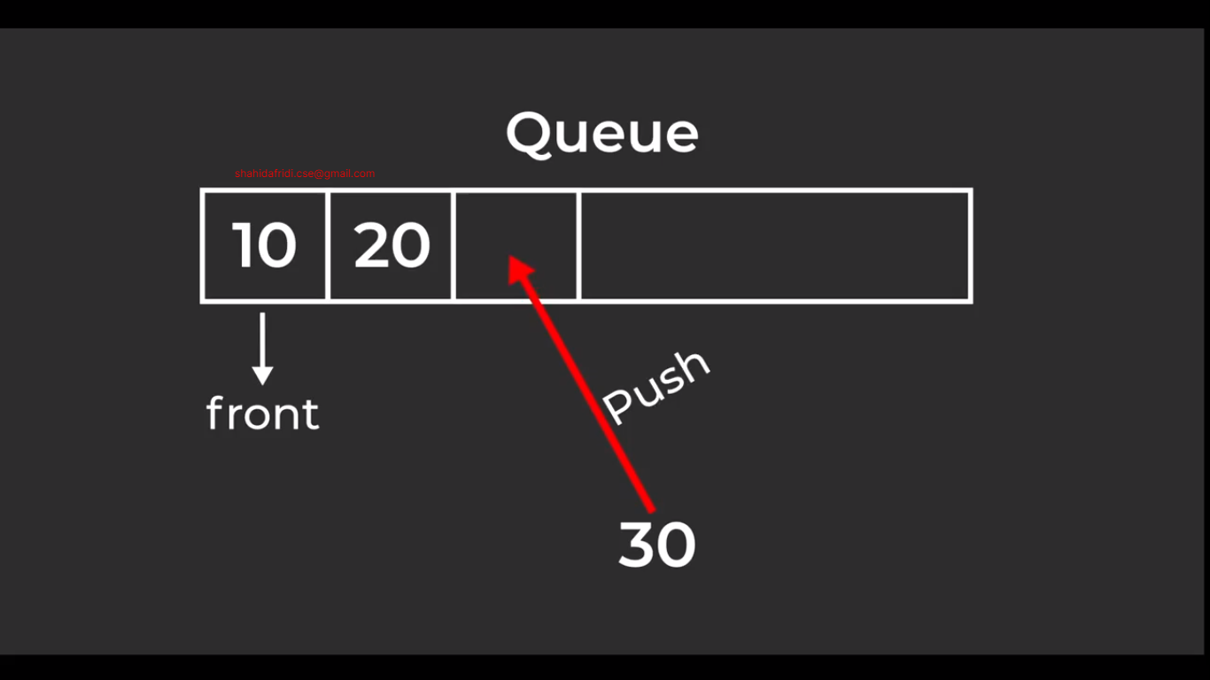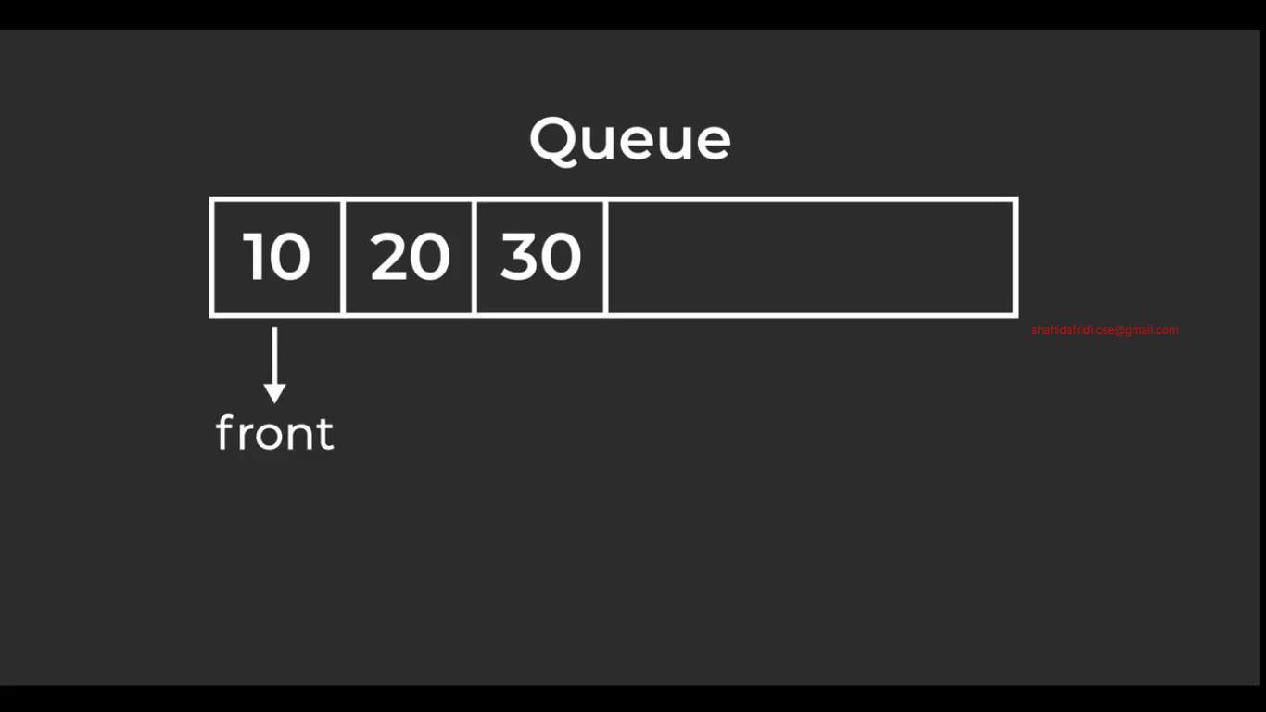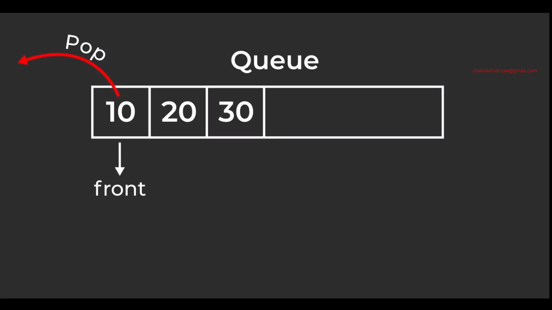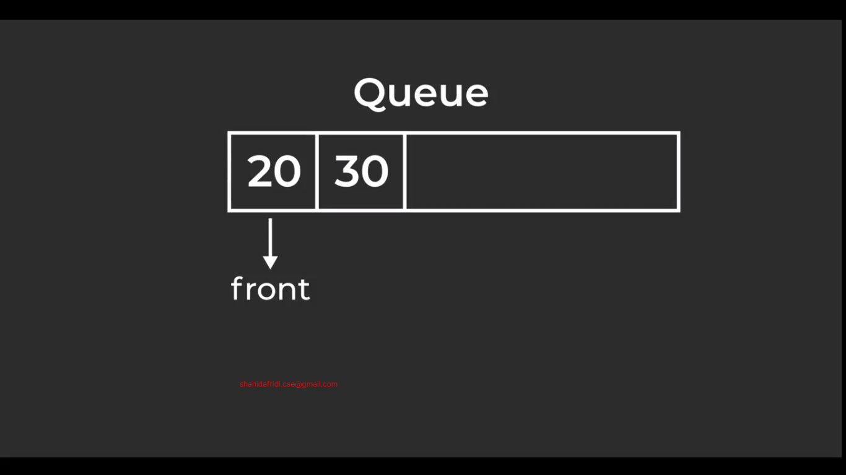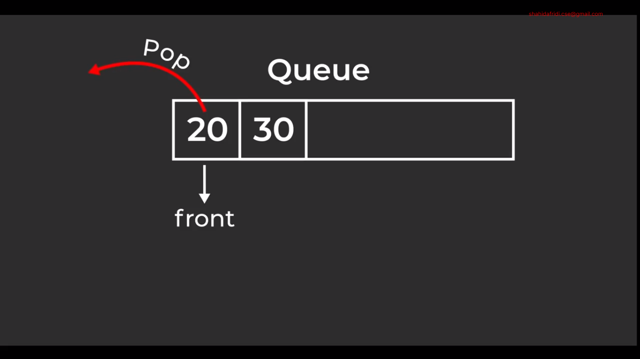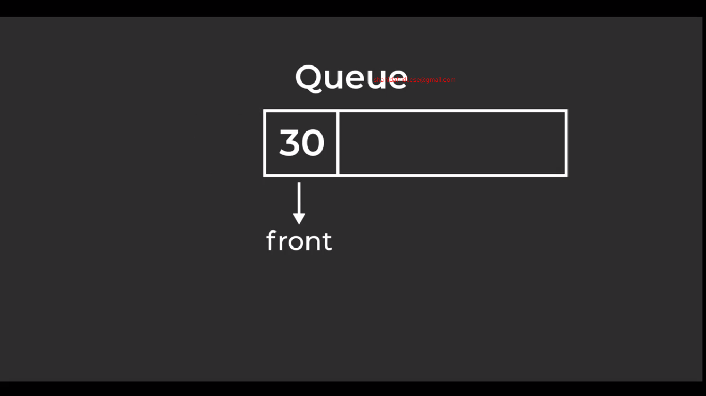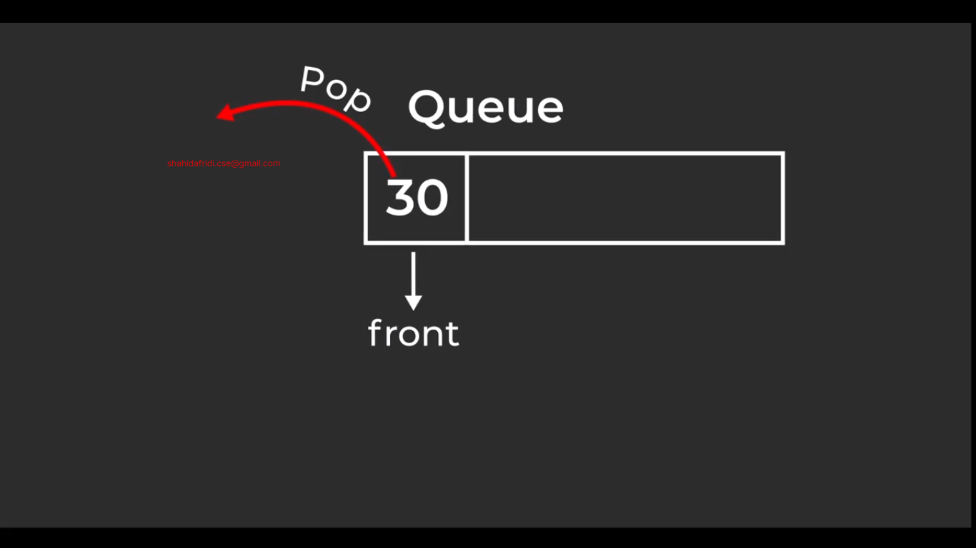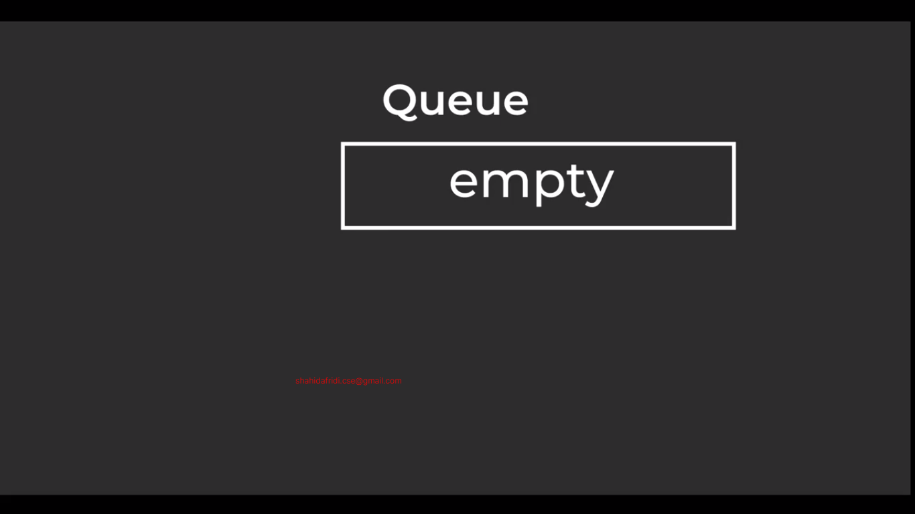

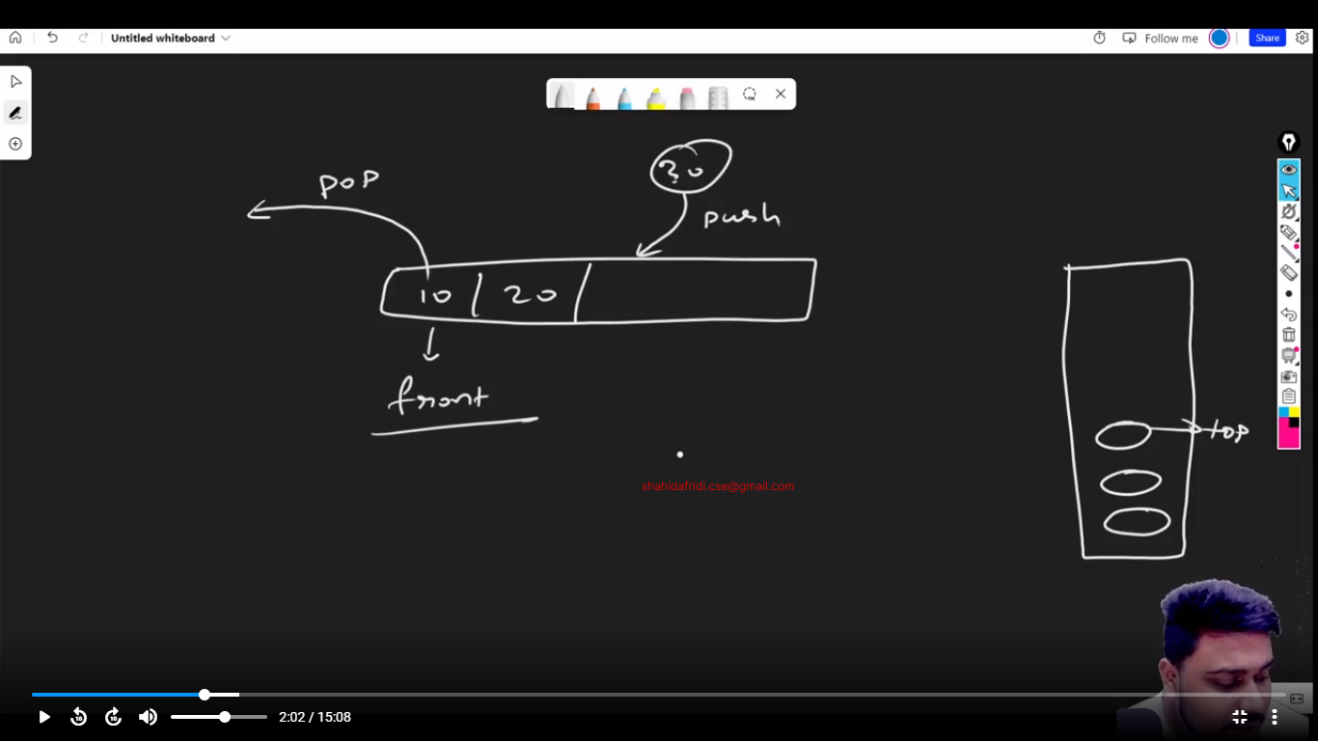

Queue Using Singly Linked List:

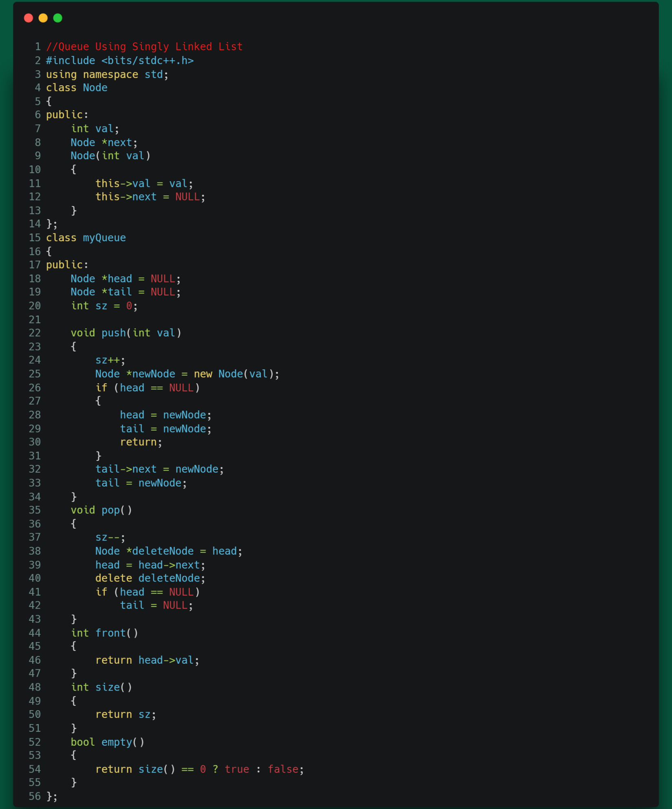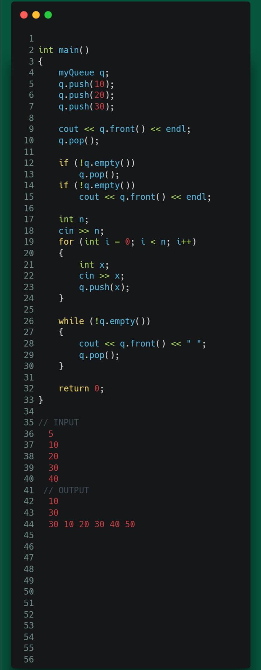

Queue using doubly linked list:

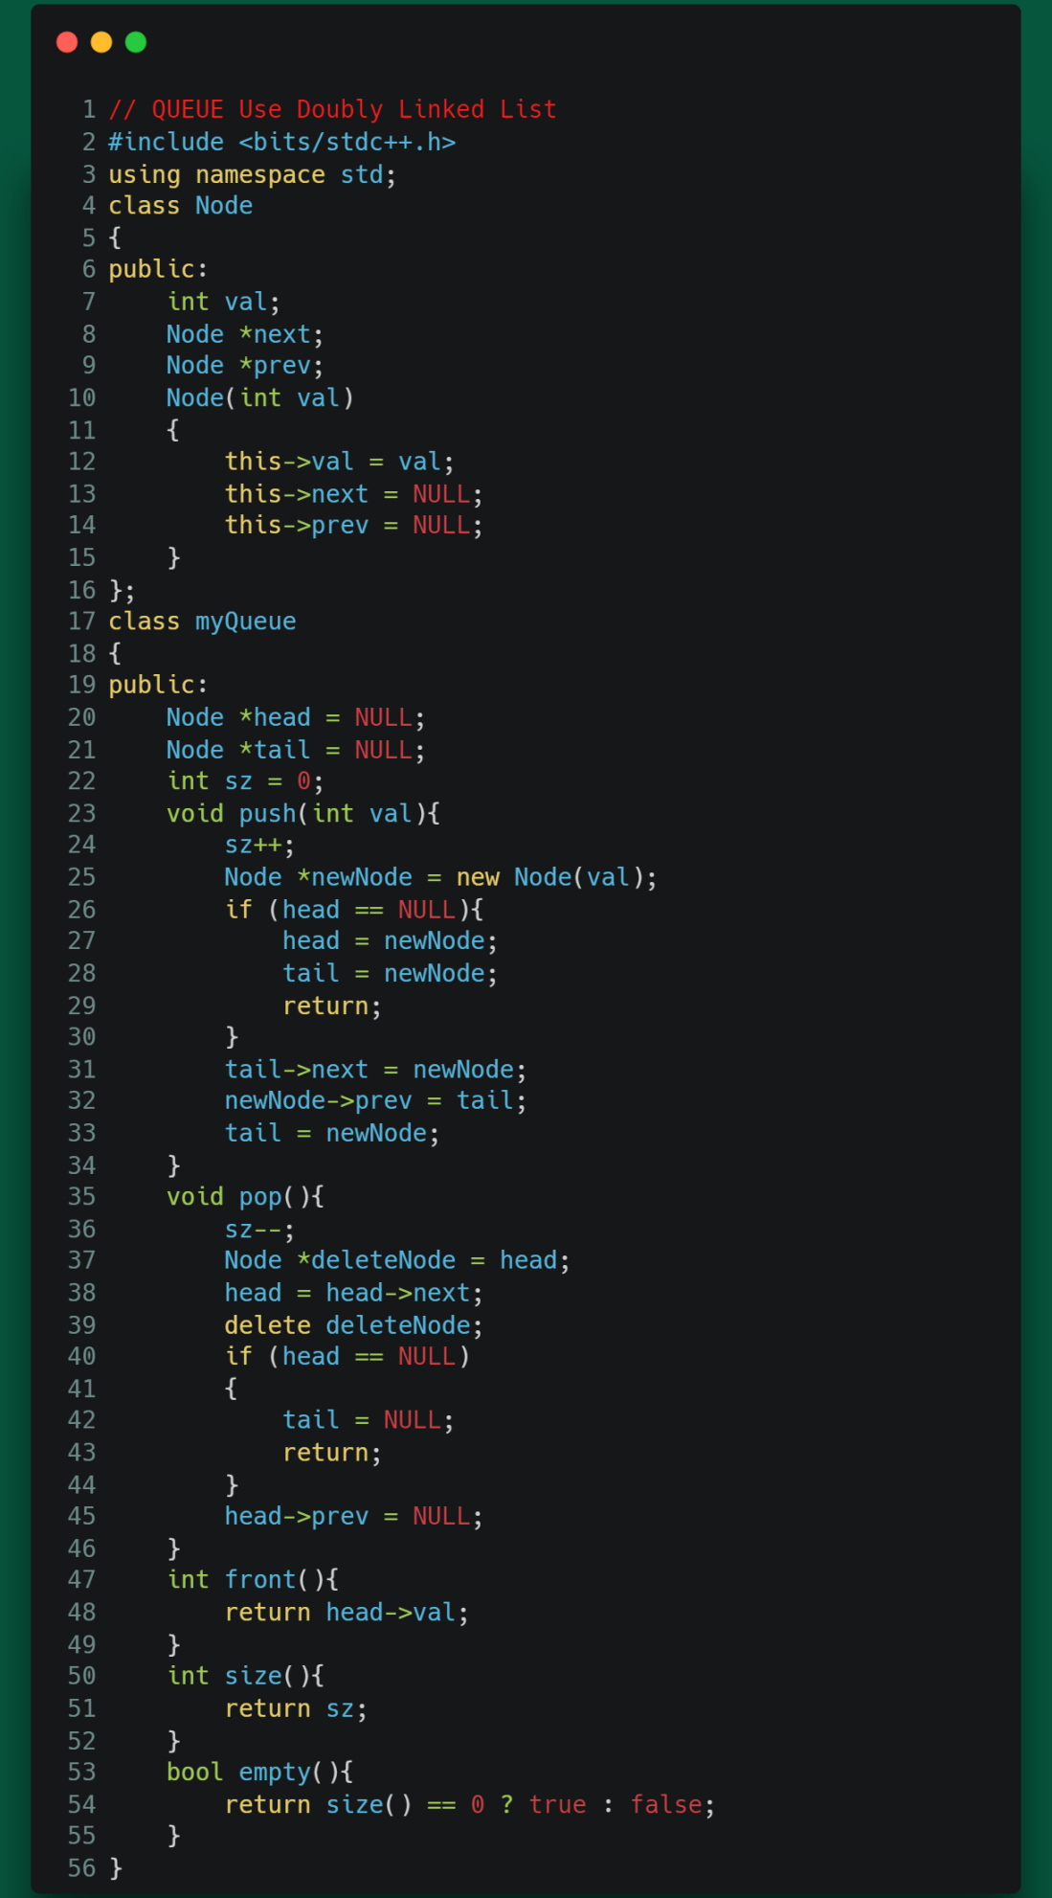

Queue using list:

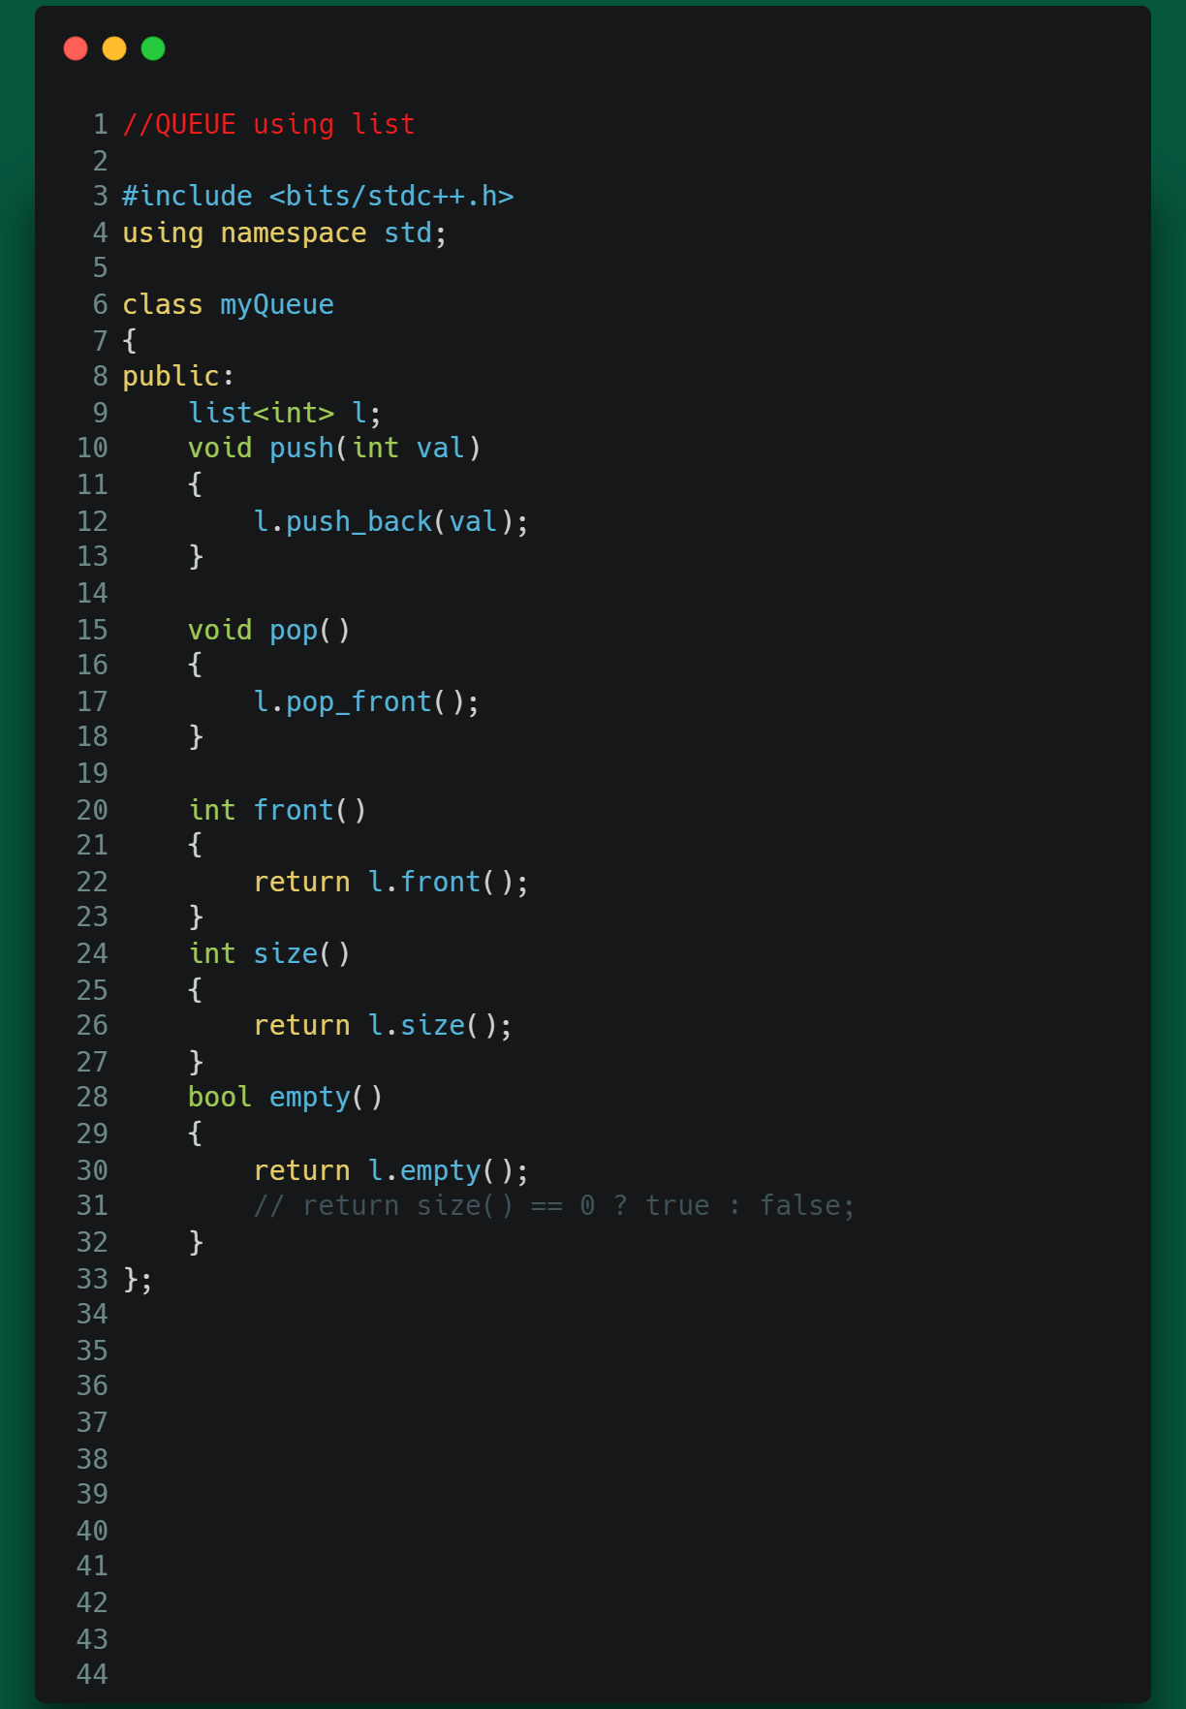

STL Queue:

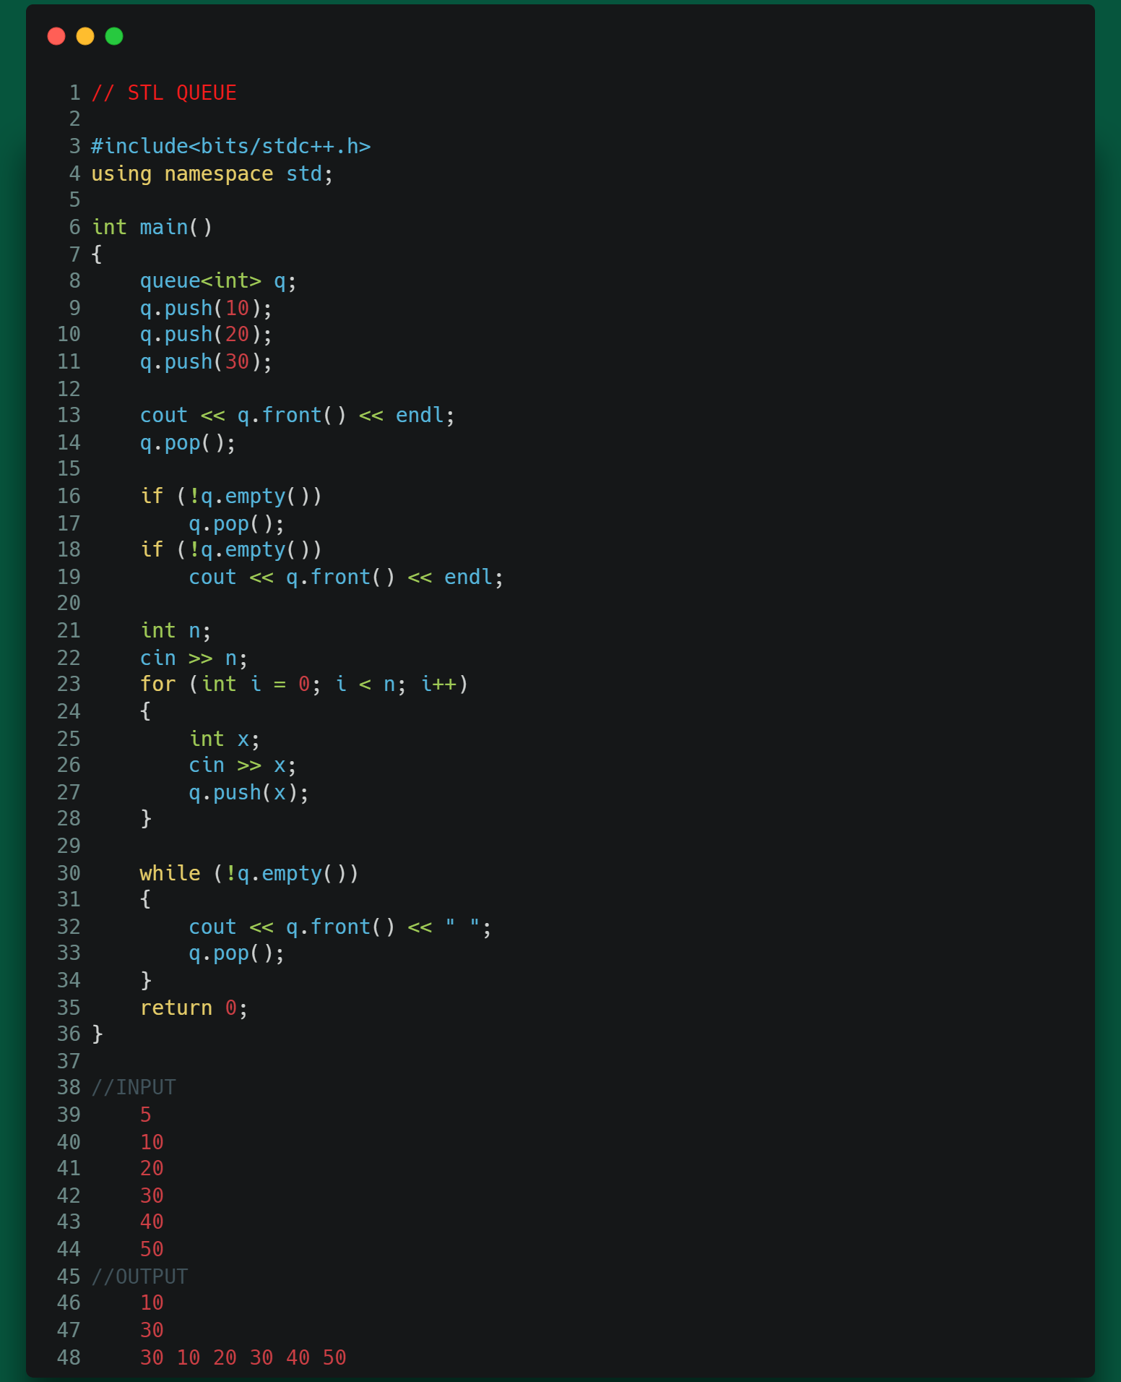

Module 14.5:

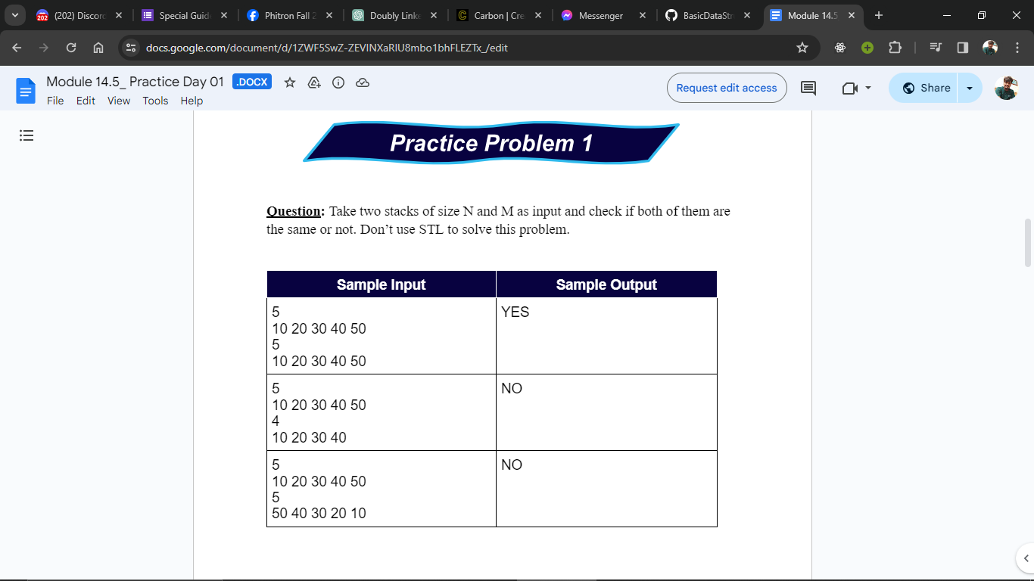

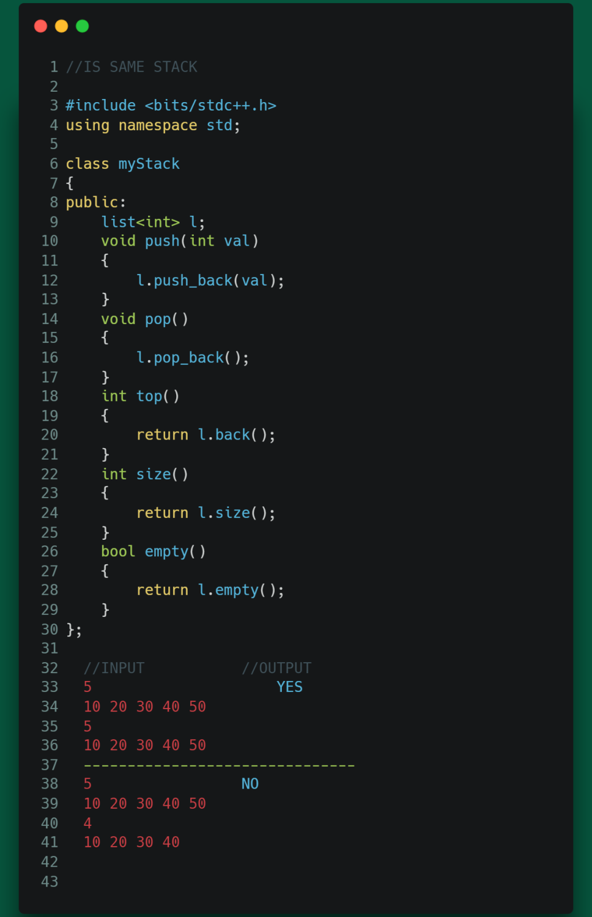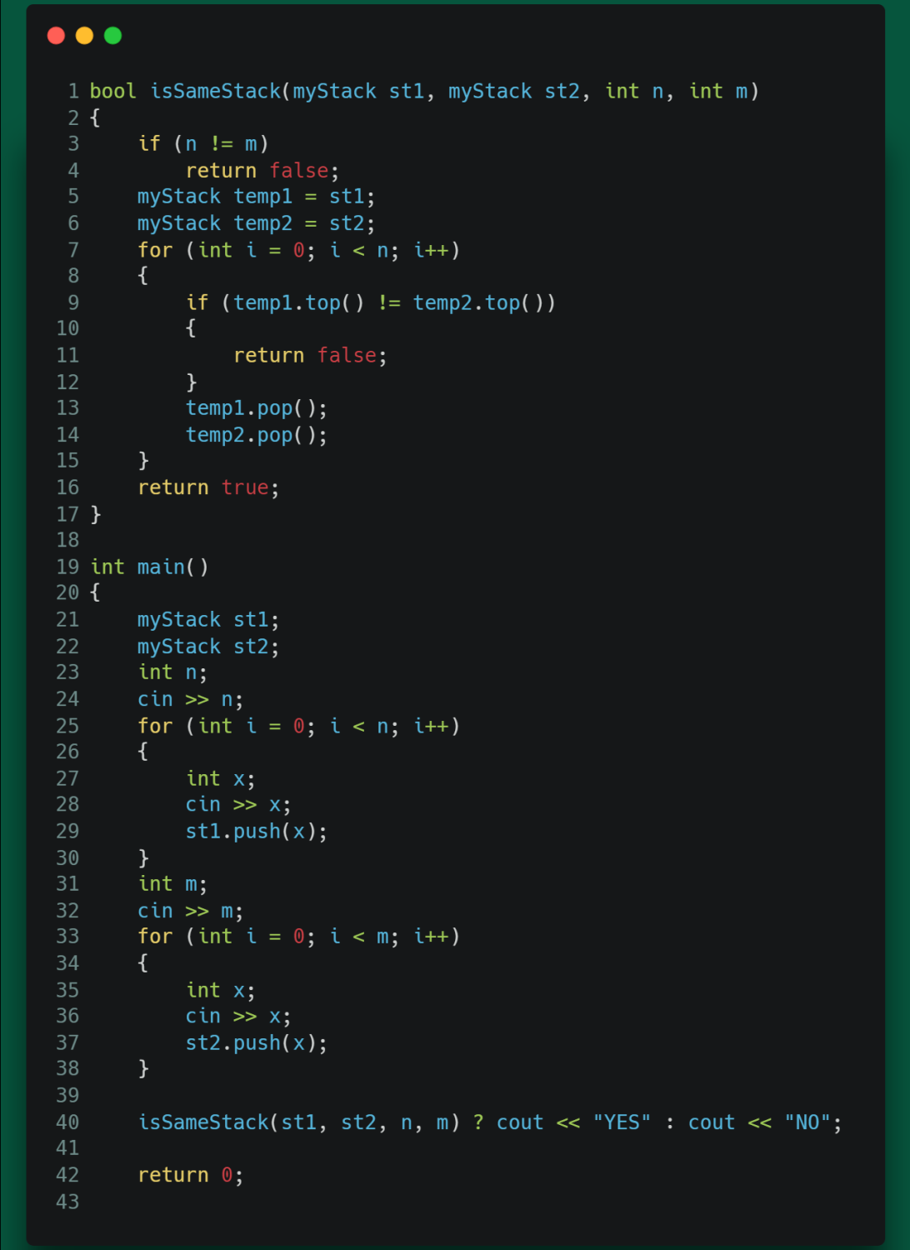

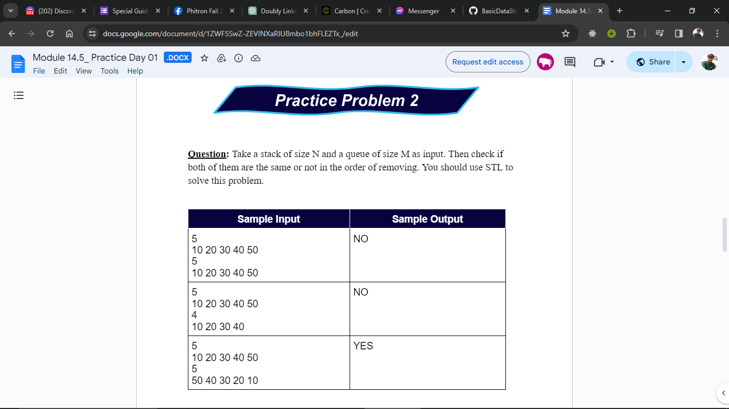

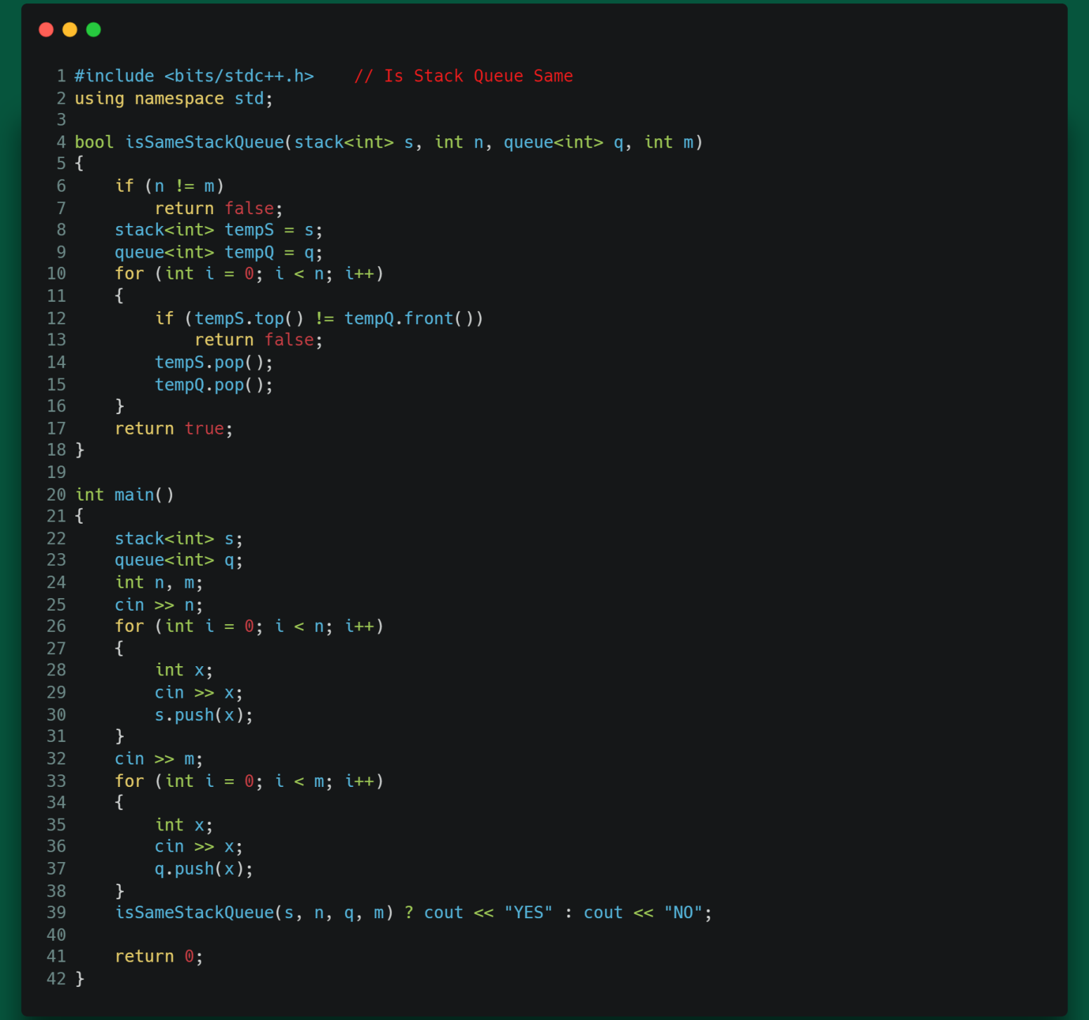

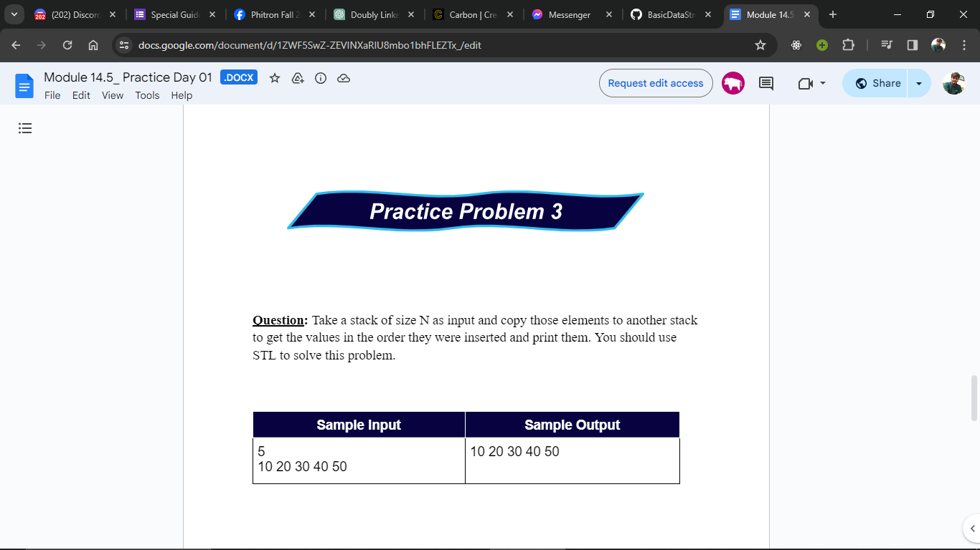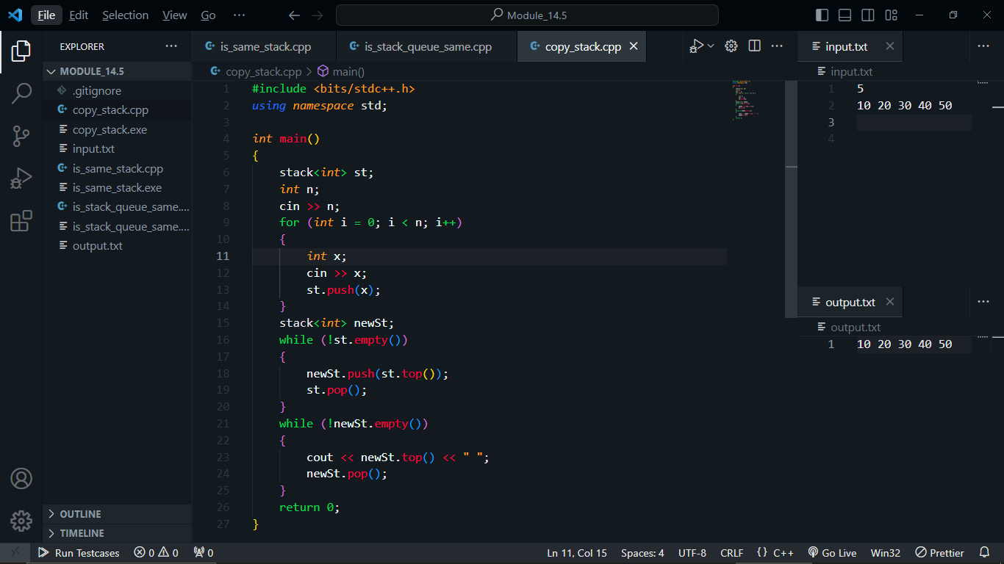

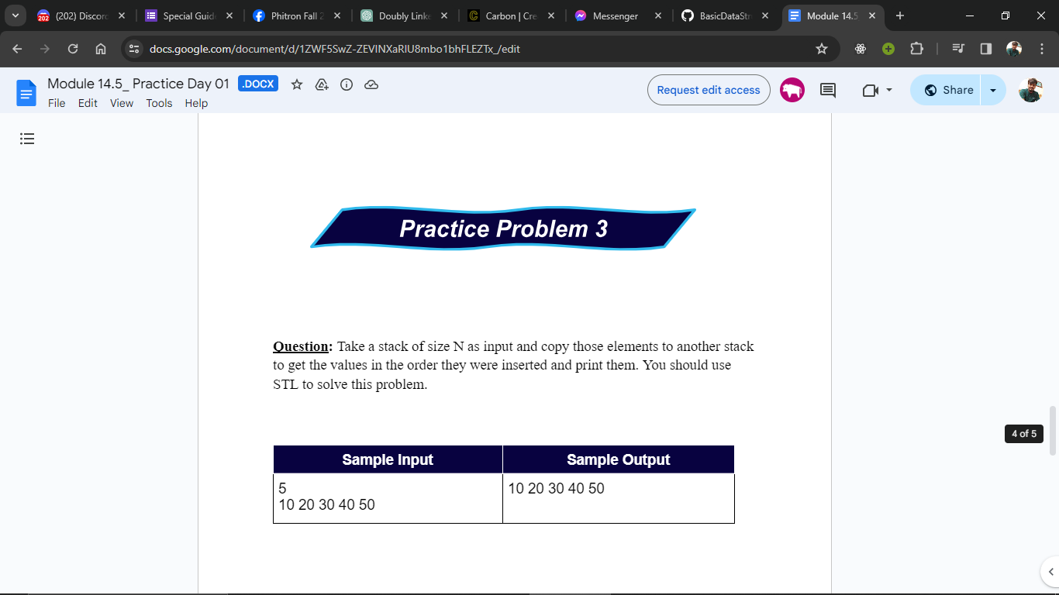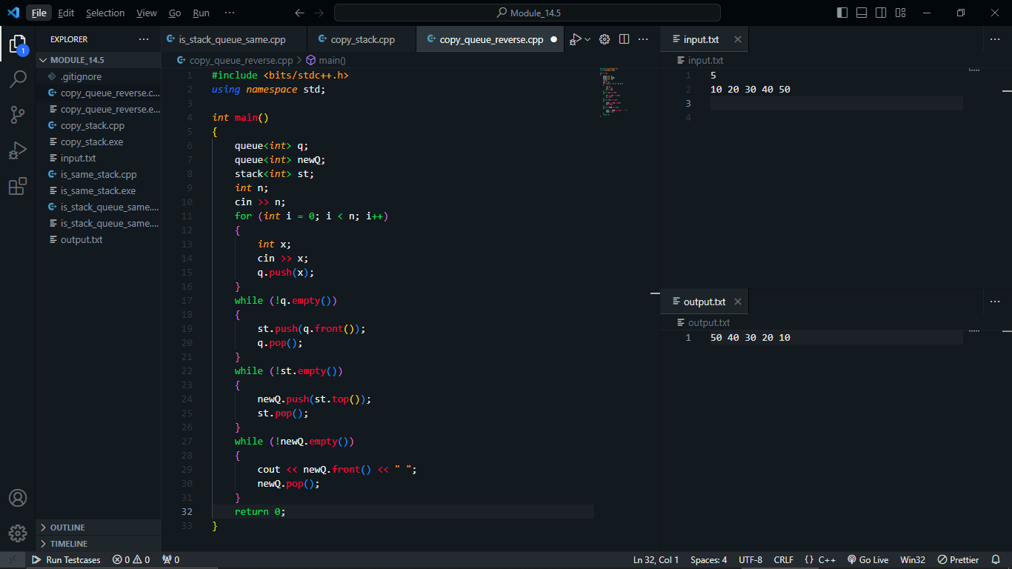

Module 17:

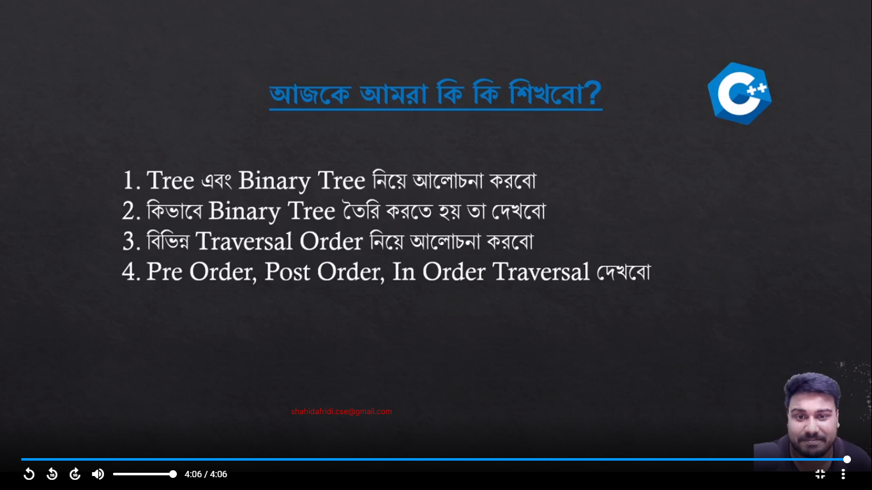

1. Array and Linked List => Linear

2. Tree => Non Linear

Binary Tree:

Node of Binary Tree:

1. val -> int /float/string/….

2. left -> Node *

3. right -> Node *

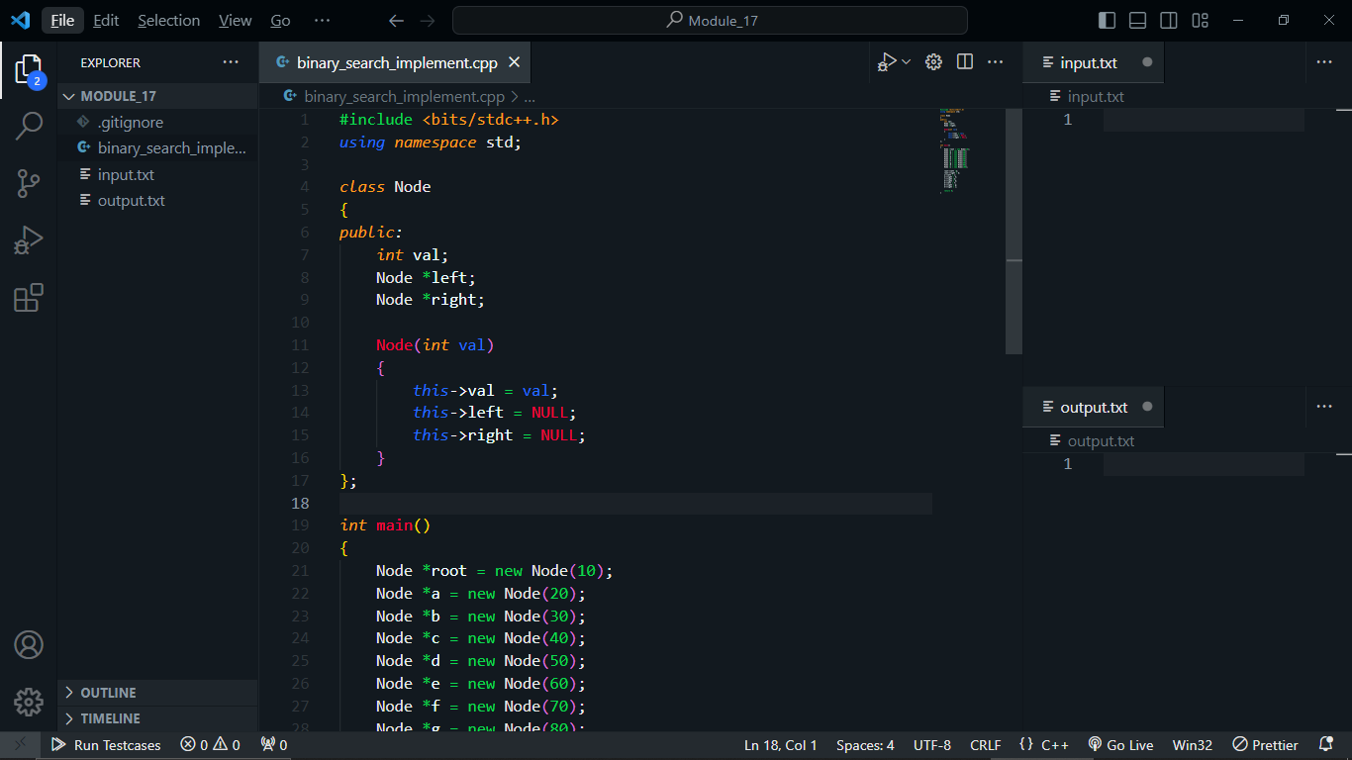

Binary Tree

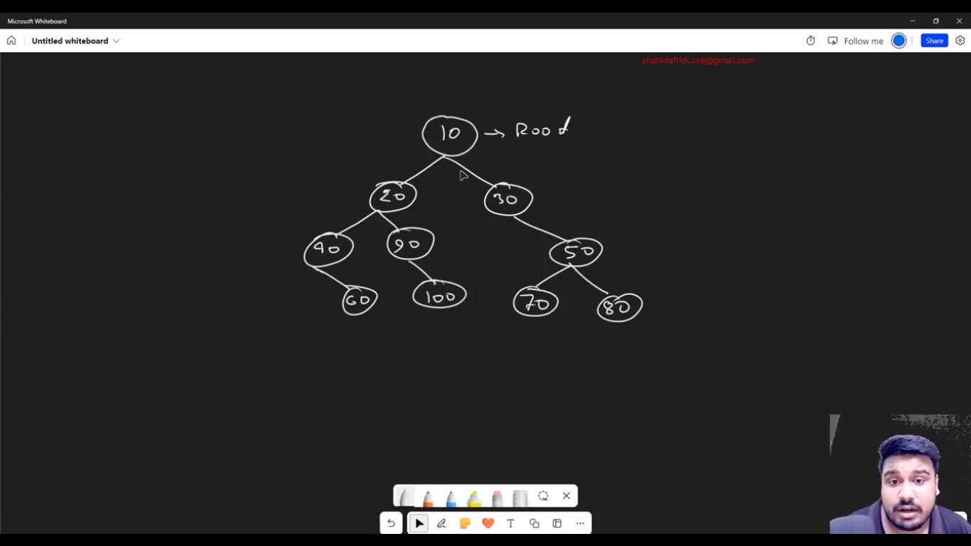

Leaf

Parent

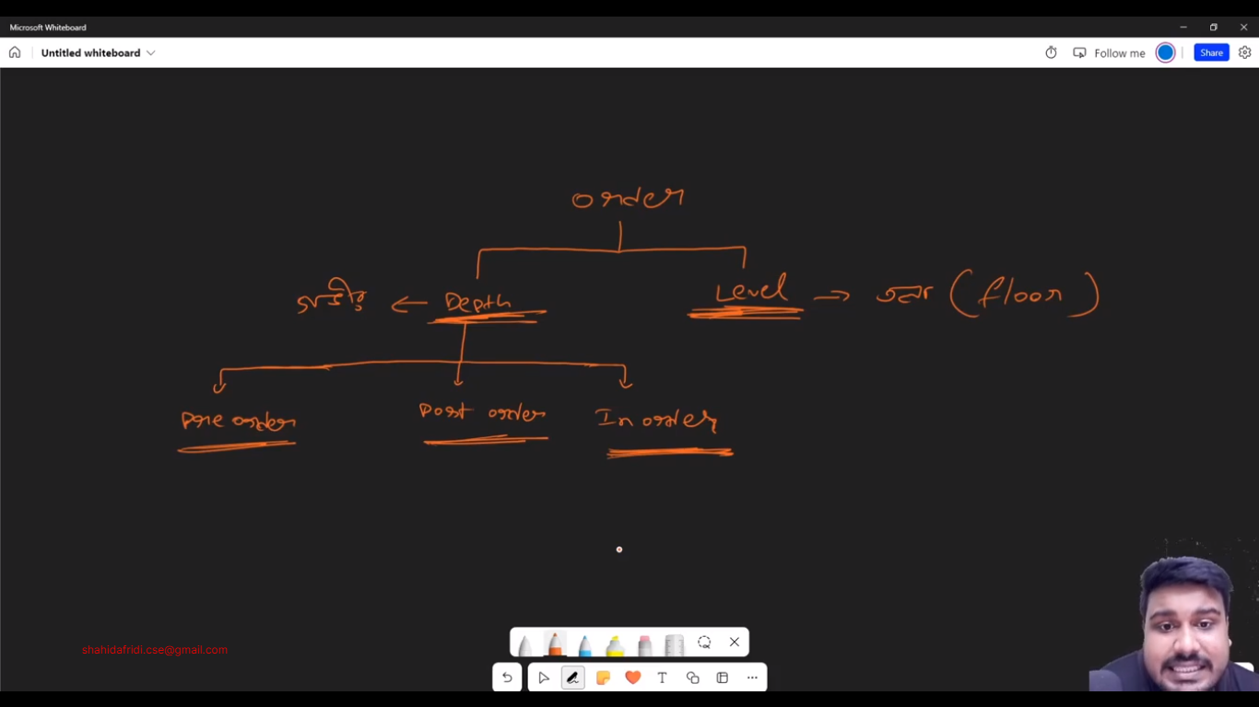

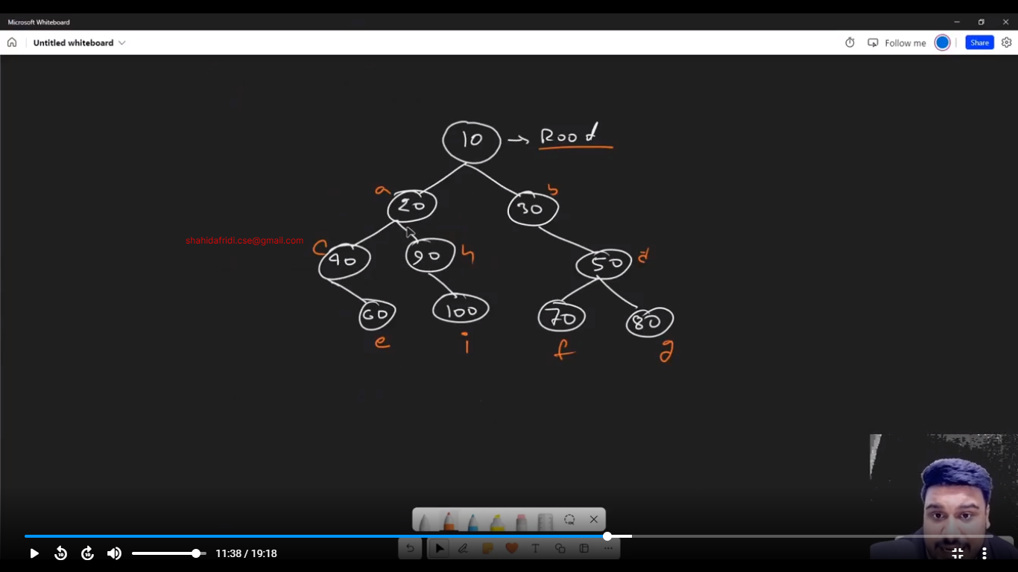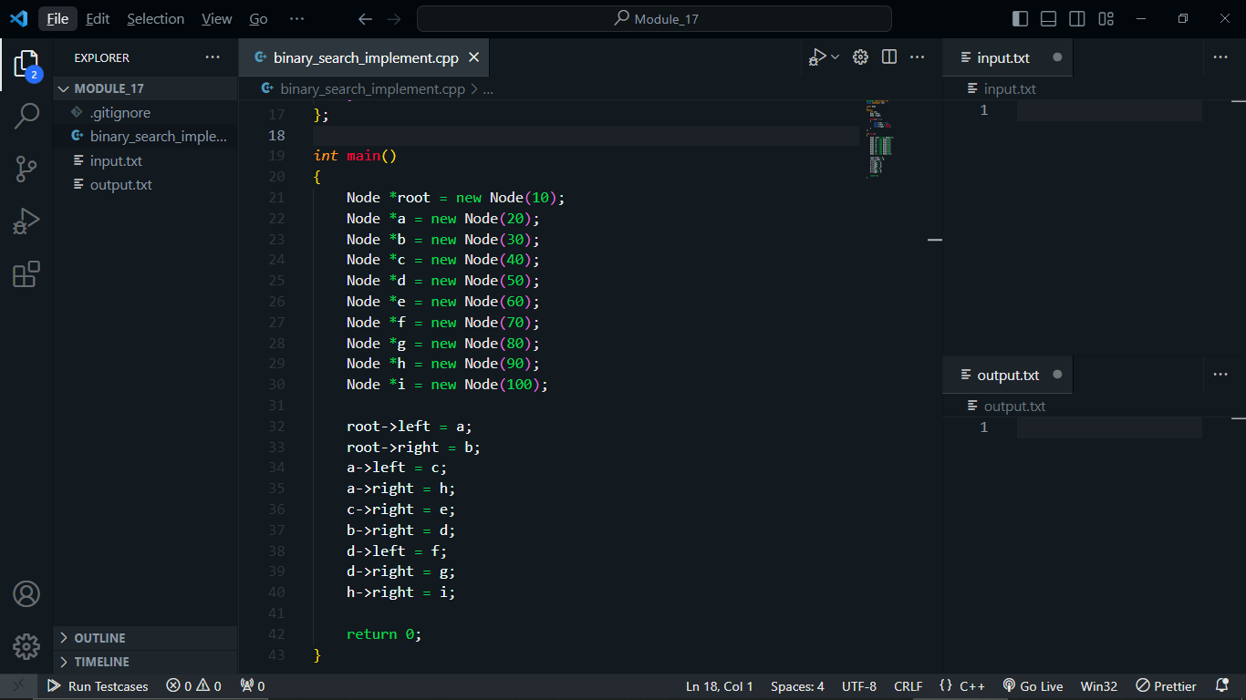

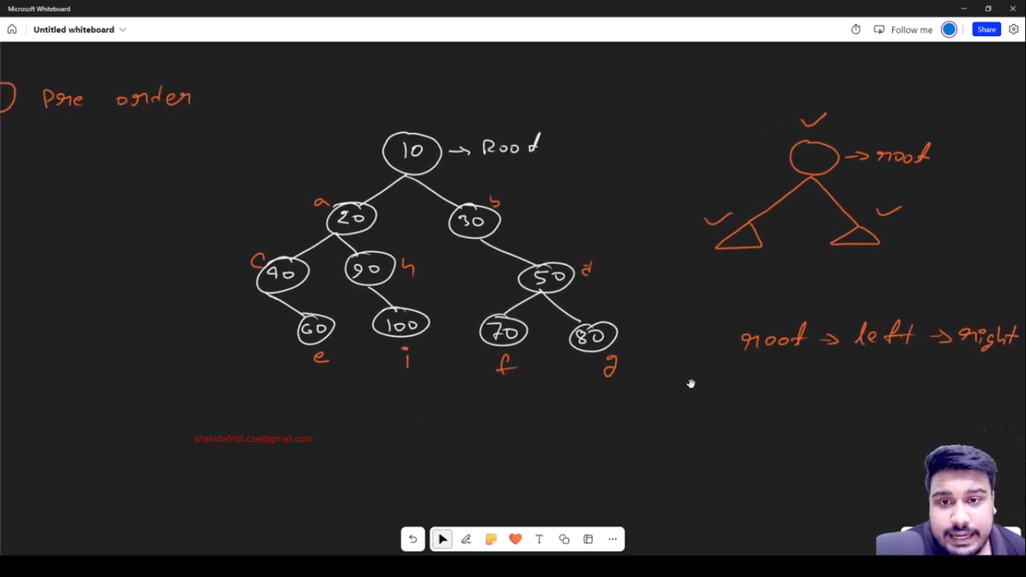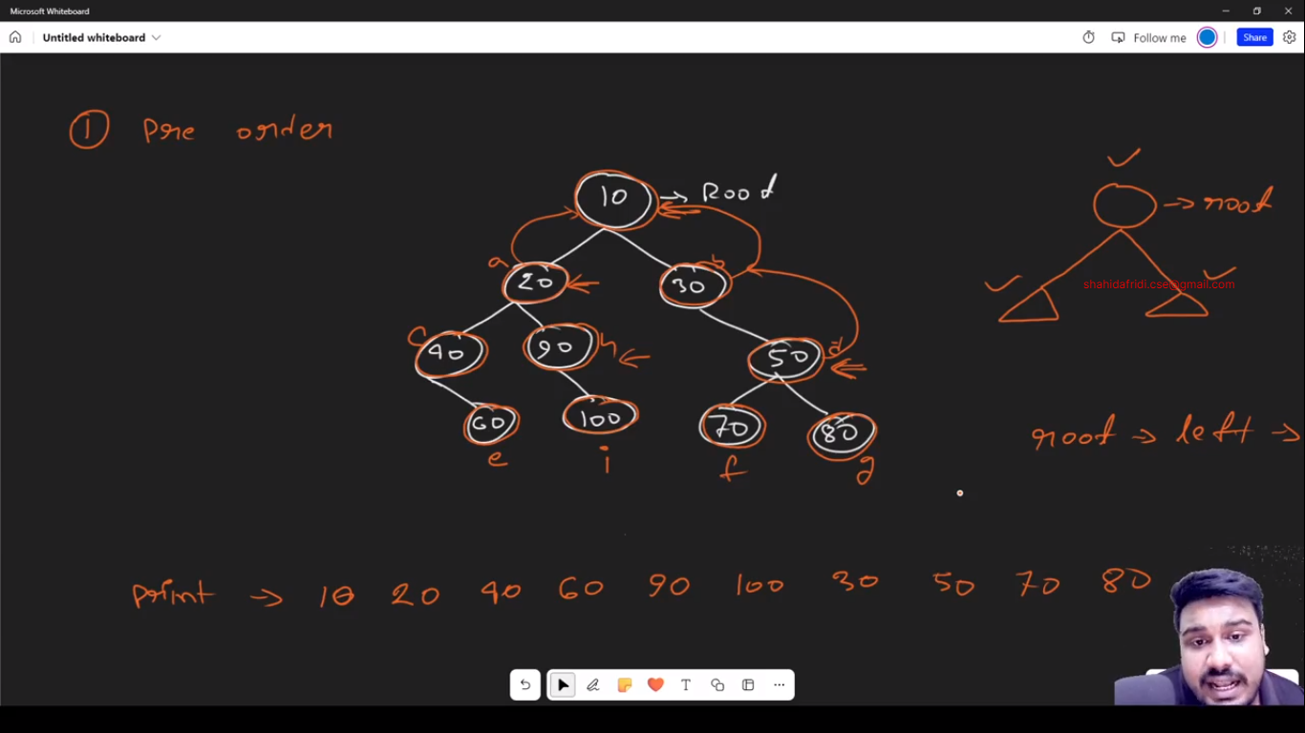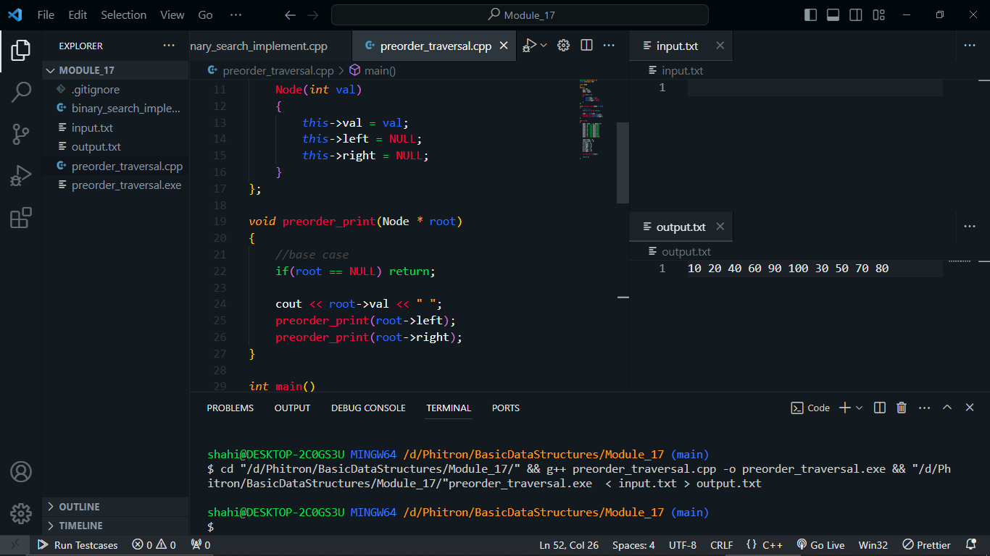

Post-order Print:

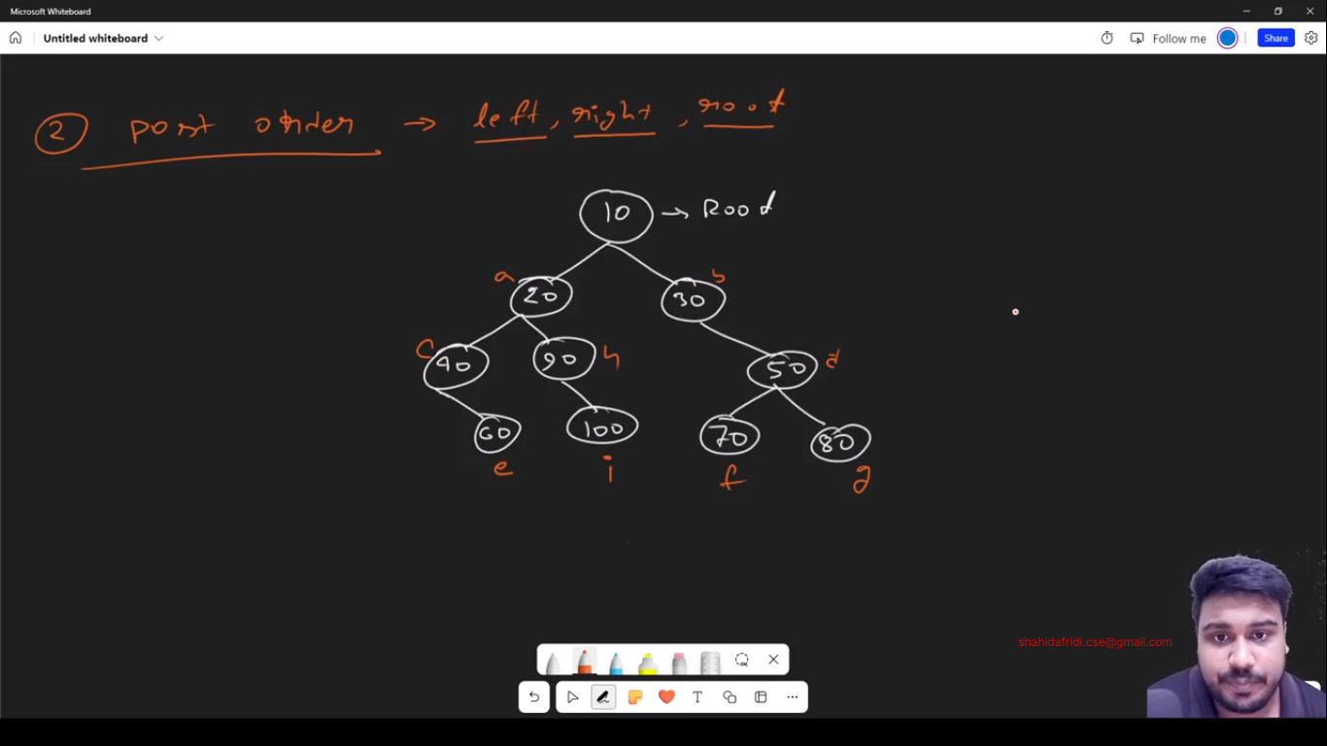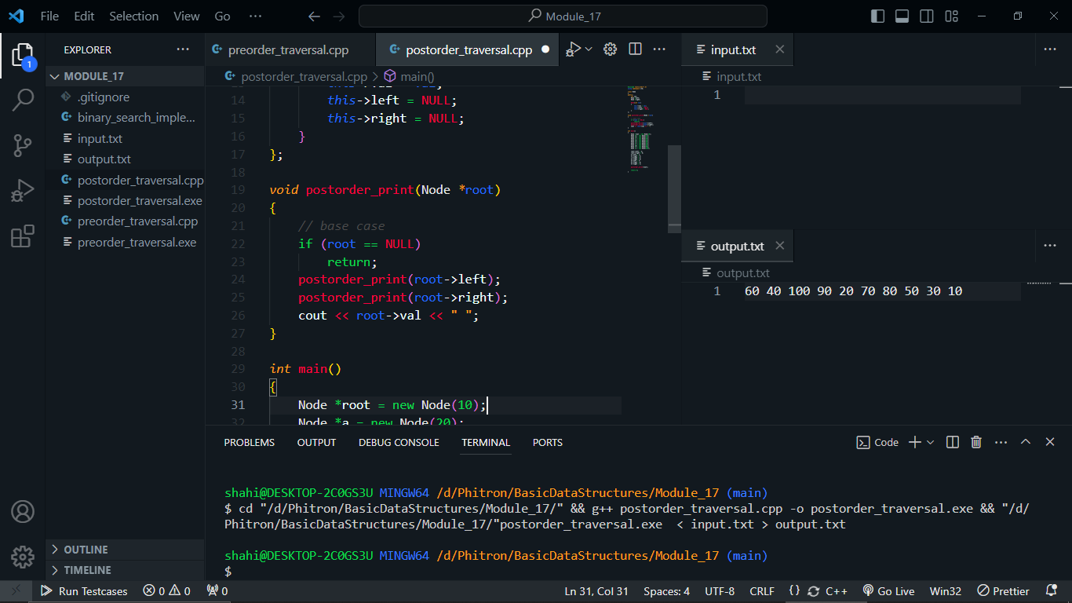

In-Order Print:

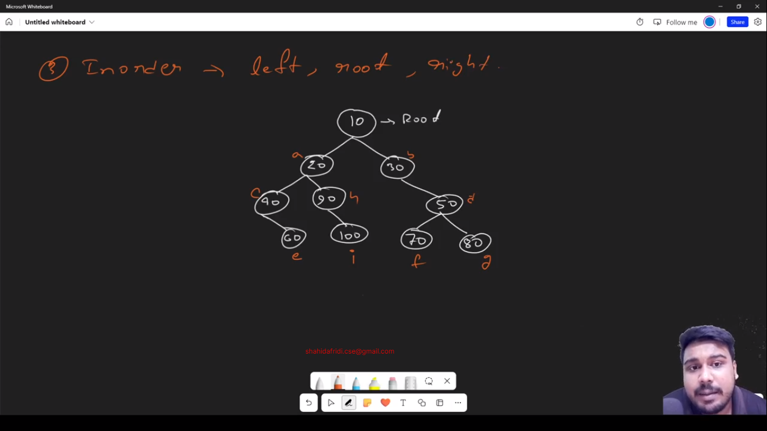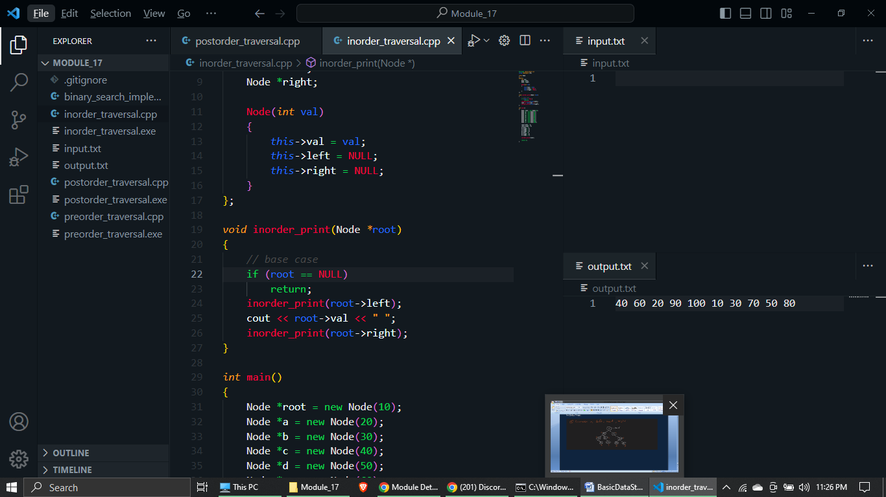

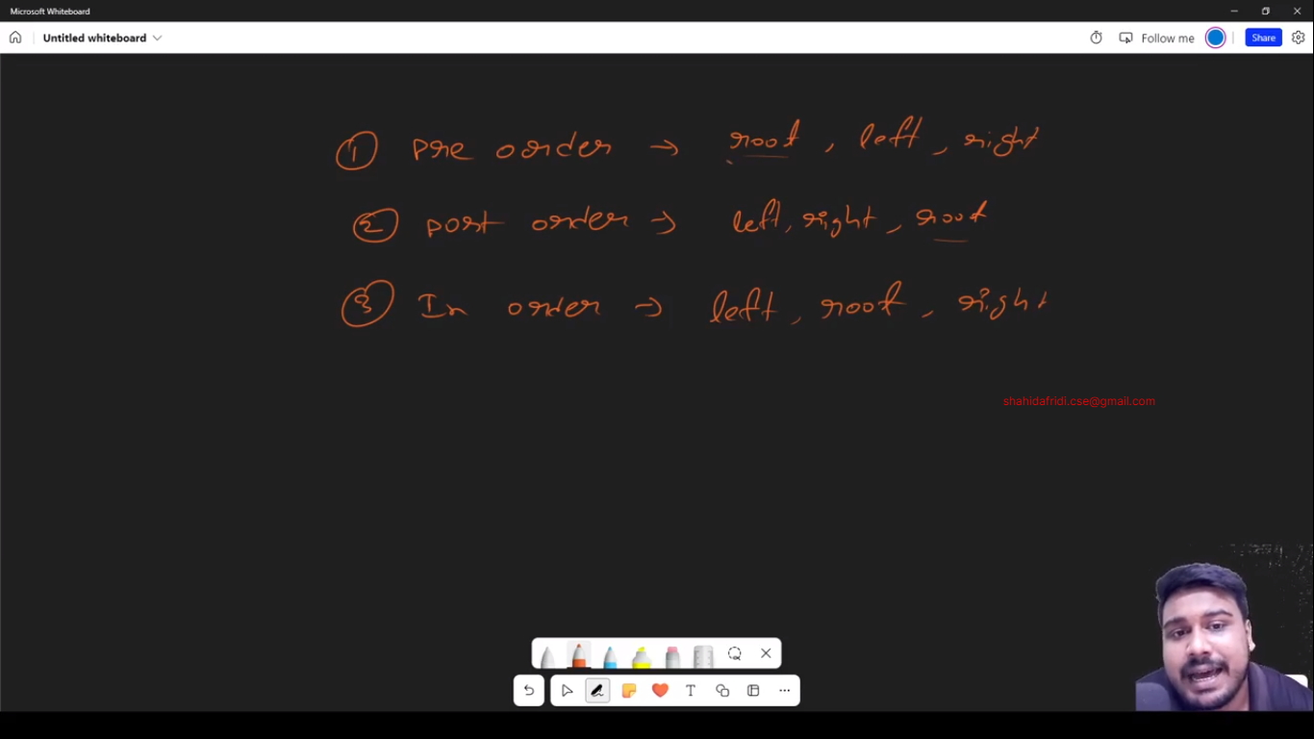

Module 18:

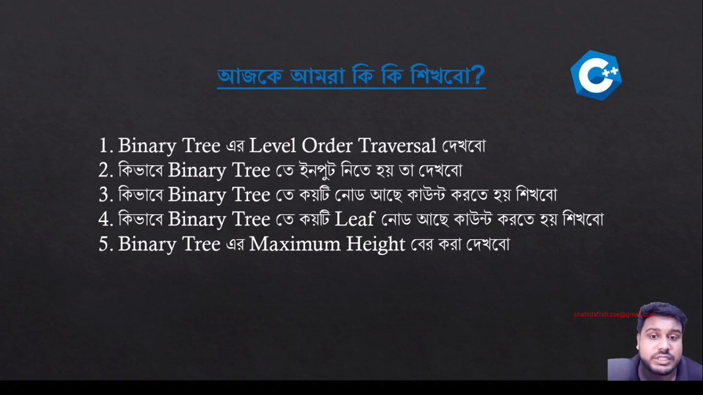

Level Order:

